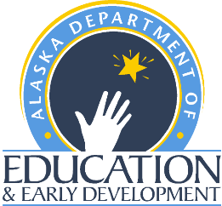 | Summer Food Service Program    2021 Annual Training  Registration Form | Child Nutrition Programs  Finance and Support Services  P.O. Box 110500  Juneau, Alaska 99811-0500  Phone (907) 465-4788  Fax (907) 465-8910

Federal Regulations require attendance at a training for approval to run a SFSP

Please bring your SFSP Administration Guide (2016) to the trainings. If you need a SFSP Administration Guide (2016), you may find a copy to download and print here:
https://fns-prod.azureedge.net/sites/default/files/sfsp/SFSP_Admin_Guide_Sept2016.pdf

Training Session Dates and Times:
Please check ONE box indicating which session you will be attending. A registration confirmation email will be sent once your form is received. Please e-mail completed registration form to:
- Jennifer Cherian, SFSP Program Assistant, Jennifer.cherian@alaska.gov

Distance-delivery login, dial-in information and training materials will be sent via email to all registered participants prior to training dates.

Distance Delivery for New and Returning Sponsors:
  - March 31, 2021 8:30 AM – 4:30 PM

Distance Delivery for School Food Authorities Only (new and returning):
  - April 1, 2021 1:00 PM – 4:30 PM

Name(s) and Title(s) ________________________________________________________________

_________________________________________________________________________________

Sponsor Name: ____________________________________________________________________

Address: _________________________________________________________________________

City: __________________________________________ State_______ Zip Code: ______________

Phone: _________________________ Email: ___________________________________________

If you have questions regarding which training session to attend, or if you have a disability and need assistance in order to participate in this training, please contact the SFSP Specialist at (907) 465-4788.

