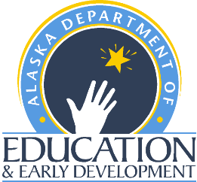 | Summer Food Service Program    2022 Annual Training  Registration Form | Child Nutrition Programs  Finance and Support Services  P.O. Box 110500  Juneau, Alaska 99811-0500  Phone (907) 465-4788  Fax (907) 465-8910

Federal Regulations require attendance at a training for approval to run a SFSP

Please bring your SFSP Administration Guide (2016) to the trainings. USDA has yet to update the 2016 version of the Administration Guide. If you need a SFSP Administrative Guide (2016), you may find a copy to download and print here: SFSP Admin Guide 2016

Training Locations, Dates, and Time:
Please check ONE box indicating date of training you will be attending. A registration confirmation email will be sent once your form is received. Please e-mail your completed registration form to: Jennifer Cherian, SFSP Program Assistant, jennifer.cherian@alaska.gov.

Distance Delivery for All Sponsors:
Training Distance Delivered via Zoom
  - March 30, 2022 1:00 PM – 4:00 PM All SFSP Administrators/Sponsors

Distance Delivery for School Food Authorities:
Training Distance Delivered via Zoom
  - March 31, 2022 1:00 PM – 3:00 PM School District SFSP Administrators Only

Name and Title: __________________________________________________________________

Sponsor/Organization Name: ________________________________________________________

Address: _________________________________________________________________________

City: __________________________________________ State_______ Zip Code: ______________

Phone: _________________________ Email: ___________________________________________
Additional Attendees:
Name | Title | Email

If you have questions regarding which virtual training to attend, registration, or if you have a disability and need assistance in order to participate in this training, please contact the SFSP Specialist at (907) 465-4788.

