- Disproportionate Rates of Access to Educators (ESEA section 1111(g)(1)(B)):
Describe how low-income and minority children enrolled in schools assisted under Title I, Part A are not served at disproportionate rates by ineffective, out-of-field, or inexperienced teachers, and the measures the SEA will use to evaluate and publicly report the progress of the SEA with respect to such description.
(Consistent with ESEA section 1111(g)(1)(B), this description should not be construed as requiring a State to develop or implement a teacher, principal or other school leader evaluation system.)

Alaska Definitions
DEED will use the following definitions to determine disproportionate rates of access to educators for low-income and minority children enrolled in schools assisted under Title I, Part A in Alaska:
- Low-income student (Economically Disadvantaged Student) – A student who is eligible for free or reduced-price school meals under the department’s Alaska Income Eligibility Guidelines for Free and Reduced Meals, as defined in 4 AAC 06.899.(5). These guidelines are based on the Federal Poverty Guidelines, and include students who are qualified for the Temporary Assistance to Needy Families (TANF) and Supplemental Nutrition Assistance Program (SNAP). In addition, students who are identified as migrant students, homeless students, or students in foster care qualify as low-income categorically by their membership in these identified categories.
- Minority Student (Students of Color) – A student identified as a member of a minority race or ethnicity (i.e., African American, Alaskan Native, American Indian, Asian or Pacific Islander, Hispanic, or two or more races, as defined in 4 AAC 06.899).
- Inexperienced Teacher (First Year Teacher) – A teacher in the first year of practice, having no previous experience leading classroom instruction other than student teaching or similar preparation experiences. Also, inexperienced principals and other school leaders would be in their first year of leading.
- Out-of-field teacher - A teacher teaching in a subject area in which the teacher does not hold an Alaska endorsement. This updates the definition from “not highly qualified.” An endorsement can be added with a passing score on a content exam and two years of experience.
- Ineffective Teacher –
  - Any teacher who was on a plan of improvement under 4 AAC 19.010(g), or was notified that their continued employment in the district was contingent on the implementation of a plan of improvement and resigned, or
  - A tenured teacher who was receiving district support or a plan of professional growth under 4 AAC 19.010(h).
An improvement plan is required when a teacher is determined to be unsatisfactory on one or more of the Alaska Teacher Standards through the district’s educator evaluation and support system. A professional growth plan (district support) District support is required when a teacher is determined to be basic on two or more of the Alaska Teacher Standards through the district’s educator evaluation and support system.
The definition of an ineffective teacher refers exclusively to required levels of support that are the result of the district’s educator evaluation and support system as outlined in employee evaluation (AS 14.20.149) and purpose and scope of evaluation (4 AAC 19.010). For example: A voluntary plan of professional growth (e.g. changing of grade levels) would not be used to determine the reported level of support.

Purposes of Alaska’s Educator Evaluation and Support Systems

All districts are encouraged to use plans of professional growth to help all educators grow professionally and improve the effectiveness of instruction. The majority of Alaska’s districts have chosen to adopt one of the three state-approved evaluation frameworks (Danielson, Marzano or CEL 5D+). These three frameworks have been aligned to the Alaska Teacher Standards. All districts (including those that created their own evaluation systems) have had to demonstrate that their educator evaluation and support systems are aligned to the Alaska Teacher Standards. Alaska regulations for educator evaluations do not require district reporting of overall ratings or ratings for each of the Alaska Teacher Standards or domains of an adopted framework.

Context for Alaska’s Definitions
Alaska’s definitions of inexperienced teacher and out-of-field teacher were initially developed in 2015 through the development of the Alaska Equity Plan. Through extensive stakeholder feedback during 2016-2017, these definitions were reviewed and revised, and the definition of an ineffective teacher was developed. DEED leveraged various stakeholder groups described in Title II, Part A #5, as well as the ESSA Advisory Committee.

The definition of inexperienced teacher remains the same. This definition was based in part on the Civil Rights Data Collection (CRDC) data provided. This definition is easy to understand and is familiar to Alaska’s districts. Alaska has been collecting data on inexperienced teachers through the “new to the profession” data field in the annual DEED certified staff accounting data collection. This data has been collected and verified for multiple years which makes it a reliable data source. Also, stakeholders advised keeping the same definition to avoid increasing the burden on districts and the state by using existing data collection fields.

Based on stakeholder feedback, “first year teacher” was added parenthetically for clarification, similar to the clarifications provided for the definitions of economically disadvantaged students and students of color. There was some stakeholder feedback requesting a longer period of time due to a concern that if a teacher does not meet the definition of inexperienced (e.g., if a teacher has taught for more than one year) then he or she would be considered to be experienced. DEED understands that research suggests that teachers generally continue to increase their effectiveness in the first few years of teaching.

The definition of an out-of-field teacher was updated from “not highly qualified” to not holding an endorsement in the assigned subject area. The update was well received by stakeholders. Districts had been requesting a change to use the broader subject areas especially in the sciences and social studies. DEED will reduce the data burden on districts by having the data analysis done at the state level by matching teacher certification and certified staff accounting data collections.

Alaska is being proactive by recognizing teachers’ efforts to become highly qualified. Many of the teachers will be able to apply for an endorsement in a content area with two years of experience in the content area in which they were highly qualified. Stakeholders remain concerned that in Alaska’s one or two teacher schools it is very difficult if not impossible to find a teacher endorsed in multiple content areas at the secondary level. Moving forward, teachers will be able to obtain an endorsement in a content area by passing a state-approved content area exam and completing two years of teaching experience in that content area.

The definition of ineffective teacher generated the most stakeholder feedback as it was a new definition. In the fall, DEED started sharing the initial state-proposed definitions with the Educator Evaluation and Support Advisory Committee. The initial reaction was interest in a tiered definition that differentiated between tenured and non-tenured teachers. Over the winter, various draft definitions were provided to all districts for feedback. Overwhelmingly, district stakeholder feedback supported definitions based on educator evaluation and support system data. With only one year of collection of district level data, it is too early to have a strong degree of confidence in the data. Also, it is yet to be determined if data collected at the school level can provide the necessary distinctions in teacher effectiveness. If issues arise with data quality or the ability to differentiate, DEED will collaborate with districts to understand the causes of the issues and to address them.

Current Context
In 2015, DEED developed the Equitable Access to Excellent Educators Plan for Alaska (Alaska Equity Plan) Alaska’s Equity Plan is available at (education.alaska.gov/TeacherCertification/aep.html). The following data from that plan paint a picture of Alaska’s disproportionate rates of access to educators for low-income and minority children:
- Economically Disadvantaged (Low-Income) Students are
1.8 times more likely to be placed with first-year teachers
- Students of Color (Minority) are
Two times more likely to be placed with first-year teachers
- Economically Disadvantaged (Low-Income) Students are
Almost twice as likely to be taught a core content course by a teacher who is not highly qualified
- Students of Color (Minority) are
Two times more likely to be taught a core content course by a teacher who is not highly qualified
The disproportionate rates of access to educators are displayed in the graphs that follow.
Economically Disadvantaged (Low Income) Students Disproportionate Rate of
Access to Inexperienced Teachers (10 Year Average)
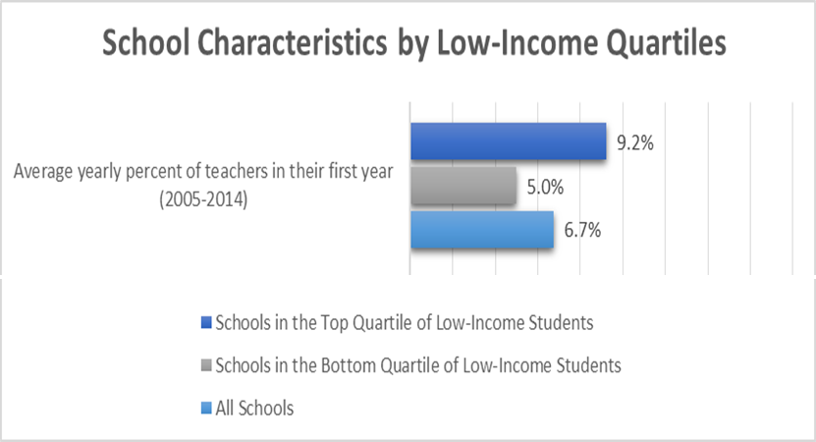
Students of Color (Minority) Disproportionate Rate of
Access to Inexperienced Teachers (10 Year Average)
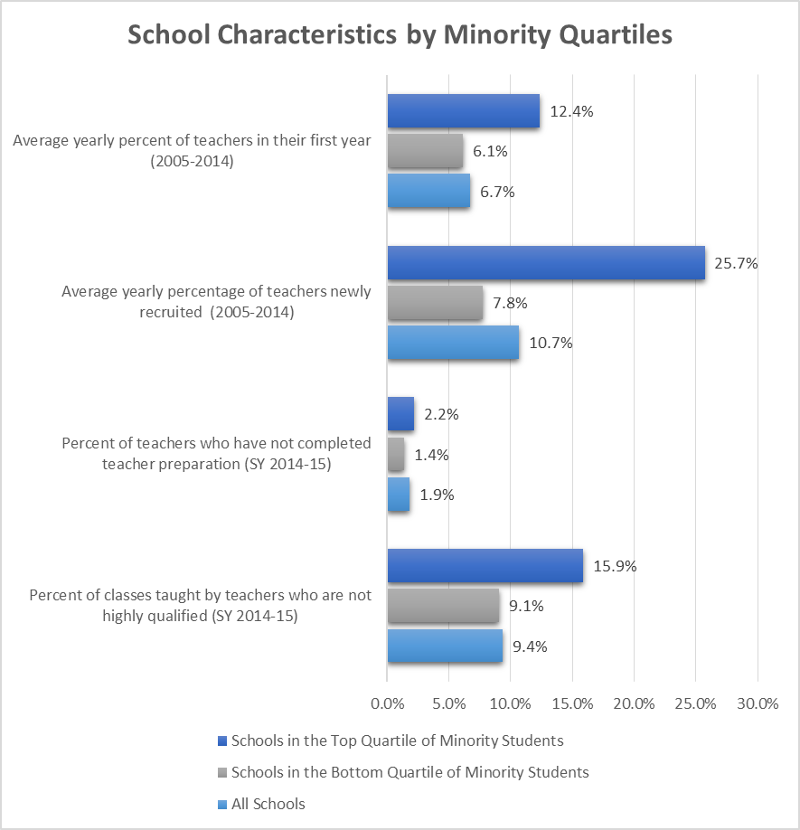
The disproportionate rates of access to out-of-field teachers shown below are based on the previous definition in the 2015 Alaska State Equity Plan and not the current proposed definition.
Economically Disadvantaged (Low Income) Students Disproportionate Rate of
Access to Out-Of-Field Teachers (10 Year Average)
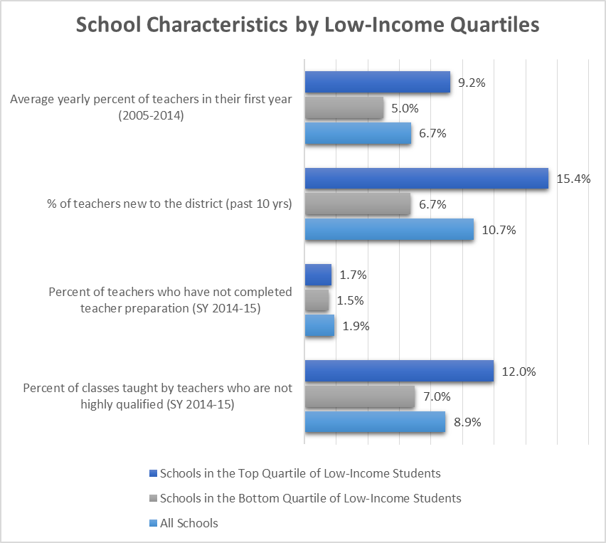
Students of Color (Minority) Disproportionate Rate of
Access to Out-of-Field Teachers (10 Year Average)

Background: Initial Root Cause Analysis
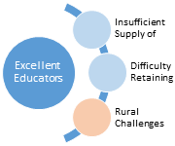
Stakeholder work in 2015 to develop the Alaska Equity Plan identified an initial picture of the challenges in Alaska. Through the analysis of data, information gathered from meetings, conversations with stakeholders, and various research studies, DEED identified root causes in three areas.

DEED will continue to work with districts and stakeholders to reassess root causes for disproportionate access to educators and will focus on strategies to address the causes identified in the blue areas that can be affected more directly by districts and schools.

Strategies to Address Root Causes and Eliminate Equity Gaps
Alaska recognizes that ensuring students’ equitable access to excellent teachers is a long-term issue, and achieving teacher equity goals will require implementation of strategies in collaboration with Alaska’s school districts. Alaska’s plan, therefore, is built on the following theory of action.

Alaska’s theory of action is based on the following principles and key beliefs:
- Research shows that teachers have a greater impact on student achievement than any other in-school factor. Students in many of Alaska’s high-needs schools and districts do not have the same access to excellent teaching as other students.
- There are a number of factors that impact a district’s supply of excellent teachers and students’ access to those teachers. To address these issues, DEED needs to continue working with districts to improve and tailor talent management, including identifying and addressing critical shortage areas. These are likely to include:
  - Ways to recruit and retain teachers of the science, technology, engineering, and math fields as well as teachers of students receiving special education services. DEED will leverage best practices from the research (e.g., recruiting math, science, and special education teachers), as well as, practices piloted in Alaska to support districts in those areas as needed.
  - Continuing technical assistance to improve talent management for all districts. Using resources such as Increasing Equitable Access to Excellent Educators Opportunities: A Talent Management Guide for School Districts produced by the Equitable Access Support Network. As part of this support, DEED will work with districts to train administrators on effective supervision and expectations.
  - Alaska has been garnering information from states that have started planning or implementing “Equity Labs.” This is a collaborative process with select school districts to begin to address the inequitable distribution of teachers. DEED will be exploring the usefulness and feasibility of this approach in Alaska.
- Providing improved access to meaningful data will likely lead to improved district-level decisions making in the area of talent management. DEED will continue to provide data on rates of access to inexperienced and out-of-field teachers, and will provide data on rates of access to ineffective teachers in the future.
- Stakeholder engagement will continue to be a critical component of reviewing and revising Alaska’s plan.

Key Strategies: Awareness, Preparation, Recruitment and Support
DEED has identified four strategic areas: awareness of access to excellent teachers, preparation of teachers, recruitment of teachers, and support of teachers and leaders (retention). Working collaboratively with Alaska’s districts and other stakeholder groups, DEED will continue to seek out and share strategies that improve teacher retention rates. The following are key strategies and two sample activities that will be used to increase equity across Alaska:

Approach to Address Disproportionality of Inexperienced and Out-of-Field Teachers
There have been disproportional rates of access to inexperienced and out-of-field teachers in Alaska. Alaska will continue to implement and refine the approaches outlined in Alaska’s Equity Plan. After the data on ineffective teachers is available, Alaska will begin to address any disproportional rates of access to ineffective teachers. In Title II, Part A, there are planned actions to improve equitable access to effective teachers in Title I, Part A Schools, as described below.

DEED will be using the multi-phase approach to address any of Alaska’s disproportionate rates of access to educators for low-income and minority children enrolled in schools assisted under Title I, Part A.
- Phase 1: Awareness - Share Alaska’s disproportionate rates of access to Educators for low-income and minority children enrolled in schools assisted under Title I, Part A.
- Phase 2: Support – Identify districts with challenges in disproportionate rates of access to educators for low-income and minority children and provide support. Identify areas where DEED can provide technical assistance and help districts access necessary resources.
- Phase 3: Review - Review the Alaska Equity Plan and make necessary adjustments, and engage stakeholders to review the initial root causes and strategies for improving Alaska’s Disproportionate Rate of Access to Educators for low-income and minority children enrolled in schools assisted under Title I, Part A.

Measuring and Reporting Progress on Rates of Disproportionality
DEED will use the following tables to measure and report progress with respect to reducing disproportionate rates of access to excellent educators for low-income and minority children enrolled in schools assisted under Title I, Part A. The rates will be calculated as the percentage of teachers in each category in all schools in the highest and lowest quartiles statewide for low-income and minority students. . The rates will also be calculated for teachers in Title I schools and in Non-Title I schools.

DEED will publicly report this information on the department’s website (https://education.alaska.gov/data-center). As with all reporting done by DEED, extra care will be taken to protect educator privacy using data suppression rules similar to those used for reporting student data.

Inexperienced Teachers
Data from the 2016-2017 and 2017-2018 school years is are available, and will be reported as shown in the following tables. There are duplicated counts in this table for teachers who were assigned to more than one school. Teachers were not reported who were assigned to schools with no enrollment (includes shared-time status schools where students are enrolled in their school of attendance) or assigned to the district office rather than a school.
Economically Disadvantaged (Low Income) Students Disproportionate Rate of Access to Inexperienced Teachers (2016-17)
School type | High poverty quartile  # inexperienced teachers | High poverty quartile  Total teachers | High poverty quartile  % inexperienced | Low poverty quartile  # inexperienced teachers | Low poverty quartile  Total teachers | Low poverty quartile % inexperienced | All schools  # inexperienced teachers | All schools  Total teachers | All schools  % inexperienced
Title I | 123 | 1,438 | 8.6% | 6 | 68 | 8.8% | 244 | 3,784 | 6.4%
Non-Title I | 3 | 85 | 3.5% | 75 | 2,418 | 3.1% | 142 | 4,583 | 3.1%
All schools | 126 | 1,523 | 8.3% | 81 | 2,486 | 3.3% | 386 | 8,367 | 4.6%

Economically Disadvantaged (Low Income) Students Disproportionate Rate of Access to Inexperienced Teachers (2017-18)
School type | High poverty quartile  # inexperienced teachers | High poverty quartile  Total teachers | High poverty quartile  % inexperienced | Low poverty quartile  # inexperienced teachers | Low poverty quartile  Total teachers | Low poverty quartile  % inexperienced | All schools  # inexperienced teachers | All schools  Total teachers | All schools  % inexperienced
Title I | 99.03 | 1379.41 | 7.2% | 1 | 82.6 | 1.2% | 221.15 | 3587.21 | 6.2%
Non-Title I | 9.5 | 179.81 | 5.3% | 54.65 | 2106.1 | 2.6% | 115.16 | 4063.62 | 2.8%
All schools | 108.53 | 1559.22 | 7.0% | 55.65 | 2188.7 | 2.5% | 336.31 | 7650.83 | 4.4%

Students of Color (Minority) Disproportionate Rate of Access to Inexperienced Teachers (2016-2017)
School type | High Minority quartile  # inexperienced teachers | High Minority quartile  Total teachers | High Minority quartile  % inexperienced | Low Minority quartile  # inexperienced teachers | Low Minority quartile  Total teachers | Low Minority quartile  % inexperienced | All Schools  # inexperienced teachers | All Schools  Total teachers | All Schools  % inexperienced
Title I | 109 | 992 | 11.0% | 27 | 669 | 4.0% | 244 | 3,784 | 6.4%
Non-Title I | 8 | 92 | 8.7% | 49 | 1,537 | 3.2% | 142 | 4,583 | 3.1%
All schools | 117 | 1,084 | 10.8% | 76 | 2,206 | 3.4% | 386 | 8,367 | 4.6%

School type | High Minority quartile  # inexperienced teachers | High Minority quartile  Total teachers | High Minority quartile  % inexperienced | Low Minority quartile  # inexperienced teachers | Low Minority quartile  Total teachers | Low Minority quartile  % inexperienced | All Schools  # inexperienced teachers | All Schools  Total teachers | All Schools  % inexperienced
Title I | 80.14 | 884.51 | 9.1% | 14.49 | 552.26 | 2.6% | 221.15 | 3587.21 | 6.2%
Non-Title I | 8.0 | 112.5 | 7.1% | 28.95 | 1352.29 | 2.1% | 115.16 | 4063.62 | 2.8%
All schools | 88.14 | 997.01 | 8.8% | 43.44 | 1904.55 | 2.3% | 336.31 | 7650.83 | 4.4%
Students of Color (Minority) Disproportionate Rate of Access to Inexperienced Teachers (2017-18)

Note: This data was previously compiled by the headcount of inexperienced teachers. To match the Ed Facts data collection, this data is now compiled using FTE. The number of inexperienced teachers has decreased overall in the state and all quartiles. The difference may be in part due to change in compilation by FTE. The rate of access to inexperienced teachers for low-income and minority students has remained consistent. A more accurate comparison can be made to the 2018-19 data collection.

Out-of-Field Teachers
Data for out-of-field teachers was not available will be able to be reported for 2016-2017 because_Alaska is currently was in the process of changing from the former definition of out-of-field (highly qualified) to the new definition of out-of-field teachers. DEED will finalized the business rules for determining which endorsements will be required for each of the 50 + teaching assignments available for reporting. Special rules are required for special education, specialist assignments (e.g. elementary mathematics specialist), and Career and Technical Education. These rules will be were provided to stakeholders for consideration and feedback this spring. Stakeholder groups include the Title I Committee of Practitioners, District Human Resource Directors, and the Commissioner’s advisory committees.

DEED will calculated the preliminary rates of out-of-field teachers for 2016-17 2017-2018 school year when the new definition was in effect. Districts will be provided a preliminary data review to provide any necessary corrections and/or updates. The final data for 2016-2017 2017-2018 school year will be is reported in the charts below and will be submitted to the U.S. Department of Education no later than November 30, 2018 as supplemental information for Alaska’s ESSA Consolidated State Plan.
Economically Disadvantaged (Low Income) Students Disproportionate Rate of Access to Out-of-Field Teachers (2016-17 2017-2018)
School type | High Poverty Quartile  # out-of-field teachers | High Poverty Quartile  Total teachers | High Poverty Quartile  % out-of-field | Low Poverty Quartile  # out-of-field teachers | Low Poverty Quartile  Total teachers | Low Poverty Quartile  % out-of-field | All Schools  # out-of-field teachers | All Schools  Total teachers | All Schools  % out-of-field
Title I | 264.09 | 1379.41 | 19.1% | 14.44 | 82.60 | 17.5% | 731.39 | 3587.21 | 20.4%
Non-Title I | 27.27 | 179.81 | 15.2% | 519.47 | 2106.10 | 24.7% | 995.36 | 4063.62 | 24.5%
All schools | 291.36 | 1559.22 | 18.7% | 533.91 | 2188.7 | 24.4% | 1726.75 | 7650.83 | 22.6%

Note: Teachers were not reported who were assigned to schools with no enrollment (includes shared-time status schools where students are enrolled in their school of attendance) or assigned to the district office rather than a school. This data was previously compiled by the number of classes taught by an out-of-field teachers. To match the Ed Facts data collection, this data is now compiled using FTE instead of class count. Since out-of-field definition is linked to certification, the addition of endorsements could occur on the three to five year certificate cycle.

Students of Color (Minority) Disproportionate Rate of Access to Out-of-Field Teachers (2016-2017-2018)
School type | High Minority quartile  # out-of-field teachers | High Minority quartile  Total teachers | High Minority quartile  % out-of-field | Low Poverty quartile  # out-of-field teachers | Low Poverty quartile  Total teachers | Low Poverty quartile  % out-of-field | All schools  # out-of-field teachers | All schools  Total teachers | All schools  % out-of-field
Title I | 226.97 | 884.51 | 25.7% | 92.12 | 552.26 | 16.7% | 731.39 | 3587.21 | 20.4%
Non-Title I | 17.17 | 112.50 | 15.3% | 320.80 | 1352.29 | 23.7% | 995.36 | 4063.62 | 24.5%
All schools | 244.14 | 997.01 | 24.5% | 412.92 | 1904.55 | 21.7% | 1726.75 | 7650.83 | 22.6%

Ineffective Teachers
As the definition for ineffective teachers is a new requirement under ESSA, Alaska does not have school-level data to report for the 2016-2017 school year. Alaska has collected only district-level data on the level of supports for tenured and non-tenured teachers, special service providers, and administrators. Ineffective teachers are determined from the level of support (e.g. plan of improvement) data as shown in the definition at the beginning of Section 5. DEED will only request data from Alaska’s districts that are aggregated at the school and district level to ensure educator privacy. Educator evaluations are not public records, are not subject to disclosure, and will not be reported at the educator level. The new evaluation regulations reinforce this by requiring districts to adopt procedures to protect the confidentiality of evaluations. DEED will pay special attention to ensure that individual educators cannot be identified in any reporting by using data suppression rules similar to those used for reporting student data.

DEED will collected school-level data from all districts for the 2017-18 school year. Districts will be provided preliminary data review to provide any necessary corrections and/or updates. The final data for 2017-2018 will be is reported in the charts below and will be submitted to the U.S. Department of Education no later than November 30, 2018 as supplemental information for Alaska’s ESSA Consolidated State Plan.

Note: There are duplicated counts in this table for teachers who were assigned to more than one school. Teachers were not reported who were assigned to schools with no enrollment (includes shared-time status schools where students are enrolled in their school of attendance) or assigned to the district office rather than a school. This data is compiled by the headcount of ineffective teachers.

Economically Disadvantaged (Low Income) Students Disproportionate Rate of Access to Ineffective Teachers (2017-18)
School Type | High poverty quartile  # ineffective teachers | High poverty quartile  Total teachers | High poverty quartile  % ineffective | Low poverty quartile  # ineffective teachers | Low poverty quartile  Total teachers | Low poverty quartile  % ineffective | All schools  # ineffective teachers | All schools  Total teachers | All schools  % ineffective
Title I | 40 | 1568 | 2.6% | 3 | 88 | 3.4% | 80 | 3756 | 2.1%
Non-Title I | 0 | 200 | 0.0% | 18 | 2213 | 0.8% | 32 | 4369 | 0.7%
All schools | 40 | 1768 | 2.3% | 21 | 2301 | 0.9% | 112 | 8155 | 1.4%

Students of Color (Minority) Disproportionate Rate of Access to Ineffective Teachers (2017-2018)
School Type | High minority quartile  # ineffective teachers | High minority quartile  Total teachers | High minority quartile  % ineffective | Low minority quartile  # ineffective teachers | Low minority quartile  Total teachers | Low minority quartile  % ineffective | All schools  # ineffective teachers | All schools Total teachers | All schools  % ineffective
Title I | 39 | 971 | 4.0% | 6 | 572 | 1.0% | 80 | 3756 | 2.1%
Non-Title I | 1 | 104 | 1.0% | 13 | 1435 | 0.9% | 32 | 4369 | 0.7%
All schools | 40 | 1075 | 3.7% | 19 | 2007 | 0.9% | 112 | 8155 | 1.4%

Ensuring Excellent Educators
Notably, this year, DEED launched the Alaska’s Education Challenge to address Alaska’s student achievement gaps and increase graduation rates by making sure that every student across the state has an equal opportunity to learn and succeed. Through a process of gathering public input, the State Board of Education and Early Development has already identified five priorities for Alaska’s public education system: Amplify Student Learning, Ensure Excellent Educators, Modernize the Education System, Inspire Tribal and Community Ownership of Educational Excellence, and Promote Safety and Well-Being.
Ensuring excellent educators is critical both as an impact on student learning, but more importantly on success in meeting Alaska’s mission and vision for public education.
Mission: An excellent education for every student every day.
Vision: All students can succeed in their education and work; shape worthwhile and satisfying lives for themselves; exemplify the best values of society; and, be effective in improving the character and quality of the world about them.

