

SCHOOL BUS SAFETY
INSPECTION MANUAL

2006 Edition

ACKNOWLEDGEMENTS
The Alaska School Bus Safety Inspection Manual has been revised to reflect the 2005 National School Transportation Specifications & Procedures and the 2006 Minimum Standards for Alaska School Buses. This manual is the result of many months of research, preparation, commentary, revision and more commentary on the revisions from many professionals specializing in school transportation vehicles around the state of Alaska and the Lower 48. I would like to thank them all for their expertise, input, and support for this project, including, but not limited to, the following people and organizations.
Danny Allen, Alaska State School Bus Inspection Team
Garry Wolske, Alaska State School Bus Inspection Team
Steve Mann, Blue Bird Corporation
Ricky Stanley, Thomas Built Buses
Ron Briggler, International Truck and Engine Corporation
Ray Belanger, Quality Equipment, Anchorage
Donna King, Trailer Craft, Inc.
Mike Lash, Alaska Truck Center
Scott Schwald, Matanuska Susitna Borough School District
Bill Cheeseman, Matanuska Susitna Borough School District
Howard Kelly, Matanuska Susitna Borough School District
Robert Ornelas, Matanuska Susitna Borough School District - Laidlaw
Jay Adams, Anchorage School District
Steve Kalmes, Anchorage School District
Gary Halcomb, First Student
Norman Bush, First Student
Dennis Cook, Fairbanks-North Star Borough School District
Tom Hyatt – Laidlaw - Regional
Nan Spooner, Kenai Peninsula Borough School District
Bruce Galloway, Kenai Peninsula Borough School District
Nema Arndt, Kenai Peninsula Borough School District - Laidlaw
Bruce Rosing, Kenai Peninsula Borough School District - Laidlaw
Elizabeth Sweeney, Alaska Dept. of Education & Early Development
Eddy Jeans, Alaska Dept. of Education & Early Development
Thanks to all of you, and so many more.
Jim Farrington
Alaska Dept. of Education & Early Development

INTRODUCTION
In 1990, legislation was enacted directing the Alaska Department of Education to develop and implement a comprehensive school bus inspection program. The manual that was developed in 1991-92 was the basis for that program. The 2006 edition has been revised and updated to reflect changes in standards and improvement in industry safety technology and operating procedures.
The primary goal of the school bus inspection program is to provide for the safest transportation possible for the children of Alaska. Including these inspection procedures as one of the components of an operator’s preventive maintenance program is possibly the most effective way to achieve this goal. By using this manual and the included criteria in performing periodic inspections, the operator will be able to identify defects and correct them sooner, reducing the possibility of mechanical problems while children are on board and reducing out-of-service designations by the state inspector and subsequent “down time” of buses.
This program mandates three different school bus inspections. The Basic Safety inspection checks for surface defects and the condition of required equipment. The Mechanical inspection combines the requirements of the Basic Safety inspection with a more detailed mechanical inspection that includes a review of maintenance records. The Minimum Standards inspection certifies that a bus complies with the minimum equipment and construction standards for Alaska school buses. Each bus receives one Basic Safety and one Mechanical inspection each year. The Minimum Standards inspection is only required once when introducing a bus into service in the state and is generally performed in conjunction with the first Basic Safety or Mechanical Inspection.
Inspections are conducted under the direction of the Department of Education & Early Development twice a year, once between July 1st and December 31st and once between January 1st and June 30th.
The Manual is broken into several sub-sections. The Instruction sections provide directions to bus inspectors and bus owners on the details of conducting school bus inspections and re-inspections. Basic Safety, Mechanical, and Minimum Standards inspections, along with Re-inspections are outlined. Described in each are the chronological order, procedures and methodology that are generally used in conducting a state-certified school bus inspection. These instructions are used in conjunction with the School Bus Inspection Section of the national standards manual to conduct and prepare for the Basic Safety, Mechanical or Minimum Standards inspections.
The school bus inspection section of the national standards manual outlines the components of the Basic Safety and Mechanical inspections required. Each item to be inspected is included in this section. Descriptions of defects that require repair are listed for each item. The inspector then assigns an action to each defect item.

The inspector may decide that a road test needs to be performed in order to check performance of one or more components, such as steering or brake performance.
The inspectors will use these tests to verify that the equipment meets applicable standards. The list of items to be inspected is extensive, and the criteria specific. However, no list can be totally inclusive of all possible safety defects. The inspections are designed to determine the safety and fitness of each school bus. Thus, if an inspector finds an unsafe condition on a school bus, the bus will be declared out-of-service until a correction can be made. If the bus operator disagrees with the determination of the inspector, information concerning the situation will be forwarded to the State Administrator of Pupil Transportation for resolution.
The successful implementation of this program begins with the anticipation of improved safety for the more than 40,000 students who ride our school buses daily. This manual will address changes and updates to the National Specifications for School Busses and Minimum Standards for Alaska School Busses. It is a living document, which will be updated to remain consistent with updates in national and state minimum standards and improvements in safety technology.
Any successful statewide maintenance and inspection program requires work and dedication on the part of all involved in the pupil transportation system in the state. The Alaska Department of Education & Early Development extends its deepest gratitude to those pupil transportation professionals who daily strive to provide the safest school bus ride possible for the children of Alaska.

PREPARATION
The Instruction Sections of this manual are intended to provide direction to school bus inspectors and school bus owners about how to conduct and how to prepare for school bus inspections. The instructions outline a systematic approach to each of the three required inspections: Basic Safety, Mechanical and Minimum Standards. Sequencing of events and hints for things to look for are also included.
The Criteria Section contains, in very specific format, the standards for each school bus inspection. National Specifications and Alaska Minimum Standards are the principal document used to determine whether vehicles or components meet manufacturing and construction standards. The Criteria has been updated in the National Standards Manual to reflect the revised edition of those standards currently adopted by regulation. Construction standards are primarily checked during the minimum standards inspection. However, safety and mechanical inspections primarily measure wear and tear of components, which, in many cases, are not specified in minimum standards. In those cases, commonly accepted industry standards, O.E.M. recommendations, input from other states with similar inspection procedures and input from operators from diverse areas of Alaska have been utilized in assembling the Inspection Criteria. These instructions will not repeat that information. Instead, they will refer to the appropriate section(s) of the inspection manual.
The bus inspector can use these instructions to establish a pattern for inspections that remains consistent over time. They can also be used as a mental pre-trip upon arrival at an inspection site. A review of the instructions prior to beginning a series of inspections will focus thoughts and energies on the task at hand.
The bus owner can use these instructions to better understand what will occur when a DOE inspector arrives for an inspection. Few ideas for preparation are introduced because well-maintained buses are always ready for inspection. A walk-through of the fleet by members of the maintenance staff to identify and correct unattended minor maintenance should be all the preparation necessary for an inspection. Perhaps the most important goal of the program is that each operator will know exactly what the inspector looks for and incorporates that process into the regular preventive maintenance program. Consequently, the bus will be receiving safety and mechanical inspections every time the operator’s mechanic gives a bus one of its periodic inspections, whether they’re called “A” and “B” inspections or “3,000 mile” and “annuals” or whatever an operator’s in-house terms are. IN GENERAL, THE BEST WAY TO BE PREPARED FOR AN INSPECTION VISIT IS TO RUN A CAREFUL, THOROUGH PREVENTIVE MAINTENANCE PROGRAM.
Finally, a section is included to describe the procedures for completing the forms, attaching the stickers, and distributing the copies to the appropriate parties. This will allow for a complete understanding of how the various parts of the program fit together.

BASIC SAFETY INSPECTION

Preparing for the Inspection
This Instructions Section is intended to provide direction to school bus inspectors and school bus owners about how to conduct and how to prepare for a Basic Safety inspection of a school bus. The specifications for the Basic Safety inspection are divided into six separate sections. These include Exterior, Underneath Bus, Engine Compartment, Inside Bus, and Brake Tests/Overall Performance. It is recommended that inspectors follow this sequence when conducting inspections. The sequence provided in the lay-out of the forms and criteria is further refined in these instructions. Strict observance of a set inspection pattern helps to assure that inspections are properly conducted.
The specific criteria to be used for the Basic Safety inspection can be found in the Criteria Section of this manual. Procedures for completing the inspection forms and comment sheets, and attaching the inspection stickers (regular, temporary, and out-of-service), can be found under the "PROCEDURES – Forms & Stickers" tab and includes examples of forms and stickers properly filled out. Procedures for re- inspections, complete with examples of properly completed forms, are found under the "RE-INSPECTIONS" tab.

Beginning the Inspection
Every inspection begins in the same manner. The inspector approaches the bus and verifies that the bus being inspected is the bus identified on the inspection sheet. The inspector then boards the bus and removes the current inspection sticker from the windshield. This ensures the bus will not have a sticker on its windshield unless the bus passes the inspection.

Part A – Exterior (Lighting)
The first area inspected is the lighting system and exterior of the vehicle. The bus owner's employee sits in the driver's seat. He/she should activate the light switches in the sequence called out by the inspector.
The sequence to be followed begins at the front of the bus, continues down either side to the rear, and returns to the front along the other side. Lights to be inspected and the recommended order of inspection are as follows:
Bus Front - Headlights; front clearance; front marker; front turn and hazard; front 8-way red and amber; stop arm; and front reflectors.

Bus Side - Side marker and side reflectors.
Bus Rear - Rear clearance; rear marker; tail; brake; back-up; rear turn and hazard; rear 8-way red and amber; strobe; and rear reflectors.
This sequence allows the inspector to view all of the lighting equipment on the bus during one trip around the bus.
The inspector conducts a visual inspection of each piece of equipment covered by the lights inspection. Each light is observed for correct performance and for the condition of the lenses.
Complete specifications and criteria for the lighting equipment inspection can be found in Part A of the Criteria Section of this manual.

Parts A—Exterior and B—Underneath Bus
Following observation of the lighting system, the inspector(s) begin a walk-around to examine the exterior of the bus. The items covered by the exterior component of the manual and many of the items of the chassis inspection can be covered during one trip around the bus. While going along the side of the bus, the inspector(s) will also inspect the underside of the bus. Inspections of springs, shocks, drive shaft, exhaust systems, and fuel systems must be done from underneath the bus using a flashlight or other available light.
The sequence to be followed begins at the front of the bus, continues down either side to the rear, and returns to the front along the other side. The items to be inspected and the recommended order of inspection are as follows:
Bus Front - Windshield; wiper/washers; exterior mirrors; front bumper; tow hooks/eyes, body condition; and tie rod ends and drag link.
Left Side - Front tire, wheel, wheel seals (oil leakage) and mud flap; battery; body condition, paint and lettering; glass condition; underside of bus; and rear tires, wheels, wheel seals and mud flaps.
Underside - Tie rod ends and drag link; chassis springs and attachments; (engine); fuel system; shock absorbers; drive shaft; brake components; wheel seals; and exhaust system.
Bus Rear - Glass; body condition, paint and lettering; rear bumper; tow hooks/eyes; (rear emergency door operation).
Right Side - Opposite sequence of trip down the left side plus fuel cap and top of fuel tank.

Throughout this part of the inspection, the inspectors visually inspect for evidence of problems or the absence of required equipment. Any item in the manual requiring inspection for looseness or unsecured mounting should also be physically shaken by hand or tapped with a metal object such as a wrench or hammer.
After working all the way around (and under) the vehicle, the inspector will be back at the front of the bus. Inspection of the exterior operation of the emergency door and of the battery compartment can occur during this section of the inspection. Criteria for these two items can be found in the bus interior and the under the hood sections respectively.
Complete specifications and criteria for the bus exterior and chassis inspections are found in Parts A and B of the Criteria Section of this manual.

Part C – Engine Compartment
The under hood portion of the inspection begins even prior to visual inspection of the engine compartment. The inspector should always be the one to open the hood for this part of the inspection, since the first item to be covered is the latching device. A positive latch can best be determined by the inspector opening and closing the hood personally.
Under hood items to be inspected and the recommended sequence are as follows:
Engine (including motor mounts); belts; hoses; (battery, if not already inspected during exterior walk around); fuel pump and lines; firewall; steering column and box (drag link); power steering sector; (brake components); and electrical wiring.
The eleven items described in the Under Hood portion of the manual provide general categories to be visually and physically inspected under the hood. In truth, the inspector is looking at everything under the hood. Evidence of anything out of the ordinary, e.g. chafing, oil spray, coolant leakage, etc., will cause the inspector to question the conditions under the hood.
On many buses the battery, while included in this portion of the manual, may already have been inspected during the walk-around inspection of the exterior and chassis.
Complete specifications and criteria for the under the hood inspections can be found in Part C of the criteria section of this manual.

Part D – Inside Bus
The inspection of the bus interior begins with the fire extinguisher, emergency reflectors and first aid kit, which are usually located just inside the service door. The inspector then continues with a walk up and down the aisle of the bus, visually inspecting the
seats and floor covering. A check of the interior panels and interior glass is also conducted at this time. While inspecting the seat coverings and frame rails the inspector will also physically shake each seat back.
Upon reaching the back of the bus, the inspector will check the interior operation and buzzer for the emergency exit. (This door has already been checked from outside during the walk-around for the exterior component of the inspection.) Any other emergency exits or storage containers will also be checked at this time. The return to the front of the bus will complete the inspection of the seats, floor, exits, and barriers.
Upon returning to the front of the bus, the inspector takes the driver's seat. Inspection of the remainder of the interior items is done from the front of the bus. Remaining items to be checked and the recommended sequence are as follows:
Heaters, defrosters and fans; horn; interior mirror; sun visor; service door; interior lights; stepwell lights; driver's seat belt; pedal pads; and unsecured equipment.
Each of these items should be visually and physically inspected. Containers and brackets, including those for the fire extinguisher, emergency reflectors and first aid kit, will be handled and examined for positive fastening and secure mounting. Exterior mirrors, windshield glass, and washer/wipers (inspected during the walk-around) should also be re-checked from the driver's seat.
Complete specifications and criteria for the bus interior inspection can be found in Part D of the Criteria Section.

Part E – Brake Tests/Overall Performance
Inspection of portions of the brake system occurs during many of the earlier component inspections. Inspection of the condition of the brake lines, hoses, calipers, rotors, backing plates, air tanks, etc. occurs during both the under hood and chassis inspections. However, that visual (and some cases physical) inspection did not test the actual working of the brake system.
Different tests are outlined in Part E of the Criteria Section. These cover hydraulic, vacuum, electric hydraulic and air brakes. Detailed instructions for each of these tests are part of the test descriptions, and will not be repeated here. The inspector will conduct the appropriate test for the system being inspected as outlined in the manual.
Inspectors and bus owners should note that there are no repair column items on these tests. Buses that fail any portion of one of these tests will be placed out-of-service. Both parties should use this as an indication of the importance of these tests and prepare for and conduct them accordingly.

Following the appropriate test of the service brakes, the inspector will check the parking brake. This test requires sufficient room in front of the vehicle to ensure failure of the parking brake will not cause the bus to hit a vehicle parked in front of it. The owner may wish to have the buses parked in such a manner prior to the inspections to prevent delays caused by moving buses around.
Complete specifications and criteria for the parking brake inspection can be found in Part E of the Criteria section of the manual. The test of the parking brake marks the end of the Basic Safety Inspection.

Concluding the Inspection
A school bus is determined to have passed the inspection if no out-of-service defects are found and recorded during the inspection. Repair items marked on the inspection forms must be repaired and re-inspected within 10 days of the initial inspection or else the bus will be placed out-of-service at the end of the 10-day grace period. If the repair cannot occur while the inspectors are on-site, a temporary inspection sticker (valid for 10 days) will be issued. A re-inspection must be scheduled prior to the expiration of the temporary sticker. The process of re-inspecting may be delegated to a third party authorized by the Department of Education & Early Development. The inspection team will provide the third party with the information necessary to conduct an appropriate re- inspection.
Out-of-service defects must be repaired and re-inspected prior to continued use of the bus. A Temporary sticker reverts to out-of-service status at the end of 10 days unless the bus has passed a re-inspection.
Detailed instructions for the completion of forms and attachment of stickers can be found under the tab labeled "PROCEDURES – Forms & Stickers".

COMBINED MECHANICAL/ BASIC SAFETY INSPECTION

Preparing for the Inspection
This Instructions Section is intended to provide direction to school bus inspectors and school bus owners about how to conduct and how to prepare for a Mechanical inspection of a school bus. It is recommended that inspectors follow the sequence outlined below when conducting inspections. Strict observance of a set inspection pattern helps to assure that inspections are properly conducted.
The Mechanical inspection of a school bus is a combination of the mechanical and the basic safety components of the inspection program. Inspectors will conduct a Mechanical Inspection in addition to the Basic Safety Inspection on approximately 50% of an operator’s fleet, with the other 50% receiving the mechanical inspection during the next inspection. Thus, a bus undertaken for a combined Mechanical/Basic Safety inspection must successfully pass all of the tests described in the Basic Safety portion of the manual in addition to the tests outlined below for the Mechanical inspection. The additional components of a Mechanical inspection consist of a more in-depth examination of the brake system (including a wheels-off inspection), steering travel, front wheel bearings, king pins/ball joints, steering lash, and preventive maintenance records check. If the inspector has concerns about the performance of certain components, e.g., brakes or steering, a road check may be performed to gauge performance.
The specific criteria to be used for the Mechanical inspection can be found in the applicable parts of the Criteria Section of this manual. Procedures for completing the inspection forms and comment sheets, and attaching the inspection stickers (regular, temporary, and out-of-service), can be found under the "PROCEDURES – Forms & Stickers" tab and includes examples of forms and stickers properly filled out. Procedures for re-inspections, complete with examples of properly completed forms, are found under the "RE-INSPECTIONS" tab.

Beginning the Inspection
The combined Mechanical/Basic Safety inspection begins in a different sequence from the Basic Safety inspection. The combined inspection begins in the shop office. The first item to be checked for this inspection is the maintenance records on each bus. Described below as the "Preventive Maintenance Records Check", this portion of the inspection is used for a dual purpose. The first is to verify that documentation of maintenance is being kept by the bus owner. The other purpose is for the inspectors to identify the busses that are to be included in the wheels-off requirement of the inspection plan. Note, however, that other methods are also used for choosing which buses will receive the wheels-off inspection.

A two-member team can begin with one person in the shop office going through records and the other person beginning the Basic Safety portion of the combined inspection. Conclusion of the records check then places both members together completing the combined inspections.

Preventive Maintenance Programs
The keystone of any safe school bus operation is a thorough, effective preventive maintenance program. It is also the best way to ensure preparation for the semi-annual state inspections. The items checked during the state inspections, both Basic Safety and Combined Mechanical/Basic Safety, are components that every bus operator should be examining on a regular basis as part of their preventive maintenance program. By providing reasonable guidelines, consistent inspections and assistance to operators, the department hopes to encourage all school bus operators to establish and maintain a good preventive maintenance program.
Preventive maintenance is a school bus operator's least expensive form of insurance for their equipment and their children. Early detection and correction of minor mechanical problems by shop personnel prevents large expenditures due to major mechanical failures. The likelihood of an accident resulting from a parts-related failure also decreases every time a careful preventive maintenance inspection occurs. Performing maintenance record keeping is necessary to prove that adequate maintenance occurred in the event a serious accident or fatality should happen.
The guidelines in this manual for required services and record keeping can serve as a benchmark for school bus operators designing or conducting preventive maintenance programs. A program that meets or exceeds these requirements will, over time, save the operators money and provide safer equipment for their passengers. Bus operators should note that these are the minimum services and maximum time and mileage intervals recommended for preventive maintenance. School buses operated in harsh climates, difficult conditions, or as part of a large fleet should be part of a program more stringent than the minimum program designed for application to all operations in the state.

Preventive Maintenance Records Check
Initially, the inspector’s review of fleet maintenance records will be conducted in an advisory/consulting manner. Inspectors will provide recommendations and guidance to operators with record systems that do not meet the guidelines set forth in this manual. Operators are encouraged to incorporate the recommended changes in order to be in compliance with the guidelines in the event they become requirements.
The records review section of this inspection begins with an interview with the shop foreman. The foreman will be asked to describe the maintenance program run by

his/her shop operation. Services required, intervals allowed between services, and the forms used to document these services should be described in detail. A method of ensuring timely repair of minor and major equipment problems (as reported by drivers or identified in PM inspections) should also be present and verifiable.
The method used to keep maintenance records can, and will, vary according to the needs and the size of the bus operation. In general, records should demonstrate the following:
- A method of identifying when a required service is due on every vehicle in the fleet.
- A written record on the maintenance and inspections performed on each vehicle. This record should contain documentation of all maintenance services performed, the date and mileage these operations were performed, the date and/or mileage the next services are due, and the signature of the mechanic.
- A method of verifying that defects identified during PM inspections or driver pre-trips are corrected in a timely fashion.
The format of the maintenance records is up to the discretion of the bus operator. The shop foreman should be able to describe and demonstrate how the system works during a short (15-30 minute) interview. That explanation should be sufficient to provide the inspector with the knowledge needed to find and review the maintenance records of any individual bus or group of buses in the fleet.
After the interview with the shop foreman, the inspector conducts a review of the maintenance files kept on the vehicles. The inspector will examine files for at least 25% of the buses, with a minimum of 10 files inspected. (For operations with fewer than 10 buses, all files will be reviewed.) The files will be selected at random to provide a representative sample of the fleet. For each file, the inspector will log the dates and mileages of every PM inspection, lube-oil-filter service, brake inspection, and tune-up inspection conducted in the past 12 months.
From the log for each bus, the inspector will be able to calculate time and mileage intervals between services to determine adherence to preventive maintenance guidelines outlined below. The inspector will be looking to see that these guidelines have been met, as well as checking to determine that documentation was completed in accordance with the guidelines.
After the interview and the inspection of the bus files, the inspector will draft a written report on the results of the review. This report will detail the methodology used to conduct the review, a summary of the operator's preventive maintenance program, and an outline of the results and recommendations arising from the review. The results and recommendations portion of the report will detail the strengths and deficiencies of the

preventive maintenance operation. Areas of non-compliance with either record keeping or maintenance operations will be noted.
If the inspector determines that the preventive maintenance records of the bus operator do not meet State guidelines, the deficiencies will be discussed with the shop foreman and bus operator. Problem areas will be identified and suggestions for how to correct the deviations will be offered. Recommendations for ways to correct the problems will be offered in a constructive, non-confrontational manner.

Preventive Maintenance Records Guidelines
As part of a preventive maintenance program, operators need to systematically inspect, maintain and lubricate all school buses subject to their control to ensure that buses are in safe and proper operating condition. Each bus should have a written record of:
  - Inspection, maintenance, and lubrication operations performed during the previous 12 months;
  - Date and mileage when these operations were performed;
  - Date and mileage when the next operations are due and;
  - Signature of the person performing the operations.
Operators should have every bus inspected by a mechanic periodically. A recommended interval would be every 60 calendar days or 3,000 miles, whichever occurs first, or more often, if necessary to ensure safe operations. Often referred to as the “Service” or “A” inspection, this should be more in-depth than the daily inspection performed by the driver. Buses out of service exceeding 60 calendar days, e.g., not in service during the summer, need not be inspected at 60-day intervals, provided they are inspected prior to being placed back into service.
The periodic preventive maintenance inspection should, as a minimum, cover:

- Lighting Equipment - Steering and Suspension
- Tires and Wheels - Belts and Hoses
- Brake Adjustment - Tank amounting Brackets
- Exhaust System Leaks - Oil & Grease Accumulation
In addition to the requirements above, operators are to ensure that all brake system components are inspected and serviced by a mechanic at least every 12 months or 20,000 miles, whichever occurs first. This inspection is often referred to as the “Annual” or “B” inspection. If brake components are not readily visible for inspection, as with drum brakes, then removal of chassis components (i.e., wheels) will be necessary.

At the conclusion of a records review, state inspectors will prepare, discuss, and leave with the operator a written report of recommendations concerning the operator’s PM and record-keeping system.

Section 1 - Brake System Tests
Complete specifications and criteria for brake system tests for several different types of brake system are outlined in Part E of the Criteria Section. The inspector will choose the appropriate test for hydraulic, vacuum or air brake systems. The tests to be used are described in detail in the referenced pages and will not be repeated in these instructions.
Throughout the test criteria, reference is made to "manufacturer's specifications". This is to allow the bus owner to offer documentation from an owner's manual that a different test/limit is more appropriate for the brake system on their specific type of equipment. Absent specific alternate guidelines/limits offered by the bus manufacturer, the most appropriate test from the manual will be the one used by the inspection team.
In addition to the various system tests, for those fleets of six or more buses, including spares, approximately 50% of the buses receiving a mechanical/basic safety inspection will also receive a wheels-off inspection, with a minimum of 1 bus receiving a wheels-off inspection. The inspectors will select, at random, one front and/or one rear wheel to be disassembled by the bus owner's maintenance staff. Brake drums, rotors, and linings will be measured and inspected. Additionally, springs, calipers, cylinders, retention hardware, backing plates, etc. will be examined during this inspection.
Fleets of five or fewer buses, including spares, will also receive basic safety and mechanical/basic safety inspections on a 50/50 split during each round. However, a wheels-off inspection is only required once per school year, and will be performed during the Fall inspections. Additional inspections may be conducted at the inspector’s discretion, or at the request of the Department.
The inspectors have the right to request wheels-off inspections of a higher percentage of buses if a number of wheels-off inspection failures occur. They may also request additional inspections if the physical inspection of the brakes does not match the information found in the maintenance records.

Section 2 - Steering Travel
This test is conducted with two persons. The front wheels must be lifted off the ground and blocked up for this test, as well as for the next two tests. Parking/service brakes should be set. With the wheels off the ground, the bus owner's employee must turn the steering wheel through a full left turn and a full right turn. The inspector will examine the travel of the tires and the movement of the steering components while the wheel is being turned.

The inspector is checking for evidence of binding, jamming, rubbing, or wear marks during the turns. Complete specifications and criteria for the steering travel inspection can be found in Part C of the criteria.

Sections 3 & 4 - Front Wheel Bearings and King Pins/Ball Joints
With the front wheels still off the ground from the steering travel test, the inspector will check the wheel bearings and the king pins/ball joints for excessive play. Both front wheels are to be examined during this test.
Wheel bearing play is detected by using a pry bar at the bottom of the wheel while placing the free hand on the back side of the wheel. Any movement between the backing plate and the brake drum (or between the hub and the axle for disc brakes) can be determined at this time.
To test the king pin/ball joint play, the vehicle's brakes must be applied while the inspector attempts to rock the wheel in and out using a pry bar at the bottom of the wheel and the free hand at the top of the wheel. A reference object that can be easily moved (perpendicular from the floor or ground) is placed against the tire. Any movement in the king pins/ball joints will result in the tire pushing the reference object away. The clearance between that object and the tire is then measured after the inspector tries to move the wheel.
Complete specifications and criteria for the front wheel bearing and the king pin/ball joint inspections can be found in Part B of the criteria section.

Section 5 - Steering Lash
The test for steering lash requires two people. One person must be inside the bus at the driver's seat. The other must be outside the bus observing the movement of the front tires. If one of the two persons is an employee of the bus owner, that person should be outside of the bus. Tolerances for steering lash should be checked with the engine running, since tire movement is easier and quicker to discern when power assist is activated.
Complete specifications and criteria for the Steering Lash inspection can be found beginning in Part of the criteria section. Steering lash is determined by measuring the amount of steering wheel play that occurs without moving the tires. The chart on page 69 also outlines acceptable limits depending upon the diameter of the steering wheel.

Section 6 – Performance Test
The inspector may decide that a road test needs to be performed in order to check performance of one or more components, such as steering or brake performance. Section E of the criteria contains information on road tests, as well as detailed brake performance test data.

Concluding the Inspection
A school bus is determined to have passed the inspection if no repair or out-of-service defects are found and recorded during the inspection. Repair items marked on the inspection forms must be repaired and re-inspected within 10 days of the initial inspection or else the bus will be placed out-of-service at the end of the 10-day grace period. If the repair cannot occur while the inspectors are on site, a temporary inspection sticker (valid for 10 days) will be issued. A re-inspection needs to be scheduled prior to the expiration of the temporary sticker. The process of re-inspecting may be delegated to a third party authorized by the Department of Education. The inspection team will provide the third party with the information necessary to conduct an appropriate re-inspection.
Out-of-service defects must be repaired and re-inspected prior to continued use of the bus. A Temporary sticker reverts to out-of-service status at the end of 10 days unless the bus has passed a re-inspection.
Detailed instructions for the completion of forms and attachment of stickers can be found under the tab labeled "PROCEDURES – Forms & Stickers".

MINIMUM STANDARDS INSPECTION
Every bus in the state must undergo and pass one Minimum Standards inspection. This inspection is conducted to determine that the vehicle complies with the minimum construction requirements of the State of Alaska.
Inspectors and bus owners must have available the following applicable publications to conduct and prepare for a Minimum Standards inspection:
National School Transportation Specifications & Procedures, May 2015 Revised Edition.
Minimum Standards for Alaska School Buses Manufactured on or after October 1, 2017
Minimum Standards for Alaska School Buses Manufactured on or after January 1, 2012
Minimum Standards for Alaska School Buses Manufactured after January 1, 2002
National School Transportation Specifications & Procedures, 2000 Revised Edition
Minimum Standards for Alaska School Buses Manufactured after January 1, 1994
National Standards for School Buses, 1990 Revised Edition
Minimum Standards for Alaska School Buses Manufactured after January 1, 1982
National Standards for School Buses, 1980 Revised Edition
The criteria for compliance with the Minimum Standards inspection can be found in these documents, as well as the Inspection Criteria contained in this manual. New editions of Alaska and National Minimum Standards adopted by the Alaska State Board of Education & Early Development will be distributed as amendments to this manual when new standards become effective.
The instructions for a Minimum Standards inspection follow the sequence and format outlines in the most current minimum standards publication. Each item will be checked in order, and a determination made regarding compliance with the standards. The appropriate items and tests will be used on older vehicles in accordance with the applicable standards.
A school bus is determined to have passed the inspection if no items are found that are not in compliance with National Standards/Specifications and Alaska Minimum Standards. The department will be informed immediately of any vehicles that do not meet standards. Any possible changes that will bring the vehicle into compliance with Alaska standards will be approved by the department and/or inspector in advance of the repair taking place to identify problems with possible repairs, before the operator or manufacturer begin making repairs on all busses of that make and model. If the vehicle or any component does not meet Federal Motor Vehicle Safety Standards, the bus will be placed out of service until the appropriate repairs have been made. If the component does not meet national specifications or Alaska minimum standards, the item may be classified by the inspector as a repair item, which would allow the operator or manufacturer 10 days to bring the bus into compliance (only allowed if the bus may be operated safely during that period). If the repair is not completed in that time, the bus will then be placed out of service until the repairs are completed. Periods longer than 10 days for repairs may be authorized by the department solely at its discretion and must be approved in advance. A re-inspection must be scheduled prior to the expiration of the temporary sticker. The process of re-inspecting may be delegated to a third party authorized by the Department of Education & Early Development. The inspection team will provide the third party with the information necessary to conduct an appropriate re-inspection.
The tests to be used in determining compliance are as follows:

TYPE B, C, AND D VEHICLES
Axles
Front axle weight rating can be determined from the vehicle's original line setting ticket, or from the part number stamped into the axle. The weight rating of the rear axle can be determined from a tag on the rear end casing or by the part number stamped on the axle. Owners of equipment without line setting tickets or rear axle tags should prepare for this inspection by identifying the part number on the axles.
Bumpers
The test is direct observation to verify presence and condition of bumpers.
Tow Hooks/Eyes
The test is direct observation to verify presence and condition of tow hooks/eyes or towing attachment point on frame.
Alternator
The rated output can be verified by inspection of the rating stamped on the alternator case.
Flooring
The test for presence and thickness of plywood flooring will be conducted by using a 1/8" drill bit with a stop at 5/8". A small hole will be drilled under a seat, and plugged by the inspector. The presence of wood shavings will verify the flooring material.

Defrosters/Fans
Defrosters and fans will be inspected for presence and operated to demonstrate performance.
Emergency Door
The door will be inspected for operation, signs, proper slide operator, and proper buzzer actuator. Specifications for rear door can be found in the applicable editions of National and Alaska Minimum Standards.
Mud Flaps
Flaps must cover the entire width of the tire and extend to within 10" of the ground. The test is direct observation.
Fire Extinquisher
The extinguisher will be inspected for proper rating, condition (charged/uncharged), mounting, and labeling. The test is direct observation.
First Aid Kit
The first aid kit will be inspected for mounting, contents and location. The test is direct observation.
Heaters
Each bus will be inspected for the presence of the required heaters. Appropriate BTU rating (or other measurement standard approved in advance by the department) will be verified by rating on heater identification plate.
Paint and Lettering
The test is direct observation to verify proper lettering and paint color.
Identification Plate
The test is direct observation to verify the presence of the identification plate.
Insulation
The test to determine the presence of encapsulated body insulation will be to remove light assemblies from taillights and/or interior lights and to look for the presence or absence of insulation in these areas.

Lamps and Signals
The strobe light must be present and must meet standard. The directional signal visible and audible devices must be present. The test is direct observation.
Exterior Mirrors
The test is direct observation to determine presence and location of the required convex mirrors. Additionally, they will be measured to determine compliance with size standard.
Rub Rails
The test is direct observation to verify that rub rails are yellow or black.
Stop Arm Signal
The test is direct observation to verify shape, color, and lights of stop arm.
Storage Container
The test is direct observation to verify the presence and location of storage container.
Tailpipe
The test is direct observation to verify location of tailpipe. (Note: tailpipe may not be flush with the bumper or body if the exhaust is hot.)
Aisle Joint Moldings
The test is direct observation to verify presence of moldings.
Dealer Certification
The certification may be present as a plate attached to the interior bulkhead or may be part of original equipment paperwork that came with the vehicle from the factory. The test is direct observation.

TYPE A VEHICLES
Type A school buses must meet all of the standards listed above except:

- service door (d) right convex mirror
- clearance lights (e) plywood over metal floor
- sunshield (f) tow hooks, eyes, or attachment point on frame

All tests for verification and compliance remain constant.

SPECIAL EDUCATION SCHOOL BUSES
For school buses modified to transport special education students, a number of additional standards must be met. If allowed under National Specifications, a ramp may be substituted for a power lift.
There exist three general areas to be inspected on modified buses. These are the special service entrance, the power lift or ramp, and other special equipment requirements.
The special service entrance will be inspected for the following:
location drip moldings
door condition/location safety/warning switches.
The power lift will be inspected for the following:
capacity operational platform lock
proper controls operational manual lift device wheelchair restraints circuit breaker/fuse
adjustable limit switches
Other special equipment will be inspected as follows:
fastening devices inside lift area light
aisle width radios
exhaust location
When inspecting a school bus that has been modified to accommodate wheelchair passengers or other special service entrances, the inspectors may obtain a floor plan of that bus from the operator or manufacturer. The floor plan will show locations and numbers of seats, the location and direction of wheelchair tie downs, and the location of emergency exits. Buses modified by adding new entrances/exits or power lift equipment after passing a Minimum Standards inspection must be re-inspected.

RE-INSPECTION PROCEDURES

Preparing for the Inspection
This section is intended to provide direction to inspectors and school bus owners about how to prepare for and conduct re-inspections of school buses. Re-inspections are required for all repair and out-of-service items found and noted during initial inspections.
Every effort will be made to have the state inspector conduct re-inspections. However, in the event a bus cannot be re-inspected by the state inspector, the state inspector will notify the Department within 5 days of the specific bus requiring re-inspection and the nature of the defects. If appropriate, the inspector or the Department will designate and authorize a third party to conduct the re-inspection. The state inspector will provide the third party with the following:

- A School Bus Status Report listing all buses that have been inspected in that school district and the status of each. Buses with repair and out-of-service items that need to be re-inspected will be clearly identified.

- Copy of inspection report and accompanying comment sheet for each bus needing re-inspection.

- Suggestions on possible remedial actions and instructions on how to document the completion of required repairs. Documentation could include copies of parts invoices, work orders, or photographs of the repaired or replaced component.

- Regular inspection stickers, a copy of current edition of Alaska Manual for School Bus Inspections and necessary instructions.
The comment sheets describe the nature of the deficiencies and, if not obvious, the required repairs. The comment sheets also provide the name of the initial inspector and a contact address and phone number in case additional information is needed about the initial inspection.
The intent of re-inspections is to confirm that repair and out-of-service defects have been corrected. Items that passed the initial inspection need not be systematically re- inspected. However, if a deviation from the inspection criteria is discovered, the defect must be corrected following normal procedures and timelines under the inspection program.
Buses passing re-inspection will be issued a regular inspection sticker. Buses that do not pass re-inspection will retain the Temporary or Out-of-Service sticker originally issued. Another re-inspection will need to be scheduled when defects have been corrected.

Conducting the Inspection
Every re-inspection begins in the same manner. The inspector approaches the bus and verifies that the bus being inspected is the bus identified on the inspection form. The inspector determines from the inspection report and comment sheet, which items need to be re-inspected. The same procedure and criteria used during the initial inspection (Basic Safety or Mechanical) when the defects were noted is to be used for the re- inspection. The procedures are found in the instructions section of this manual under Basic Safety or Mechanical inspections, and the criteria is found in the Criteria Section of the manual.
As each defect is checked, the inspector will circle and initial on each copy of the inspection form each repair or out-of-service column item that has been corrected. Only inspectors authorized by the Department are to initial the inspection forms.
If all items are satisfactory, the Temporary or Out-of-Service sticker will be removed and a regular inspection sticker will be placed in the lower left corner of the windshield or the lower right corner of the driver's side glass. The new sticker number will be recorded on the inspection form. Both the inspector and the owner/operator of the bus will sign the bottom line of the inspection form and record the date of the re-inspection.
An example of a completed inspection report and a sticker for a bus that passed re- inspection are found on the following pages. Only inspectors authorized by the Department of Education may sign inspection forms or stickers.
Temporary stickers will not be issued during re-inspections or extended beyond their expiration date. At the conclusion of 10 days from the date of the initial inspection, the bus is out-of-service if repair items have not been corrected and re-inspected.

Concluding the Inspection
After each bus has been re-inspected, stickers affixed, and status documented on the School Bus Status Report, the inspector will send the completed inspection forms, un- issued stickers, and status report to:

Pupil Transportation Services
Department of Education & Early Development
P.O. Box 110500
Juneau, Alaska 99801-0500

PROCEDURES FOR FORMS AND STICKERS

Completion of Forms
When completing the forms for any inspection, the inspector must first verify that the identification information on the top of the form is correct for the vehicle being inspected. The inspector should then keep the form in hand (on a clipboard) while conducting an inspection.
Items found to be in satisfactory condition will be so marked. All out-of-service defects shall be accompanied by a Comment Sheet that explains the defect found and the correction required. Repair items are to be indicated on the form and followed up with a Comment Sheet if the repair will not occur while the inspector is still on-site.
At the conclusion of the inspection, the inspector and the owner/operator representative will sign the form. Signing the form does not indicate successful completion of the inspection. A school bus is determined to have passed the inspection if no repair or out-of-service defects are found and recorded during the inspection. Repair items marked on the inspection forms must be repaired by the owner within 10 days of the inspection or the bus reverts to out-of-service. Out-of-service defects must be repaired and re-inspected prior to continued use of the bus.
An inspection sticker, valid until the next scheduled inspection, will be issued to buses passing the inspection. The number on the sticker being attached to the vehicle will be recorded on the inspection form. Temporary stickers, valid for 10 days, will be issued to buses with repair column defects. The expiration date of the Temporary sticker will be noted on the back of the sticker and also on the inspection form. Out-of-Service stickers will be issued to buses with out-of-service column defects. The bus cannot be used for transportation of children until the defects are corrected.

Attachment of Stickers
Prior to beginning an inspection, the inspector will remove the current inspection sticker from the windshield of the bus. For a bus that successfully passes an inspection, a new sticker is completed and attached to the lower left corner of the windshield or the lower right corner of the driver's side glass.
Buses that fail to pass the inspection will not be issued regular inspection stickers. Instead, either a Temporary sticker or an Out-of-Service sticker will be placed in the bus. Bus operators will be responsible for scheduling re-inspections for buses that fail the initial inspection. For buses with repair column items, the re-inspection shall occur within 10 days of the original inspection or the bus reverts to out-of-service. Out-of-service defects must be repaired and re-inspected prior to continued use of the bus.

Distribution of Forms
Completed forms and comment sheets will be distributed with one copy to each party as follows:
Alaska DEED Pupil Transportation Administrator
Inspector - Inspectors' file
Bus Owner - Owner's representative
Local District - Transportation/Business Manager and/or Superintendent
The inspectors will be responsible for proper distribution of the completed forms.
SAMPLE OF STICKERS
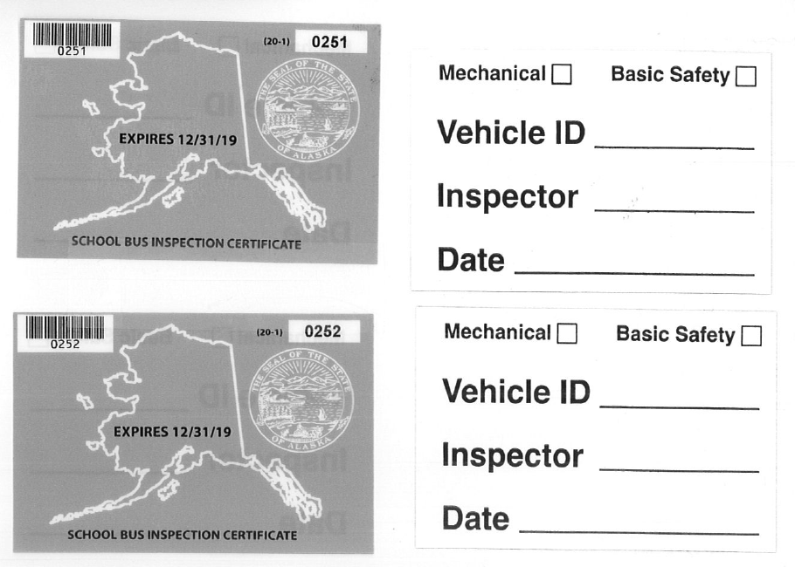
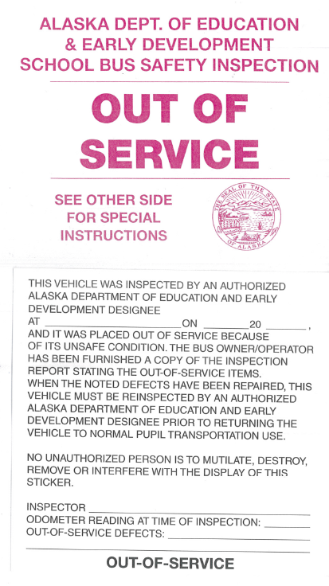

BUS PASSES BASIC SAFETY INSPECTION.
Following is an example of a properly completed inspection form. The school bus in this example successfully passed the Basic Safety inspection.
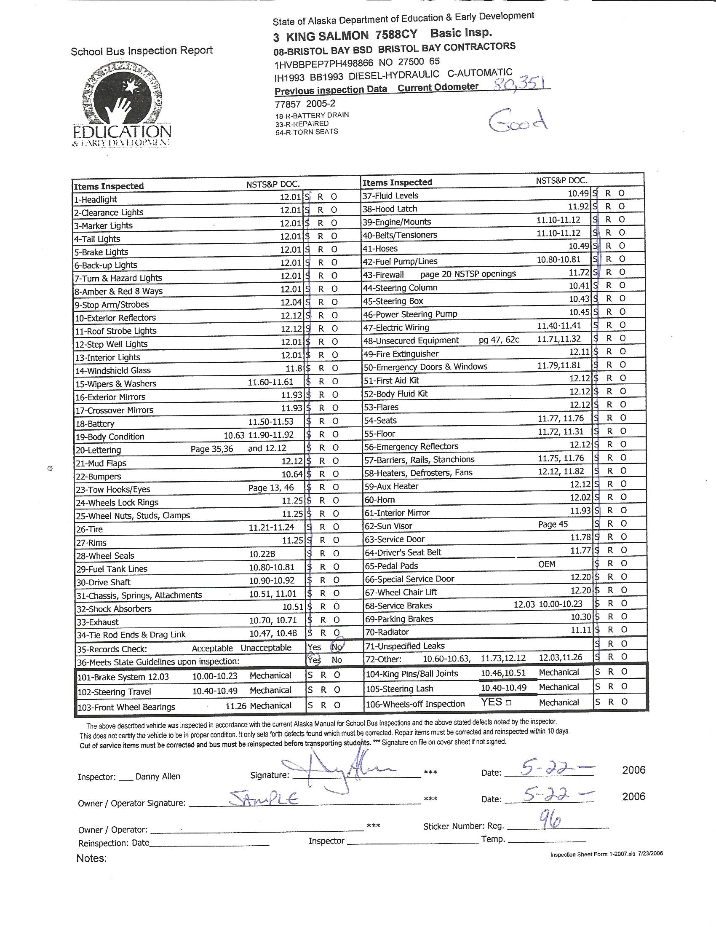

BUS FAILS INSPECTION WITH REPAIR ITEMS.
Following is an example of a properly completed inspection form for a bus with repair items. The school bus in this example failed the initial inspection.
Note: 1. A Comment Sheet was completed stating the defects found (next page).
2. Items repaired immediately and inspection sticker issued.

BUS FAILS INSPECTION WITH OUT-OF-SERVICE ITEMS.
Following is an example of a properly completed inspection form for a bus with out-of-service items. The school bus in this example failed the initial inspection.
Note: 1. A Comment Sheet was completed stating the defects found (previous page).
2. Items repaired immediately and inspection sticker issued.

BUS PASSES BASIC SAFETY/ MECHANICAL INSPECTION.
Following is an example of a properly completed inspection form. The school bus in this example successfully passed the combined Basic Safety/ Mechanical inspection.

ON-LINE INSPECTION FORM
Following is an example of an on-line form. The fields are pre-set with dropdown menus. Data can then be down-loaded directly to districts/ contractors or to the Department of Education &
Early Development. 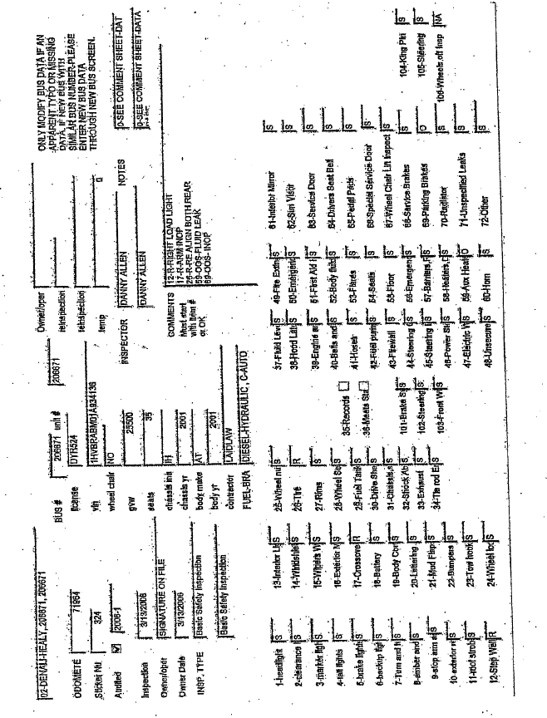

MAINTENANCE RECORDS CHECKLIST.
Following are the forms for preventive maintenance records inspections.

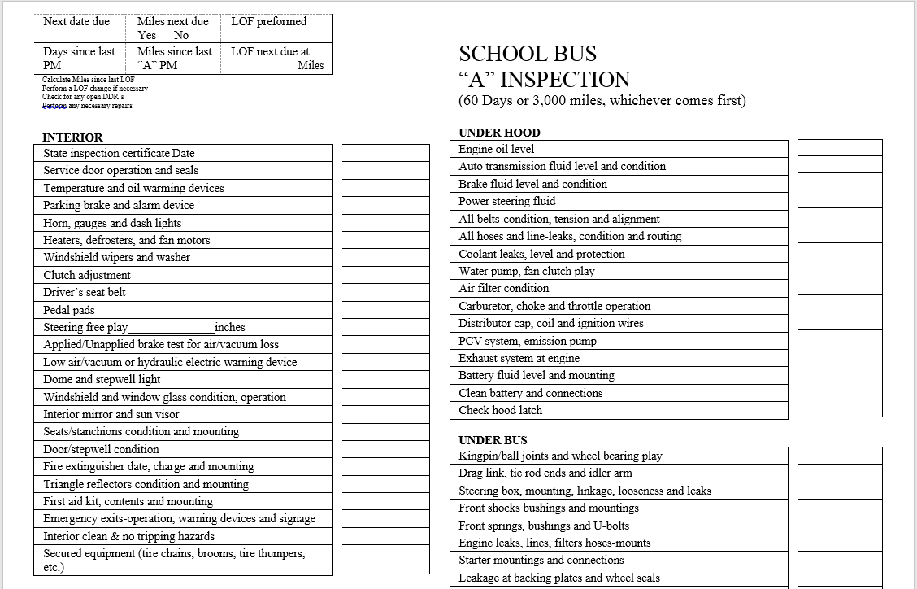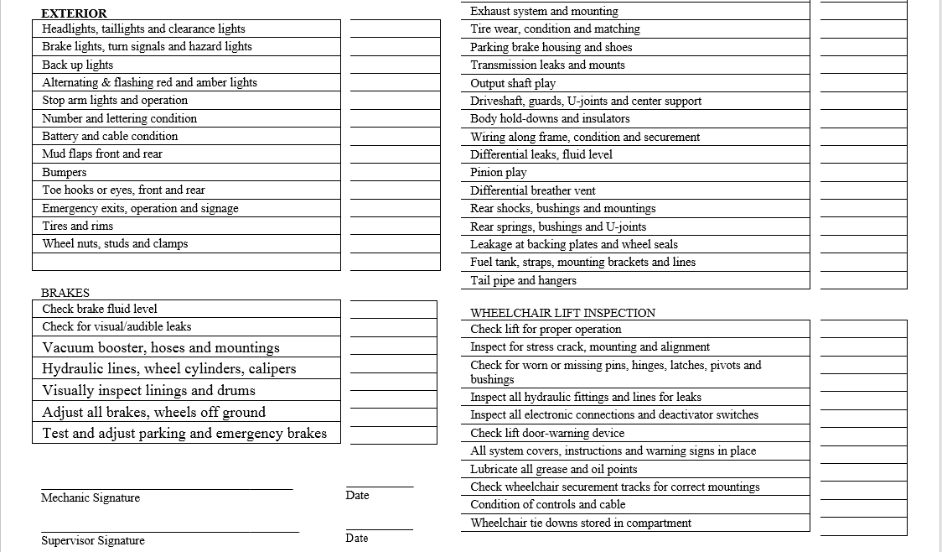

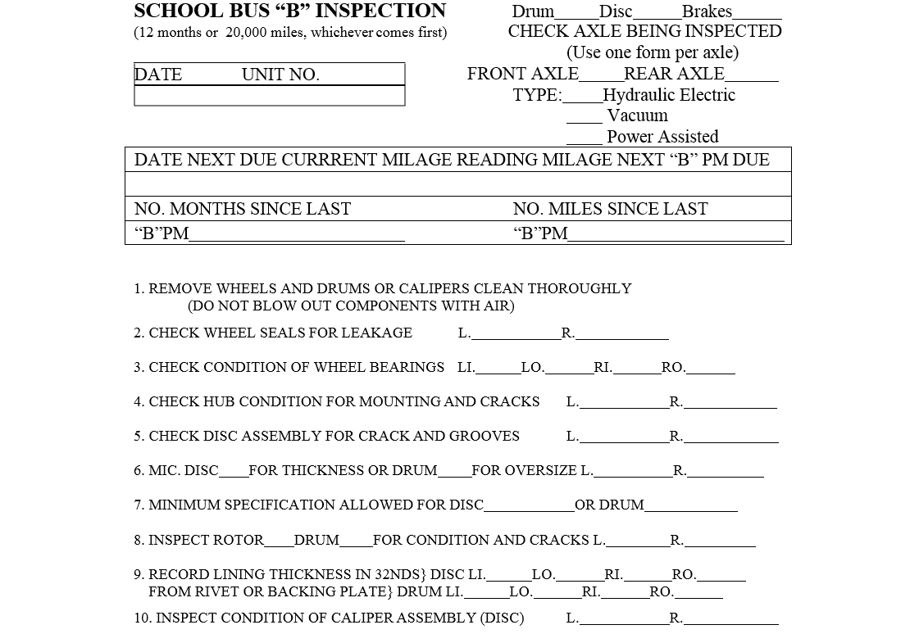 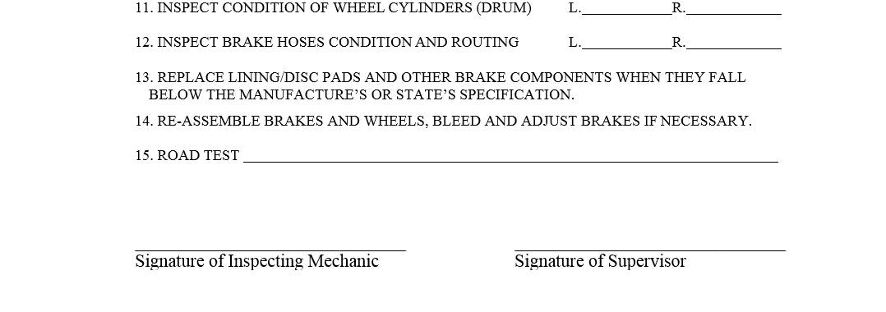
CRITERIA.
This section has been removed.
Please refer to the 2015 National School Transportation Specification & Procedures Manual, pages 79 – 115 for criteria to be used during inspections.

INTRODUCTION

The purpose of this document is to specify school bus minimum standards which modify or supplement the National School Transportation Specifications & Procedures, May 2015 Revised Edition. When using this document, you must have in hand the national specifications referred to above.

The Minimum Standards for Alaska School Buses, 2017 Revised Edition, contains the production and equipment standards required for school buses that transport students to and from school. In addition to national specifications, the Minimum Standards for Alaska School Buses must comply with applicable Federal Motor Vehicle Safety Standards (FMVSS) and other state and federal standards applicable to school buses on the date of manufacture.

The Minimum Standards for Alaska School Buses, 2017 Revised Edition, is applicable to school buses manufactured on or after October 1, 2017. Within one year after date of publication of each revised edition of the National School Transportation Specifications for School Buses, it is the intent of the Department of Education & Early Development to review the Alaska Standards and revise as appropriate to conform to public input, national standards, and statutory/regulatory requirements of Alaska.

The Minimum Standards for Alaska School Buses, 2017 Revised Edition, is organized into three distinct sections. The definitions of types of school buses are found on pages 342-343 of the National School Transportation Specifications & Procedures, May 2015 Revised Edition.

The Bus Body and Chassis Specifications section sets the standards applicable to school bus bodies and chassis manufactured for, or used in, Alaska.

The Specially Equipped School Bus Specifications section establishes standards for buses used for transporting students with special needs.

The Alaska Bus Equipment Specifications section establishes auxiliary equipment requirements for buses transporting students in Alaska.

Copies of the National School Transportation Specifications & Procedures, May 2015 Revised Edition, are available from:

NASDPTS
5307 Indigo Way
Middleton, WI 53562
Fax: (608) 827-6355
Or download from internet site:
17th National Congress on School Transportation (NCST)

BUS BODY AND CHASSIS SPECIFICATIONS

The following Alaska Standards modify or supplement the Bus Body and Chassis Specifications, found on pages 29 through 70 of the National School Transportation Specifications & Procedures, May 2015 Revised Edition.

Certification

Replace Certification, page 34 of the National Specifications, with the following:

The supplying vendor or dealer shall supply original to the District and copy to the Alaska Department of Education & Early Development, Pupil Transportation, certification in writing that its product meets Alaska Minimum Standards on items not covered by the FMVSS certification requirements of CFR 49 Part 567.

A. A permanent label or metal plate shall be secured and readily visible in the driver's compartment upon which states the bus meets minimum standards for Alaska, un-laden weight, GVWR, and the manufacturer's maximum possible rated seating capacity of the bus.

Emergency Exits

Add Emergency Exits C.5., page 43 of the National Specifications, to read as follows:

C.5. Each bus shall have a red or black arrow in the inside and a black arrow on the outside of the emergency door showing direction of throw of handle.

Exhaust

Add Exhaust C.1., page 44 of the National Specifications, to read as follows:

C.1. The exhaust tail pipe may be extended beyond the rear bumper and vertically, to exhaust above the roof line of the bus, and must be shielded or insulated.

Floors

Add to Floors D., page 46 of the National Specifications, the following:

D. The fuel tank access plate shall be insulated.

Add Floors E., page 46 of the National Specifications, to read as follows:

E. The floor shall have an overlay of 5-ply plywood 5/8 inch minimum (1/2” minimum in Type A buses,) marine-grade, or pressure-treated plywood. Edges of wood shall be located no less than ¼” from sides of bus to allow for expansion and contraction. The wood and the steel shall be bonded to prevent accumulation of moisture on the top surface of the steel floor and under the surface of the wood floor.

Fuel System

Add to Fuel System A., page 46 of the National Specifications, with the following:

A. Fuel tank(s). Each tank shall be filled from and vented to the outside of the passenger compartment. A fuel filler “bucket” shall be present on all types of buses. The filler bucket shall be designed similarly to the illustrations in Appendix A of the Minimum Standards for Alaska School Buses 2017 Revised Edition.

Heating and Air Conditioning Systems

Replace Heating System A.4, page 47 of the National Specifications, with the following:

A.4. The heating system shall be capable of maintaining the ambient temperature throughout the bus of not less than 45 degrees Fahrenheit during average minimum January temperature as established by the U.S. Department of Commerce, National Weather Service (NOAA), for the area in which the vehicle is to be operated. The inside temperature is to be measured midway back in the bus at shoulder height of seated school children.

A.A.4.A. It is the sole responsibility of the vendor to meet all requirements in line item 4 under Heating and Air Conditioning Systems of this document.

A.4.B. It is the sole responsibility of the contractor/district to supply the vendor with all pertinent information pertaining to the average weather conditions in the service areas in which the bus will be operated.

A.4.C. New heating technology must be approved in advance by the department.

Identification

Replace Identification B.1, page 52 of the National Specifications, with the following:

B.1. Ownership identification with minimum five inch high lettering on the beltline or directly below the windows on each side of the bus.

Replace Identification C.6, page 52 of the National Specifications, to read as follows:

C.6. There shall be a sign located below the rear window of the bus in area(s) visible to the approaching motorist, which reads STOP ON FLASHING RED. "STOP" shall be printed on the rear of the bus in letters at least 8 inches high. "ON FLASHING RED" shall be printed below "STOP," in letters at least 4 inches high. The sign shall be red letters on white reflective background.

Insulation

Replace Insulation (Optional), page 54 of the National Specifications, with the following:

A. All space between the inner and outer panels in the roof, sidewalls, body posts and roof channel cavities, including front and rear body cavities, shall be filled with fiberglass or other insulating material which will meet Federal Motor Vehicle Safety Standard No. 302 where applicable. The insulation shall be firmly installed so it will retain its original position.

Lamps and Signals

Add to Lamps and Signals A.1, page 55 of the National Specifications, the following:

A.1. A loading light shall be installed, outside and to the rear, or above the service door to illuminate the area in front of the door. The step-well light and loading light shall be illuminated by a service door-operated switch, to illuminate only when the service door is open.

Replace Lamps and Signals F., page 57 of the National Specifications, with the following:

F. Roof Mounted Strobe Light

1. A strobe light shall be mounted on the roof of the school bus, and meet all NSTS&P standards J845, with a 4 inch minimum height. The light shall be located on the center line of the roof no less than four (4) feet from the rear of the bus and not to exceed one third (1/3) the body length forward from the rear of the roof edge. The light must be in operation when students are on the bus.

Stirrup Steps

Replace Stirrup Steps, page 65 of the National Specifications, with the following:

If the windshield and lamps are not easily accessible from the ground, there shall be at least one folding stirrup step or recessed foothold and suitably located handles on each side of the front of the body for easy accessibility for cleaning. Steps are permitted in or on the front bumper in lieu of the stirrup steps, if the windshield and lamps are easily accessible for cleaning from that position.

Stop Signal Arm

Add to Stop Signal Arm, page 65 of the National Specifications, the following:

Stop Signal Arm shall be required.

Storage Compartment

Replace Storage Compartment (Optional), page 65 of the National Specifications, with the following:

A storage container for tools, tire chains, and/or tow chains shall be located on the right side of the bus outside the passenger compartment, whenever possible. If inside, it shall be fastened to the floor at rear of bus and have a cover with a positive fastening device.

Ventilation

Add Ventilation B.3, page 68 of the National Specifications, to read as follows:

B.3. Auxiliary window fans. Bus Types B, C, and D shall have two fans, each fan shall be operated by its own switch and not to be placed so as to interfere with vision. Bus Type A will only require one fan.

Windows

Add Windows D., page 69 of the National Specifications, to read as follows:

D. The following windows shall be thermo pane:
1. Window to left of driver. OEM factory standard is acceptable for Type A, Type B and Type C cutaway buses.

2. All windows in service door.

SPECIALLY EQUIPPED SCHOOL BUS SPECIFICATIONS

The following Alaska Standards modify or supplement the Specifications for Specially Equipped School Buses found on pages 71 through 81 of the National School Transportation Specifications & Procedures, May 2015 Revised Edition.

Communications

See Alaska Bus Equipment Specifications.

Special Light

Add Special Light A., page 78 of the National Specifications, to read as follows:

A. An exterior light shall be installed on exterior of bus, within 12 inches of the wheelchair lift door opening for the illumination of outside the bus.

ALASKA BUS EQUIPMENT SPECIFICATIONS

The following Alaska Standards supplement the Specifications for Bus Chassis, Bus Body and Specially Equipped School Buses found on pages 29 through 81 of the National School Transportation Specifications & Procedures, May 2015 Revised Edition, and in the preceding sections of this Alaska Minimum Standards document.

General

Equipment listed in this section is required to be on each bus used for transporting school children before the bus is placed into service. However, the nature of this equipment is such that it can be easily moved from a retired bus to a new one, and may not need to be purchased for each replacement bus. School bus manufacturers are not required to provide this equipment unless the items are specified in the purchase order.

Communications

All school buses shall be equipped with a two-way electronic voice communication system before the bus is placed into service. Systems may be provided by end-user.

Emergency Equipment

Add Emergency Equipment A.3. page 41 of the National Specifications, to read as follows:

A.3. Fire extinguishers shall be ABC 5 (five) pound and affixed with a current certification tag unless within first year of manufacture date code of fire extinguisher.

Add Emergency Equipment B.3., page 42 of the National Specifications, to read as follows:

B.3. First Aid Kit shall meet the national standard suggested contents.

Add Emergency Equipment C.1-3., page 42 of the National Specifications, to read as follows:

C. Body Fluid Clean-up Kit

1. Each bus shall have a removable moisture proof and dust proof body fluid clean-up kit mounted in an accessible place within the driver's compartment. This place shall be marked to identify its location.

2. Minimum contents shall include:
1-cardboard scraper and scoop
1-pair latex disposable gloves
2-packages germicidal hand wipes
1-disposable face mask
2-plastic bags
2-twist ties
3-disposable paper towels
1-4 oz. package stabilized chlorine absorbent deodorant or equivalent.

- Detailed instructions on use of contents shall accompany each kit.

Add to Emergency Equipment D., page 42 of the National Specifications, the following:

D. Warning Devices

When flares are utilized, they must be stored in an exterior compartment and labeled accordingly.

Tire Chains and Tire Chocks

Tire chains and tire chocks are required and must be stored in a Optional items: Dependent on climate, demographic, and District areas. (Including, but not limited
to.)

Auxiliary driving lights (moose lights), auxiliary heaters, thermo pane windows in passenger area, crossing gates, drop chains, heated step treads, rear air foils, rear stop arms, and heated wiper blades.

storage compartment. Ref. Storage Compartment/Bus Body Specifications for storage

Appendix A

Fuel “Bucket” Illustrations

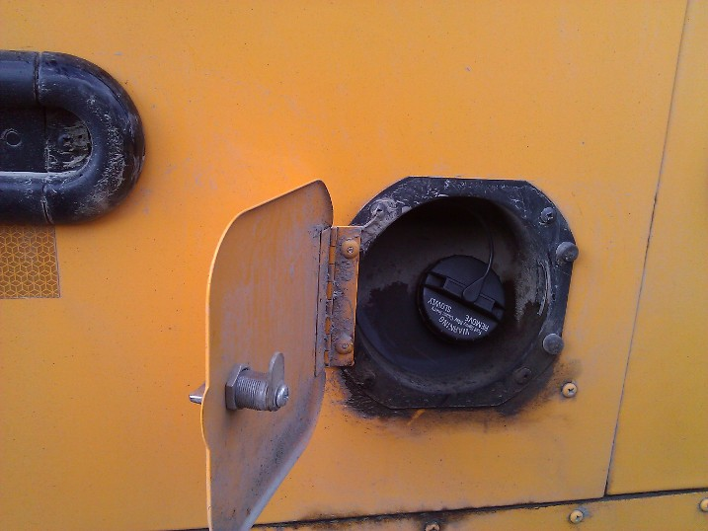

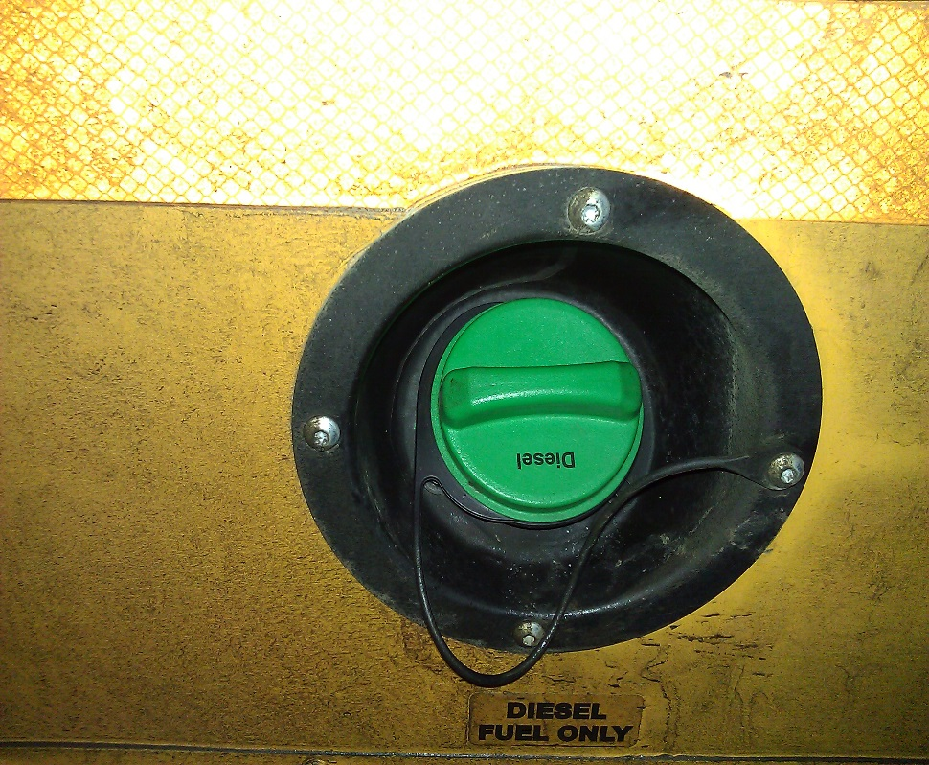

INTRODUCTION

The purpose of this document is to specify school bus minimum standards which modify or supplement the National School Transportation Specifications & Procedures, May 2010 Revised Edition. When using this document, you must have in hand the national specifications referred to above.

The Minimum Standards for Alaska School Buses, 2011 Revised Edition, contains the production and equipment standards required for school buses that transport students to and from school. In addition to national specifications, the Minimum Standards for Alaska School Buses must comply with applicable Federal Motor Vehicle Safety Standards (FMVSS) and other state and federal standards applicable to school buses on the date of manufacture.

The Minimum Standards for Alaska School Buses, 2011 Revised Edition, is applicable to school buses manufactured on or after January 1, 2012. Within one year after date of publication of each revised edition of the National School Transportation Specifications for School Buses, it is the intent of the Department of Education & Early Development to review the Alaska Standards and revise as appropriate to conform to public input, national standards, and statutory/regulatory requirements of Alaska.

The Minimum Standards for Alaska School Buses, 2011 Revised Edition, is organized into three distinct sections. The definitions of types of school buses are found on page 15 of the National School Transportation Specifications & Procedures, May 2010 Revised Edition.

The Bus Body and Chassis Specifications section sets the standards applicable to school bus bodies and chassis manufactured for, or used in, Alaska.

The Specially Equipped School Bus Specifications section establishes standards for buses used for transporting students with special needs.

The Alaska Bus Equipment Specifications section establishes auxiliary equipment requirements for buses transporting students in Alaska.

Copies of the National School Transportation Specifications & Procedures, May 2010 Revised Edition, are available from:

Missouri Safety Center
Central Missouri State University
Humphreys Suite 200
Warrensburg, MO 64093
Phone: (660) 543-4832
Or download from internet site: National Congress on School Transportation (NCST) website

BUS BODY AND CHASSIS SPECIFICATIONS

The following Alaska Standards modify or supplement the Bus Body and Chassis Specifications, found on pages 19 through 57 of the National School Transportation Specifications & Procedures, May 2010 Revised Edition.

Certification

Replace Certification, page 22 of the National Specifications, with the following:

The supplying vendor or dealer shall supply original to the District and copy to the Alaska Department of Education & Early Development, Pupil Transportation, certification in writing that its product meets Alaska Minimum Standards on items not covered by the FMVSS certification requirements of CFR 49 Part 567.

A. Body and Chassis. The manufacturer, supplying vendor or dealer will provide with each bus a written certification stating that the bus meets Minimum Standards for Alaska School Buses in effect on date of manufacture of bus.

B. A permanent label or metal plate shall be secured and readily visible above window level in the driver's compartment upon which is stated the bus meets minimum standards for Alaska, un-laden weight, GVWR, and the manufacturer's maximum possible rated seating capacity of the bus.

Color

Replace Color C., page 22 of the National Specifications, with the following:

The roof color shall be school bus yellow consistent with the side and rear body color.

Emergency Exits

Add Emergency Exits C., page 30 of the National Specifications, to read as follows:

5. Each bus shall have a red or black arrow in the inside and a black arrow on the outside of the emergency door showing direction of throw of handle.

Floors

Add to Floors D., page 33 of the National Specifications, the following:

D. The fuel tank access plate shall be insulated.

Add Floors E., page 33 of the National Specifications, to read as follows:

E. The floor shall have an overlay of 5-ply 5/8 inch minimum (1/2” minimum in Type A buses,) marine-grade, or pressure-treated plywood. Edges of wood shall be located no less than ¼” from sides of bus to allow for expansion and contraction. The wood and the steel shall be bonded to prevent accumulation of moisture on the top surface of the steel floor and under the surface of the wood floor.

Fuel Tank

Add to Fuel System A., page 34 of the National Specifications, with the following:

1. Fuel tank(s). Each tank shall be filled from and vented to the outside of the passenger compartment, and each fuel filler should be placed in a location where accidental fuel spillage will not drip or drain on any part of the exhaust system, flooring or insulation material.

Heating Systems

Replace Heating System A. 1 -4, page 35 of the National Specifications, with the following:

1. The heating system shall be capable of maintaining the ambient temperature throughout the bus of not less than 45 degrees Fahrenheit during average minimum January temperature as established by the U.S. Department of Commerce, National Weather Service (NOAA), for the area in which the vehicle is to be operated. The inside temperature is to be measured midway back in the bus at shoulder height of seated school children.

2. In addition to a front heater/defroster system, Type A and Type B buses shall have a rear heater with a minimum rated heating capacity of 40,000 BTU.

All other buses shall have a heating system with a minimum rated heating capacity of 200,000 BTU, (rated according to SBMI Standards No. 001) distributed as follows:

A. Front heaters (including front heater, defrosters, step-well and driver heater) shall be provided.

B. Mid heaters shall be provided.

C. Rear heaters shall be provided.

3. New heating technology must be approved in advance by the department.

Hinges

Replace Hinges, page 39 of the National Specifications, with the following:

All exterior doors and hatch hinge pins shall be constructed from stainless steel, brass or non-metallic materials to prevent corrosion and shall be designed to allow lubrication to be channeled to the center 75% of each hinge loop without disassembly.

Identification

Replace Identification B., pages 39-40 of the National Specifications, with the following:

1. Ownership identification with minimum five inch high lettering on the beltline or directly below the windows on each side of the bus.

Add Identification D., to page 40 of the National Specifications, to read as follows:

D. There shall be a sign located below the rear window of the bus in area(s) visible to the approaching motorist, which reads STOP ON FLASHING RED. "STOP" shall be printed on the rear of the bus in letters at least 8 inches high. "ON FLASHING RED" shall be printed below "STOP," in letters at least 4 ¾ inches high. The sign shall be red letters on white reflective background.

Insulation

Replace Insulation (Optional), page 42 of the National Specifications, with the following:

A. All space between the inner and outer panels in the roof, sidewalls, body posts and roof channel cavities, including front and rear body cavities, shall be filled with fiberglass or other insulating material which will meet Federal Motor Vehicle Safety Standard No. 302 where applicable. The insulation shall be firmly installed so it will retain its original position.

Lamps and Signals

Add to Lamps and Signals A, page 43 of the National Specifications, the following:

A.1. A loading light shall be installed, outside and to the rear, or above the service door to illuminate the area in front of the door. The step-well light and loading light shall be illuminated by a service door-operated switch, to illuminate only when the service door is open.

Replace Lamps and Signals F., page 45 of the National Specifications, with the following:

F. Roof Mounted Strobe Light

1. A strobe light shall be mounted on the roof of the school bus, and meet all NSTS&P standards J845, with a 4 inch minimum height. The light shall be located on the center line of the roof no less than four (4) feet from the rear of the bus and not to exceed one third (1/3) the body length forward from the rear of the roof edge.

Stirrup Steps

Replace Stirrup Steps, page 52 of the National Specifications, with the following:

If the windshield and lamps are not easily accessible from the ground, there shall be at least one folding stirrup step or recessed foothold and suitably located handles on each side of the front of the body for easy accessibility for cleaning. Steps are permitted in or on the front bumper in lieu of the stirrup steps, if the windshield and lamps are easily accessible for cleaning from that position.

Storage Compartment

Replace Storage Compartment (Optional), page 53 of the National Specifications, with the following:

A. Storage container for tools, tire chains, and/or tow chains shall be located on the right side of the bus outside the passenger compartment, whenever possible. If inside, it shall be fastened to the floor at rear of bus and have a cover with a positive fastening device.

Exhaust

Add Exhaust C., page 32 of the National Specifications, to read as follows:

C. The exhaust tail pipe may be extended beyond the rear bumper and vertically, to exhaust above the roof line of the bus, and must be shielded or insulated.

Windows

Add Windows D., page 57 of the National Specifications, to read as follows:

D. The following windows shall be thermo pane:

1. Window to left of driver. OEM factory standard is acceptable for Type A, Type B and Type C cutaway buses.

2. All windows in service door.

SPECIALLY EQUIPPED SCHOOL BUS SPECIFICATIONS

The following Alaska Standards modify or supplement the Specifications for Specially Equipped School Buses found on pages 61 through 70 of the National School Transportation Specifications & Procedures, May 2010 Revised Edition.

Communications

See Alaska Bus Equipment Specifications.

Special Light

Add Special Light B., page 67 of the National Specifications, to read as follows:

A. An exterior light shall be installed within 12 inches of the wheelchair lift door opening.

ALASKA BUS EQUIPMENT SPECIFICATIONS

The following Alaska Standards supplement the Specifications for Bus Chassis, Bus Body and Specially Equipped School Buses found on pages 19 through 70 of the National School Transportation Specifications & Procedures, May 2010 Revised Edition, and in the preceding sections of this Alaska Minimum Standards document.

General

Equipment listed in this section is required to be on each bus used for transporting school children before the bus is placed into service. However, the nature of this equipment is such that it can be easily moved from a retired bus to a new one, and may not need to be purchased for each replacement bus. School bus manufacturers are not required to provide this equipment unless the items are specified in the purchase order.

Communications

All school buses shall be equipped with a two-way electronic voice communication system before the bus is placed into service. Systems may be provided by end-user.

Emergency Equipment

Add Emergency Equipment A. 3. page 29 of the National Specifications, to read as follows:

A. Fire extinguishers shall be ABC 5 (five) pound and affixed with a current certification tag unless within first year of manufacture date code of fire extinguisher.

B. Body Fluid Clean-up Kit

1. Each bus shall have a removable moisture proof and dust proof body fluid clean-up kit mounted in an accessible place within the driver's compartment. This place shall be marked to identify its location.

2. Minimum contents shall include:
1-cardboard scraper and scoop
1-pair latex disposable gloves
2-packages germicidal hand wipes
1-disposable face mask
2-plastic bags
2-twist ties
3-disposable paper towels
1-4 oz. package stabilized chlorine absorbent deodorant or equivalent.

- Detailed instructions on use of contents shall accompany each kit.

4. A State certification seal will be placed over the clasp of the first aid and body fluid kit to insure the kit is complete. A broken seal indicates it is a repair item.

Add to D., page 30 of the National Specifications, the following:

D. Warning Devices

When flares are utilized, they must be stored in an exterior compartment and labeled accordingly. The flares must be in a waterproof container and expiration dates must be legible.
If expired it will be a repair item.

Mud Flaps

Each bus shall be equipped with
rear mud flaps.

Tire Chains and Tire Chocks

Tire chains and tire chocks are required and must be stored in a storage compartment. Ref. Storage Compartment/Bus Body Specifications for storage

Optional items: Dependent on climate, demographic, and District areas.
(Including, but not limited to.)

Auxiliary driving lights (moose lights), window fans, auxiliary heaters, thermo pane windows in passenger area, crossing gates, drop chains, heated step treads, rear air foils, rear stop arms, and heated wiper blades.

INTRODUCTION

The purpose of this document is to specify school bus minimum standards which modify or supplement the National School Transportation Specifications & Procedures, May 2005 Revised Edition. When using this document, you must have in hand the national specifications referred to above.

The Minimum Standards for Alaska School Buses, 2006 Revised Edition, contains the production and equipment standards required for school buses that transport students to and from school. In addition to national specifications and Alaska minimum standards, school buses must comply with applicable Federal Motor Vehicle Safety Standards, and other state and federal standards applicable to school buses on the date of manufacture.

The Minimum Standards for Alaska School Buses, 2006 Revised Edition, is applicable to school buses manufactured on or after January 1, 2007. Within one year after date of publication of each revised edition of the National School Transportation Specifications for School Buses, it is the intent of the Department of Education & Early Development to review the Alaska Standards and revise as appropriate to conform to public input, national standards, and statutory/regulatory requirements of Alaska.

The Minimum Standards for Alaska School Buses, 2006 Revised Edition, is organized into four distinct sections. The definitions of types of school bus are found on page 6 of the National School Transportation Specifications & Procedures, May 2005 Revised Edition. The Bus Chassis Specifications section sets the standards applicable to school bus chassis manufactured for, or used in, Alaska. The Bus Body Specifications section sets the standards applicable to school bus bodies manufactured for, or used in, Alaska. The section entitled Specially Equipped School Bus Specifications establishes standards for buses used for transporting students with special needs. The last section, Alaska Bus Equipment Specifications, establishes auxiliary equipment requirements for buses transporting students in Alaska.

Copies of the National School Transportation Specifications & Procedures, May 2005 Revised Edition, are available from:

Missouri Safety Center
Central Missouri State University Humphreys Suite 201
Warrensburg MO 64093
Phone: (660) 543-4830
Or download from internet site National Congress on School Transportation (NCST) website

BUS CHASSIS SPECIFICATIONS

The following Alaska Standards modify or supplement the Bus Chassis Specifications found on pages 11 through 22 of the National School Transportation Specifications & Procedures, May 2005 Revised Edition.

Certification
Replace Certification, page 13 of National Specifications, with the following:

The supplying vendor or dealer shall supply to the Alaska Department of Education & Early Development, Pupil Transportation, certification in writing that its product meets Alaska Minimum Standards on items not covered by the FMVSS certification requirements of 49 CFR, Part 567.

Fuel Tank
Add to Fuel System, page 17. A. of National Specifications the following:

Fuel tank(s) having a minimum 30-gallon capacity shall be provided by the chassis Manufacturer. Each tank shall
be filled from and vented to the outside of the passenger compartment, and each fuel filler should be placed in a location where accidental fuel spillage will not drip or drain on any part of the exhaust system or insulation material.

Passenger Load
Replace Passenger Load C., page 20 of National Specifications, with the following:

C. Manufacturer's GVWR for a particular school bus shall be furnished by manufacturers in duplicate to the Alaska Department of Education & Early Development, Pupil Transportation Services.

BUS BODY SPECIFICATIONS

The following Alaska Standards modify or supplement the Bus Body Specifications, found on pages 25 through 50 of the National School Transportation Specifications & Procedures, May 2005 Revised Edition.

Certification
Replace Certification, page 26 of National Specifications, with the following:

- Body manufacturer will provide with each bus a written certification stating that the bus meets Minimum Standards for Alaska School Buses in effect on date of manufacture of bus.

- A metal plate shall be secured and readily visible in the driver's compartment upon which is stated the unladen weight, GVWR, and the manufacturer's rated seating capacity of the bus.

- The manufacturer shall supply certification label stating the vehicle meets requirements of 49cfr 396

Chains (tire)
Replace Chains (Tire), page 26 of National Specifications, with the following:

See Alaska Bus Equipment Specifications

Color
Replace Color C., page 26 of National Specifications, with the following:

C. Reflective material shall be installed on the bus; placement
shall meet criteria appendix B, page 251-252 of National Specifications.

Add Colors E., page 26 of National Specifications, to read as follows:

E. Reflectors are required: two red on rear and amber on sides

Communications Systems

Replace Communications Systems, page 26 of National Specifications, with the following:

See Alaska Bus Equipment Specifications

Emergency Exits
Add Emergency Exits C. 5.., page
29 of National Specifications, to read as follows:

5. Each bus shall have a red or black arrow in the inside and a black arrow on the outside of the emergency door showing direction of throw of handle.

Floors
Add to Floors D., page 32 of National Specifications, the following:

- The fuel tank access plate shall be insulated.

Add Floors E., page 32 of National Specifications, to read as follows:

- The floor shall have an overlay of 5-ply 5/8 inch minimum (1/2” minimum in Type A buses,) marine-grade, or pressure-treated plywood. Edges of wood shall be located no less than ¼” from sides of bus to allow for expansion and contraction. The wood and the steel shall be bonded to prevent accumulation of moisture on the top surface of the steel floor and under the surface of the wood floor.

Heating and Air Conditioning Systems
Replace Heating System A., 1. - 4., page 32 of National Specifications, with the following:

  - In addition to a front heater/defroster system, Type A and Type B buses shall have a rear heater with a minimum rated heating capacity of 40,000 BTU.

All other buses shall have a heating system with a minimum rated heating capacity of 210,000 BTU, (rated according to SBMI Standards No. 001) distributed as follows:

    - Front heaters capacity (including front heater, defrosters, stepwell and driver heater) shall have a combined
capacity of no less than 100,000 BTU;

    - Mid heaters capacity shall have a combined capacity of no less than 40,000 BTU; and

    - Rear heaters capacity shall have a combined capacity of no less than 70,000 BTU.

  - Measurement standards other than BTU must be approved in advance by the department.

  - The heating system shall be capable of maintaining the ambient temperature throughout the bus of not less than 45 degrees Fahrenheit during average minimum January temperature as established by the U.S. Department of Commerce, Weather Bureau, for the area in which the vehicle is to be operated. The inside temperature is to be measured midway back in the bus at shoulder height of seated school children.

  - Intentionally left blank.

Hinges
Replace Hinges, page 35 of National Specifications, with the following:

All exterior doors and hatch hinge pins shall be constructed from stainless steel, brass or non-metallic materials to prevent corrosion and shall be designed

to allow lubrication to be channeled to the center 75% of each hinge loop without disassembly.

Identification
Replace Identification B. 1., page 35-36 of National Specifications, with the following:

1. Ownership identification with minimum five inch high lettering on the beltline or directly below the windows on each side of the bus.

Add Identification D to page 36 of National Specifications, to read as follows:

D. There shall be a sign located below the rear window of the bus in area(s) visible to the approaching motorist, which reads STOP ON FLASHING RED. "STOP" shall be printed on the rear of the bus in letters at least 8 inches high. "ON FLASHING RED" shall be printed below "STOP," in letters at least 5 inches high. The sign shall be red letters on white reflective background.

Insulation
Replace Insulation (Optional), page 36 of National Specifications, with the following:

- Ceiling and walls shall be insulated with proper material to
deaden sound and to reduce vibration to a minimum.

- All space between the inner and outer panels in the roof, sidewalls, body posts and roof channel cavities, including front and rear body cavities, must be filled with fiberglass or other insulating material which will meet Federal Motor Vehicle Safety Standard No. 302 where applicable. The insulation must be firmly installed so it will retain its original position.

Lamps and Signals
Add to Lamps and Signals A., 2. page 37 of National Specifications, the following:

A.2. A loading light shall be installed, outside and to the rear, or above the service door to illuminate the area in front of the door. The stepwell light and loading light shall be illuminated by a service door-operated switch, to illuminate only when the service door is open.

Replace Lamps and Signals F., page 39 of National Specifications, with the following:

- Roof Mounted Strobe Light

  - A strobe light shall be mounted on the roof of the school bus. The light shall be located on the center line of the roof no less than four (4) feet

from the rear of the bus and not to exceed one third (1/3) the body length forward from the rear of the roof edge. Light shall be of sufficient height to be visible at a distance of 100 feet from the rear of the bus measured at four feet above ground level. The strobe light shall:

    - Meet Class 1 requirements of SAE Standard J1318.

    - Either, have a minimum of 60 double flashes per minute and a minimum of 10 joules and maximum of 16 joules;

OR:

incorporate four high energy pulses per light burst with a flash rate minimum of 80 light bursts per minute.

Stirrup Steps
Replace Stirrup Steps, page 45 of National Specifications, with the following:

If the windshield and lamps are not easily accessible from the ground, there shall be at least one folding stirrup step or recessed foothold and suitably located handles on each side of the front of the body for easy accessibility for cleaning. Steps are permitted in or on the front bumper in lieu of the stirrup steps, if the windshield and
lamps are easily accessible for cleaning from that position.

Stop Signal Arm
Add to Stop Signal Arm, page 45 of National Specifications, the following:

A. Arm shall have two (double flash) alternately flashing strobe lights of a minimum of 10 joules with red lenses.

OR:

Arm shall be equipped with the word “STOP” illuminated by light-emitting diodes (LED) with minimum luminosity specifications in accordance with FMVSS 131.

In either system, the lights shall be connected to the alternately red flashing signal lamp circuits.

Storage Compartment
Replace Storage Compartment (Optional), page 45 of National Specifications, with the following:

A storage container for tools, tire chains, and/or tow chains shall be located on the right side of the bus outside the passenger compartment, when possible. If inside, it shall be fastened to the floor at rear of bus and have a cover with a positive fastening device.

Tailpipe
Add Tailpipe C., page 45 of National Specifications, to read as follows:

- The exhaust tail pipe may be extended beyond the rear bumper and vertically, to exhaust above the roof line of the bus and must be shielded or insulated.

Windows
Add Windows D., page 48 of National Specifications, to read as follows:

- The following windows shall be thermo pane or an equivalent approved by the department:

  - Window to left of driver. OEM factory standard is acceptable for Type A, Type B and Type C cutaway buses.

  - All windows in service door.

SPECIALLY EQUIPPED SCHOOL BUS SPECIFICATIONS

The following Alaska Standards modify or supplement the
Specifications for Specially Equipped School Buses found on pages 53 through 63 of the National School Transportation Specifications & Procedures, May 2005 Revised Edition.

Communications

See Alaska Bus Equipment Specifications

Special Light
Add Special Light B., page 60 of National Specifications, to read as follows:

B. An exterior light shall be installed above or immediately to the rear (within 12 inches) of the wheelchair lift.

ALASKA BUS EQUIPMENT SPECIFICATIONS

The following Alaska Standards supplement the Specifications for Bus Chassis, Bus Body and Specially Equipped School Buses found on pages 11 through
63 of the National School Transportation Specifications & Procedures, May 2005 Revised Edition, and in the preceding

sections of this Alaska Minimum Standards document.

General
Equipment listed in this section is required to be on each bus used for transporting school children. However, the nature of this equipment is such that it can be easily moved from a retired bus to a new one, and may not need to be purchased for each replacement bus. School bus manufacturers are not required to provide this equipment unless the items are specified in the purchase order.

Communications

All school buses shall be equipped with a two-way electronic voice communication system. Systems may be provided by end-user.

Emergency Equipment

Add Emergency Equipment A. 3., page 30-31 of National Specifications, to read as follows:

A. 3. Fire extinguishers shall be affixed with a current certification tag unless within first year of manufacture date code of fire extinguisher.

Replace C., page 48 of National Specifications, with the following:

- Body Fluid Clean-up Kit
  - Each bus shall have a removable moisture proof and dust proof body fluid clean-up kit mounted in an accessible place within the driver's compartment. This place shall be marked to identify its location.

  - Minimum contents shall include:
1-cardboard scraper and scoop 1-pair latex disposable gloves 2-packages germicidal hand
wipe
- disposable face mask 2-plastic bags
- twist ties
- disposable paper towels 1-4 oz. package stabilized
chlorine absorbent deodorant or equivalent.

  - Detailed instructions on use of contents shall accompany each kit.

Add to D., page 31 National Specifications, the following:

- Warning Devices

When flares are utilized, they must be stored in exterior compartment and labeled accordingly.

Mud Flaps
Each bus shall be equipped with rear mud flaps.

Tire Chains and Tire Chocks

Tire chains and tire chocks are required.

Ref. Storage Compartment/ Bus Body Specifications for storage.

Optional items: Dependent on climate, demographic, and District areas.
Auxiliary heater, thermo pane windows in passenger area, crossing gates, drop chains, heated step treads, rear air foils, rear stop arms, heated wiper blades.

INTRODUCTION

The purpose of this document is to specify school bus minimum standards which modify or supplement the National School Transportation Specifications & Procedures, 2000 Revised Edition. When using this document, you must have in hand the national specifications referred to above.

The Minimum Standards for Alaska School Buses, 2001 Revised Edition, contains the production and equipment standards required for school buses that transport students to and from school, and for which school districts receive reimbursement from the State of Alaska, Department of Education & Early Development. In addition to national specifications and Alaska minimum standards, school buses must comply with applicable Federal Motor Vehicle Safety Standards, and other state and federal standards applicable to school buses on the date of manufacture.

The Minimum Standards for Alaska School Buses, 2001 Revised Edition, is applicable to school buses manufactured on or after January 1, 2002. Within one year after date of publication of each revised edition of the National School Transportation Specifications for School Buses, it is the intent of the Department of Education & Early Development to review the Alaska Standards and revise as appropriate to conform with public input, national standards, and statutory/regulatory requirements of Alaska.

The Minimum Standards for Alaska School Buses, 2001 Revised Edition, is organized into four distinct sections. The definitions of types of school bus are found on page 6 of the National School Transportation Specifications & Procedures, 2000 Revised Edition. The Bus Chassis Standards section sets the standards applicable to school bus chassis manufactured for, or used in, Alaska. The Bus Body Standards section sets the standards applicable to school bus bodies manufactured for, or used in, Alaska. The section entitled Specially Equipped School Bus Standards establishes standards for buses used for transporting students with special needs. The last section, Bus Equipment Standards, establishes auxiliary equipment requirements for buses transporting students in Alaska. Methods for measuring component minimum performance standards are located in the Alaska Manual for School Bus Inspections.

Copies of the National School Transportation Specifications & Procedures, 2000 Revised Edition, are available from:

Missouri Safety Center
Central Missouri State University
Humphreys Suite 201
Warrensburg MO 64093
Phone: (660) 543-4830

BUS CHASSIS
STANDARDS

The following Alaska Standards modify or supplement the Bus Chassis Specifications found on pages 11 through 20 of the National School Transportation Specifications & Procedures, 2000 Revised Edition.

Bumper, Front

Replace Bumper: Front, D., page 12 of the National Specifications, with the following:

D. Toweyes, hooks or towbar or towing-attachment points located on the frame shall be furnished on all buses and attached so they do not project beyond the front bumper. Toweyes, hooks or towbar shall be attached to the frame chassis furnished by the chassis manufacturer. Installation shall be in accordance with the chassis manufacturer's specifications.

Note: Rear toweyes are addressed in the Body Specifications in “Towing Attachment Point” section.

Certification

Replace Certification, page 12 of National Specifications, with the following:

The supplying vendor or dealer shall supply to the Alaska Department of Education & Early Development, Pupil Transportation , certification in writing that its product meets Alaska Minimum Standards on items not covered by the FMVSS certification requirements of 49 CFR, Part 567.

Electrical System

Replace Electrical System A. Battery 1., page 13 of National Specifications, with the following:

A. Battery

1. Storage battery systems (single or in combination) shall have minimum capacity ratings as follows:
- Type A diesel-powered buses shall have, as a minimum, a battery system capable of producing 675 cold cranking amps (for 30 seconds at 0 degrees Fahrenheit) and a minimum reserve capacity rating of 120 minutes at 25 amps.
- Type A gasoline-powered buses shall have, as a minimum, a battery system capable of producing 600 cold cranking amps (for 30 seconds at 0 degrees Fahrenheit) and a minimum reserve capacity rating of 120 minutes at 25 amps.

- Type B-1, B-2, C and D buses shall have, as a minimum, a battery system (commercial grade) capable of producing 950 cold cranking amps (for 30 seconds at 0 degrees Fahrenheit) and a minimum reserve capacity rating of 175 minutes at 25 amps.

- Any bus with a power lift (except Type A gasoline-powered buses) shall have, as a minimum, a battery system capable of producing 1,000 cold cranking amps (for 30 seconds at 0 degrees Fahrenheit) and a minimum reserve capacity rating of 250 minutes at 25 amps.

Replace Electrical System--B. Alternator 1., 2., page 13 of National Specifications, with the following, and add B-3 and B-7:

1. Type A-1 and A-2 buses shall have a minimum 100 ampere per hour alternator.

- Type A buses that have a power lift shall be equipped with a heavy-duty truck or bus type alternator meeting SAE J180, having a minimum output rating of 130 amperes.

- All Type B buses up to 15,000 lbs GVWR shall have a minimum 105 ampere per hour alternator.

- Type B buses 15,000 GVWR or higher, and all Type C and D buses shall be equipped with a heavy-duty truck or bus type alternator meeting SAE J180, having a minimum output rating of 160 amperes. Alternator shall be capable of producing a minimum of 50% of its maximum rated output at the engine manufacturer's recommended idle speed.

Electrical System--B. Alternator 3, 4,and 5 of National Specifications, become 4, 5, and 6. Add 7.

7. Refer to SBMI Design Objectives, May 1990 edition for estimating required alternator capacity.

Replace Electrical System E., page 14 of National Specifications, with the following:

- Daytime Running Lights (DRL)

Automatic Daytime Running Lights (DRL) system shall be provided.

Exhaust System

Add Exhaust System G., page 15 of National Specifications:

G. If engine tailpipe is designed to exit left side of bus, tailpipe shall extend to the left side of the bus,

behind the driver's compartment, outboard of chassis center line and shall extend to but not beyond the perimeter of the body.

Frame

Replace Frame E., page 15 of National Specifications, with the following:

E. Frame lengths shall be appropriate for the body to be mounted on the chassis.

Fuel Tank

Add to Fuel Tank section, page 16 of National Specifications the following:

G. On Types B, C, and D buses, no portion of the fuel tank which is located to the rear of the engine compartment (on buses with rear engines, …… located to the front of the engine compartment), except the filler tube, shall extend above the top of the chassis frame rail.

Passenger Load

Replace Passenger Load C., page 18 of National Specifications, with the following:

C. Manufacturer's GVWR for a particular school bus shall be
furnished by manufacturers in duplicate to the Alaska Department of Education & Early Development, Pupil Transportation Services.

BUS BODY
STANDARDS

The following Alaska Standards modify or supplement the Bus Body Specifications, found on pages 23 through 43 of the National School Transportation Specifications & Procedures, 2000 Revised Edition.

Certification

Replace Certification, page 24 of National Specifications, with the following:

A. Body manufacturer will provide with each bus a written certification stating that the bus meets Minimum Standards for Alaska School Buses in effect on date of manufacture of bus.

- A metal plate or equivalent approved by the Department shall be secured and readily visible in the driver's compartment upon which is stated the chassis weight, GVW rating (ready for installation of body), and the manufacturer's rated seating capacity of the bus.

Chains (tire)

Replace Chains (tire) narrative, page 24 of National Specifications, with the following:

See Bus Equipment Standards

Color

Delete Color C., page 24 of National Specifications. Replace with the following:

C. Reflective material shall be installed on the bus. Material shall be automotive engineering grade or better, meeting initial reflectance values in FHWA FP-85 and retaining at least 50% of those values for a minimum of six years. Reflective materials and markings shall be School Bus Yellow in color and shall not interfere, obscure or cover-up required lettering on the bus. Reflective markings on roof hatch may be white.

NOTE: Reflectivity of stop signal arm is to be addressed under Stop Signal Arm Section. Reflectivity of "STOP ON FLASHING RED" sign on rear of bus is addressed under Identification Section.

See Reflective Material Section, National Specifications, page 36

Communications

Communications
See Bus Equipment Standards

Crossing Control Arms

Replace Crossing Control Arms A., page 25 of National Specifications, with the following:

A. Type C buses shall be equipped with a crossing control arm mounted on the right side of the front bumper. When opened, this arm shall extend in a line parallel with the body side and positioned on a line with the right side wheels.

Defrosters

Replace Defrosters A., page 25 of National Specifications, with the following:

A. The bus shall be equipped with defrosting and defogging equipment which directs a sufficient flow of heated air onto the windshield, the window to the left of the driver, the glass in the viewing area directly to the right of the driver, and the entrance door to eliminate frost, fog and snow. The system shall also be designed to keep these areas reasonably clear of condensation, ice and snow during average minimum January temperatures as established by the U.S. Department of Commerce, Weather Bureau, for the area in which the vehicle is to be operated. The defroster unit shall have a separate blower motor in addition to the heater motors. Defrosting and defogging equipment for Type A and Type B vehicles shall direct a sufficient flow of heated air onto the windshield to eliminate frost, fog, and snow.

Emergency Exits

Add Emergency Exits B., 6., 7., and 8., page 27 of National Specifications, to read as follows:

6. Emergency door shall be equipped with slide bar, cam operated lock. Slide bar shall have minimum stroke of 1 inch. Emergency door lock shall be equipped with suitable electric plunger-type switch, connected with buzzer located in driver's compartment. Switch shall be enclosed in metal case (or equivalent approved by the department), and wires leading from switch shall be concealed in bus body. Switch shall be so installed that plunger contacts farthest edge of slide bar in such a manner that any movement of slide bar will immediately activate switch circuit and activate buzzer.

7. Each bus shall have a red or black arrow in the inside and a black arrow on the outside of the emergency door showing direction of throw of handle.

8. Left Side Emergency Door: If bus is equipped with a left side emergency door, the school bus body manufacturer shall provide minimum 12” wide dedicated aisle from center aisle to left side emergency door. Access to emergency door shall meet all requirements of Federal Motor Vehicle Safety Standard 217. Flip-up seats are prohibited. School bus body manufacturer shall provide for occupant protection as required by FMVSS 222 for all passenger seats fore, aft, and adjacent to emergency door location.

Floors

Replace Floors D., page 29 of National Specifications, with the following:
- Manufacturer shall provide a flush-mounted, screw-down plate to access fuel tank sending unit that is secured and insulated. For Type B, C and D buses, the access shall be aligned and large enough for removal and installation of sending unit/fuel pump assembly.

Add Floors E., page 29 of National Specifications:

- The floor shall have an overlay of 5-ply 5/8 inch minimum pressure-treated plywood (1/2” minimum in Type A buses,) A-face with minimum 90% solid core, treated in accordance with AWPA Standard C9 with CCA, ACQ, ACZA or ACA to 0.40 pcf retention, kiln-dried after treating (KDAT) to 18% or less. Edges of wood shall be located no less than ¼” from sides of bus to allow for expansion and contraction. The wood and the steel shall be bonded so as to prevent accumulation of moisture on the top surface of the steel floor and under the surface of the wood floor.

Heaters

Delete Heaters A., 1. - 4., page 29 of National Specifications, and replace with the following:

1. In addition to a front heater/defroster system, Type A and Type B buses shall have a rear heater with a minimum rated heating capacity of 40,000 BTU.

All other buses shall have a heating system with a minimum rated heating capacity of 210,000 BTU, (rated according to SBMI Standards No. 001) distributed as follows:

a. front heaters capacity (including front heater, defrosters, stepwell and driver heater) shall have a combined capacity of no less than 100,000 BTU;

- mid heaters capacity shall have a combined capacity of no less than 40,000 BTU; and

c. rear heaters capacity shall have a combined capacity of no less than 70,000 BTU.

Measurement standards other than BTU must be approved in advance by the department.

2. The heating system shall be capable of maintaining the ambient temperature throughout the bus of not less than 45 degrees Fahrenheit during average minimum January temperature as established by the U.S. Department of Commerce, Weather Bureau, for the area in which the vehicle is to be operated. The inside temperature is to be measured midway back in the bus at shoulder height of seated school children.

Renumber A. Heating System 5.-12., pages 29-30 of National Specifications, as follows:

Heaters 5. - Renumber to Heaters 3.

Heaters 6. - Renumber to Heaters 4.

Heaters 7. - Renumber to Heaters 5.

Heaters 8. - Renumber to Heaters 6.

Heaters 9. - Renumber to Heaters 7.

Heaters 10.- Renumber to Heaters 8.

Heaters 11.- Renumber to Heaters 9.

Heaters 12.- Renumber to Heaters 10.

Replace 3., d. (Renumbered from 5. d.) page 29 of National Specifications, with the following:

3. d. Auxiliary heating systems, must be installed on the left side of the bus pursuant to the manufacturer’s recommendations and shall direct exhaust to the left side of the bus. Exhaust shall not be routed directly beneath any emergency exit. Fuel lines to auxiliary heating systems shall not be routed over the frame.

Identification

Replace Identification B. 1., page 32 of National Specifications, with the following:

1. Ownership identification with minimum five inch high lettering on the beltline or directly below the windows on each side of the bus.

Add Identification D to page 32 of National Specifications, to read as follows:

- There shall be a sign located below the rear window of the bus in area(s) visible to the approaching motorist which reads STOP ON FLASHING RED. "STOP" shall be printed on the rear of the bus in letters at least 8 inches high. "ON FLASHING RED" shall be printed below "STOP," in letters at least 5 inches high. The sign shall be red letters on white reflective background.

Insulation

Replace Insulation narrative, page 32 of National Specifications, with the following:

A. Ceiling and walls shall be insulated with proper material to deaden sound and to reduce vibration to a minimum.

- All space between the inner and outer panels in the roof, sidewalls, body posts and roof channel cavities, including front and rear body cavities, must be filled with fiberglass or other insulating material which will meet Federal Motor Vehicle Safety Standard No. 302 where applicable. The insulation must be firmly installed so it will retain its original position.

Lamps and Signals
Add the following words immediately preceding A. under Lamps and Signals, page 33 of National Specifications:

For Stop Signal Arm, see Alaska Minimum Standards.

Replace Lamps and Signals A., page 33 of National Specifications, with the following:

A. Interior lights shall be provided which adequately illuminate the aisle and the stepwell. A loading light shall be installed, outside and to the rear, or above the service door to illuminate the area in front of the door. The stepwell light and loading light shall be illuminated by a service door-operated switch, to illuminate only when the service door is open.

Replace Lamps and Signals F., page 34 of National Specifications, with the following:

F. Roof Mounted Strobe Light

1. A strobe light shall be mounted on the roof of the school bus. The light shall be located on the center line of the roof no less than four (4) feet from the rear of the bus and not to exceed one half (½) the body length forward from the rear of the roof edge. Light shall be of sufficient height to be visible at a distance of 100 feet from the rear of the bus measured at four feet above ground level. The strobe light shall:
a. Meet Class 1 requirements of SAE Standard J1318.
b. Either have a minimum of 60 double flashes per minute and a minimum of 10 joules and maximum of 16 joules;
or
incorporate four high energy pulses per light burst with a flash rate minimum of 80 light bursts per minute.

2. The light may be equipped with a high-low intensity feature.

Add Lamps and Signals H., page 35 of National Specifications, to read as follows:

H. Directional Signal

1. There shall be visible and audible (tone) devices which indicate to the driver that the directional signal is turned "on".

Seat and Restraining Barriers

Delete Seat and Restraining Barriers A. 6., page 37 of National Specifications.

Step Treads

Replace Step Treads B., page 38 of National Specifications, with the following:

B. Metal back of tread, minimum 24-gauge cold roll steel (or approved equivalent), shall be permanently bonded to ribbed rubber (or approved equivalent); grooved design shall be such that said grooves run at 90-degree angles to long dimension of step tread.

Stirrup Steps

Replace Stirrup Steps Narrative., page 39 of National Specifications, with the following:

If the windshield and lamps are not easily accessible from the ground, there shall be at least one folding stirrup step or recessed foothold and suitably located handles on each side of the front of the body for easy accessibility for cleaning. Steps are permitted in or on the front bumper in lieu of the stirrup steps, if the windshield and lamps are easily accessible for cleaning from that position.

Stop Signal Arm

Replace Stop Signal Arm, page 39 of National Specifications, with the following:

There shall be a stop signal arm installed on the left outside of the body. It shall meet the applicable requirements of FMVSS 131.
- Arm shall be of an octagonal shape with white letters and border and a red background and shall be of a reflective material meeting U.S. Department of Transportation FHWA FP-85 Type 2A or Type 3A.

- Arm shall have two (double flash) alternately flashing strobe lights of a minimum of 10 joules with red lenses.

OR:

Arm shall be equipped with the word “STOP” illuminated by light-emitting diodes (LED) with minimum luminosity specifications in accordance with FMVSS 131.

In either system, the lights shall be connected to the alternately red flashing signal lamp circuits.

- The stop signal arm shall be electric or air-operated.

Storage Compartment

Replace Storage Compartment, page 39 of National Specifications, with the following:

A storage container for tools, tire chains, and/or tow chains shall be located on the right side of the bus outside the passenger compartment.

Tailpipe

Replace Tailpipe A., page 39 of National Specifications, with the following:

A. Tailpipe shall extend to but not beyond perimeter of the body or the bumper. The exhaust tailpipe may be extended beyond the rear bumper and vertically to exhaust above the roof line of the bus.

Rear Towing Attachment Points

Replace Towing Attachment Points, page 39 of National Specifications, with the following:

Each bus shall have two rear towhooks or toweyes or one rear towbar which are chassis mounted and do not protrude beyond the bumper. Installation shall be in accordance with the chassis manufacturer’s specifications. If access to towing attachment points is through holes in the bumper, bumper must be equipped with access hole covers sufficient to eliminate the possibility of hitching rides by grabbing bumper through the access hole.

Windows

Add Windows C., page 41 of National Specifications, to read as follows:

C. The following windows shall be thermopane or an equivalent approved by the department:

1. Window to left of driver. OEM factory standard is acceptable for Type A or Type B buses.

2. All windows in service door.

3. First two windows back of driver in passenger seating area on each side of bus.

SPECIALLY EQUIPPED SCHOOL BUS STANDARDS

The following Alaska Standards modify or supplement the Specifications for Specially Equipped School Buses found on pages 47 through 59 of the National School Transportation Specifications & Procedures, 2000 Revised Edition.

Communications

Replace Communications narrative, page 48 of National Specifications, with the following:

See Bus Equipment Standards

Special Light
Existing language, page 57 of National Specifications becomes Section A. Add Special Light B., to read as follows:

B. An exterior light shall be installed above or immediately to the rear (within 12 inches) of the wheelchair lift.

BUS EQUIPMENT
STANDARDS

The following Alaska Standards supplement the Specifications for Bus Chassis, Bus Body and Specially Equipped School Buses found on pages 11 through 59 of the National School Transportation Specifications & Procedures, 2000 Revised Edition, and in the preceding sections of this Alaska Minimum Standards document.

General
Equipment listed in this section is required to be on each bus used for transporting school children. However, the nature of this equipment is such that it can be easily moved from a retired bus to a new one, and may not need to be purchased for each replacement bus. School bus manufacturers are not required to provide this equipment unless the items are specified in the purchase order.

Communications

All school buses shall be equipped with a two-way electronic voice communication system. Systems may be provided by end-user.

Emergency Equipment

Replace Emergency Equipment A., C., and D., page 27-28 of National Specifications, with the following:

A. Fire Extinguishers

1. The bus shall be equipped with at least one pressurized, five pound dry chemical fire extinguisher complete with hose, to meet Underwriters Laboratories, Inc. approval. Extinguisher must be mounted in a bracket, located in the driver's compartment and readily accessible to the driver and passengers. A pressure gauge shall be mounted on the extinguisher and easily read without moving the extinguisher from its mounted position.

2. The fire extinguisher shall be of a type approved by Under-writers Laboratories, Inc., with a total rating of 2A10BC or greater. The label shall state that it has a rating of not less than 2A10BC.
The operating mechanism shall be sealed with a type of seal which will not interfere with the use of the fire extinguisher.

C. Body Fluid Clean-up Kit

1. Each bus shall have a removable moisture proof and dust proof body fluid clean-up kit mounted in an accessible place within the driver's compartment. This place shall be marked to identify its location.

2. Minimum contents shall include:

1 - cardboard scraper and scoop
1 - pair latex disposable gloves
2 - packages germicidal hand wipe
1 - disposable face mask
2 - plastic bags
2 - twist ties
3 - disposable paper towels
1 - 4 oz. package stabilized chlorine absorbent deodorant or equivalent.

3. Detailed instructions on use of contents shall accompany each kit.

D. Warning Devices

Each school bus shall contain at least three (3) reflectorized triangle road warning devices mounted in an accessible place in the driver's compartment. The reflectors may be placed in the outside storage compartment in Type A buses. These devices must meet requirements in FMVSS 125.

Tire Chains and Tire Chocks

If tire chains and tire chocks are used, they shall be carried in the outside storage compartment.
Mud Flaps

Each bus shall be equipped with front and rear mud flaps.

INTRODUCTION

The purpose of this document is to specify school bus minimum standards which modify or supplement the National Standards for School Buses, 1990 Revised Edition. Therefore, when using this document you must have in hand the national standards referred to above.

The Minimum Standards for Alaska School Buses, 1994 Revised Edition, contains the production and equipment standards required for school buses that transport students to and from school, and for which school districts receive reimbursement from the State of Alaska, Department of Education. In addition to national and Alaska minimum standards, school buses must comply with applicable Federal Motor Vehicle Safety Standards, and other state and federal standards applicable to school buses on the date of vehicle manufacture.

The Minimum Standards for Alaska School Buses, 1994 Revised Edition, is applicable to school buses manufactured on or after September 11, 1994. Within one year after date of publication of each revised edition of the National Standards for School Buses, it is the intent of the Department of Education to review the Alaska standards and revise as appropriate to conform with public input, national standards, and statutory/ regulatory requirements of the State of Alaska.

The Minimum Standards for Alaska School Buses, 1994 Revised Edition, is organized into four distinct sections. The Bus Chassis Standards section sets the standards applicable to school bus chassis manufactured for, or used in, Alaska. The Bus Body Standards section sets the standards applicable to school bus bodies manufactured for, or used in, Alaska. The section entitled Specially Equipped School Bus Standards establishes standards for buses used for transporting students with special needs. The last section, Bus Equipment Standards, establishes auxiliary equipment requirements for buses transporting students in Alaska.

# # #

Copies of the National Standards for School Buses, 1990 Revised Edition, are available from:

National Safety Council
444 N. Michigan Ave.
Chicago, Illinois 60611

Price information is available from the council upon request.

BUS CHASSIS
STANDARDS

The following Alaska Standards modify or supplement the Bus Chassis Standards found on pages 5 through 10 of the National Standards for School buses, 1990 Revised Edition.

Axles

Replace Axles 1., page 5 of National Standards, with the following:

1. The front and rear axle, including suspension assemblies, shall have a gross axle weight rating at ground, at least equal to that portion of the load as would be imposed by the chassis manufacturer's maximum gross vehicle weight rating.

Bumper, Front

Replace Bumper, Front 4., page 5 of National Standards, with the following:

4. Each bus shall have two towhooks or toweyes which are chassis mounted and do not protrude beyond the bumper. Installation shall be in accordance with the chassis manufacturer's standards. Towhooks or toweyes shall be of sufficient strength to withstand the stress of towing the vehicle when fully loaded.

Certification

Replace Certification 1., page 6 of National Standards, with the following:

1. Chassis manufacturer will certify to the Alaska Department of Education, Pupil Transportation Services, that their product meets minimum standards on items not covered by certification issued under requirements of the National Traffic and Motor Vehicle Safety Act.

Color

Replace Color 1., page 6 of National Standards, with the following:

1. Chassis, including front bumper, shall be black. Cowl and fenders shall be in national school bus yellow. Hood may be painted either national school bus yellow or non-reflective black.

Rims shall be of a color used by rim manufacturers (silver, grey, or black).

Electrical System
Replace Electrical System 1. Battery a. and b., and 2. Alternator a., b., c. and e., page 6 of National Standards, with the following:

1. Battery

a. Storage battery systems (a single or in combination) shall have minimum capacity ratings as follows:
- Type A buses shall have, as a minimum, a battery system capable of producing 675 cold cranking amps (for 30 seconds at 0 degrees Fahrenheit) and a minimum reserve capacity rating of 120 minutes at 25 amps.

- Type B, C and D buses shall have, as a minimum, a battery system (commercial grade) capable of producing 950 cold cranking amps (for 30 seconds at 0 degrees Fahrenheit) and a minimum reserve capacity rating of 175 minutes at 25 amps.

- Any Type bus with a power lift shall have, as a minimum, a battery system capable of producing 1,000 cold cranking amps (for 30 seconds at 0 degrees Fahrenheit) and a minimum reserve capacity rating of 250 minutes at 25 amps.
b. Since all batteries in Type B, C and D buses are to be located in a sliding tray, the battery shall be temporarily mounted on the chassis frame by the chassis manufacturer.

The battery cables shall be of sufficient length to permit the battery tray to slide out to its full extension without disconnecting the batteries.

2. Alternator

a. All Type A buses shall have a minimum 100 ampere per hour alternator.

b. All Type B buses up to 15,000 lbs GVWR shall have a minimum 105 ampere per hour alternator.

c. Type B buses over 15,000 lbs GVWR and all C and D buses shall be equipped with a heavy-duty truck or bus type alternator meeting SAE J180; having a minimum output rating of 130 amperes, alternator shall be capable of producing a minimum of 50% of its maximum rated output at the engine manufac-turer's recommended idle speed.

e. Refer to SBMI Design Objectives, May 1990 edition for estimating required alternator capacity.

Engine Fire

Extinguishers

Replace Engine Fire Extinguishers 1., page 7 of National Standards, with the following:

1. Automatic fire detection and suppression systems may be installed according to manufacturer's recommendation.

Exhaust System

Replace Exhaust System 3. (b), page 7 of National Standards, with the following:

3. Tailpipe shall:

or (b) may extend to the left side of the bus , behind the driver's compartment, outboard of chassis center line and shall extend to but not beyond the perimeter of the body.

Frame

Replace Frame 5., page 7 of National Standards, with the following:

5. Frame lengths shall be appropriate for the body to be mounted on the chassis.

Fuel Tank

Replace Fuel Tank section, page 8 of National Standards, with the following:

1. Fuel tank or tanks having a minimum 30 gallon capacity with a 25 gallon actual draw (or 83% if greater than 30 gallon capacity) shall be provided by the chassis manufacturer. The tank shall be filled and vented to the outside of the body, the location of which shall be so that accidental fuel spillage will not drip or drain on any part of the exhaust system.

2. No portion of the fuel system which is located to the rear of the engine compartment, except the filler tube, shall extend above the top of the chassis frame fail. Fuel lines shall be mounted to obtain maximum possible protection from the chassis frame and other chassis/ body components.

3. Fuel filter with replaceable element shall be installed between fuel tank and engine.

4. Auxiliary tank may be added in accordance with SBMI Design Objectives, January, 1990 edition.

5. Installation of alternative fuel tanks shall comply with all applicable fire codes.

Instruments and Instrument Panel
Replace Instruments and Instrument Panel 1.c.(1), 1.h.(1) and 3., pages 8-9 of National Standards, with the following:

1. c. Voltmeter
(1) Ammeter with graduated charge and discharge with ammeter and its wiring compatible with generating capacities is permitted in addition to but not in lieu of voltmeter.

h. Brake indicator gauge (vacuum or air).
(1) Light indicator in lieu of gauge permitted on vehicles equipped with hydraulic-over-hydraulic brake system. (Also see Brakes 3. Chassis Standards)

3. Instruments and gauges shall be mounted on the instrument panel in such a manner that each is clearly visible to the driver while in a normal seated position in accordance with SBMI Design Objectives, January 1990 edition.

Passenger Load

Replace Passenger Load 3., page 9 of National Standards, with the following:

3. Manufacturer's gross vehicle weight rating shall be furnished in duplicate (unless more are requested) by manufacturers to the Alaska Department of Education, Pupil Transportation Services.

BUS BODY
STANDARDS

The following Alaska Standards modify or supplement the Bus Body Standards found on pages 11 through 21 of the National Standards for School Buses, 1990 Revised Edition.

Aisle

Replace Aisle 1., page 11 of National Standards, with the following:

1. All emergency doors shall be accessible by a 12-inch minimum aisle. Aisle shall be unobstructed at all times by any type barrier or seat, including flip-up seats.

Bumper (Front)

Add Bumper (Front) 2., page 11 of National Standards, to read as follows:

2. Towhooks or toweyes - See Bumper (Front, Chassis Standard

Bumper (Rear)

Replace Bumper (Rear) 6., page 11 of National Standards, with the following:

6. Each bus shall have two towhooks or toweyes which are chassis mounted and do not protrude beyond the bumper. Towhooks or toweyes shall be of sufficient strength to withstand the stress of towing the vehicle when fully loaded.

Certification

Replace Certification 1., page 12 of National Standards, with the following:

1. Body manufacturer will provide with each bus a written certification stating that the bus meets Minimum Standards for Alaska School Buses in effect on date of manufacture of bus.

Chains (tire)

Replace Chains (tire) narrative, page 12 of National Standards, with the following:

See Bus Equipment Standards

Color

Replace Color 1., page 12 of National Standards, with the following:

1. The school bus body shall be painted National School Bus Yellow. (See Appendix) The hood may be painted with non-reflective black.

Delete Color 3. and 4., page 12 of National Standards. Replace with the following:

3. Reflective material may be installed on the bus. Material, if used, shall be automotive engineering grade or better, meeting initial reflectance values in FHWA FP-85 and retaining at least 50% of those values for a minimum of six years. Reflective materials and markings shall not interfere, obscure or cover-up required lettering on the bus.

NOTE: Reflectivity of stop signal arm is to be addressed under Stop Signal Arm Section. Reflectivity of "UNLAWFUL TO PASS WHEN RED LIGHTS ARE FLASHING" sign on rear of bus is addressed under Identification Section.

Communications

Add the following section to page 12 of National Standards:

Communications
See Bus Equipment Standards

Construction

Add Construction 5., page 13 of National Standards, to read as follows:

5. The floor shall have an overlay of 5-ply 5/8 inch nominal plywood, exterior type manufactured in accordance with Federal Standard CS 45-55 or other applicable commercial standards. The wood and the steel shall be bonded so as to prevent accumulation of moisture on the top surface of the steel floor and under the surface of the wood floor.

Defrosters

Replace Defrosters 1., page 13 of National Standards, with the following:

1. The bus shall be equipped with defrosting and defogging equipment which directs a sufficient flow of heated air onto the windshield, the window to the left of the driver, the glass in the viewing area directly to the right of the driver, and the entrance door to eliminate frost, fog and snow. The system shall also be designed to keep these areas reasonably clear of condensation, ice and snow during average minimum January temperatures as established by the U.S. Department of Commerce, Weather Bureau, for the area in which the vehicle is to be operated. The defroster unit shall have a separate blower motor in addition to the heater motors. Defrosting and defogging equipment for Type A and Type B cutaway vehicles shall direct a sufficient flow of heated air onto the windshield to eliminate frost, fog, and snow.

Emergency Exits

Replace Emergency Door 1.b. and f., pages 13-14 of National Standards, with the following:

1. Emergency Door:

b. Upper portion of the emergency door shall be equipped with approved safety glazing, exposed area of which shall be at least 400 square inches. The lower portion of the rear emergency door on Type B, C and D vehicles may be equipped with a minimum of 350 square inches of approved safety glazing.

f. The side emergency door, if installed, must meet the requirements as set forth in FMVSS 217.

Add Emergency Door 1.h and i., page 14 of National Standards, to read as follows:

h. Emergency door shall be equipped with slide bar, cam operated lock. Slide bar shall have minimum stroke of 1 inch. Emergency door lock shall be equipped with suitable electric plunger-type switch, connected with buzzer located in driver's compartment. Switch shall be enclosed in metal case, and wires leading from switch shall be concealed in bus body. Switch shall be so installed that plunger contacts farthest edge of slide bar in such a manner that any movement of slide bar will immediately close circuit on switch and activate buzzer.

i. Each bus shall have a red or black arrow in the inside and a black arrow on the outside of the emergency door showing direction of throw of handle.

Replace Emergency Exits 2. Emergency Exits a., page 14 of National Standards, with the following:

2. Emergency Exits

a. Type A, B, C and D vehicles shall be equipped with emergency exits which comply with FMVSS 217. The reflective tape required by this Standard shall be yellow.

Emergency Equipment

Replace Emergency Equipment narrative, pages 14-15 of National Standards, with the following:

See Bus Equipment
Standards for

1. Fire Extinguishers

2. First-Aid Kit

3. Body Fluid Clean-up Kit

4. Warning Devices

5. Tire Chains and Tire Chocks

6. Mud Flaps

Floors

Replace Floors 4., page 15 of National Standards, with the following:

4. Provide a screw-down plate to access fuel tank sending unit that is secured and insulated. For Type B, C and D buses, the access shall be aligned and large enough for removal and installation of sending unit/fuel pump assembly.

Heaters

Delete Heaters 1. - 4., page 15 of National Standards, and replace with the following:

1. In addition to a front heater/defroster system, Type A and Type B cutaway van chassis buses shall have a rear heater of not less than 40,000 BTU.

All other buses shall have a heating system with a minimum rated heating capacity of 210,000 BTU, (rated according to SBMI Standards No. 001) distributed as follows:

a. front heaters capacity (including front heater, defrosters, stepwell and driver heater) shall have a combined capacity of no less than 100,000 BTU;

b. mid heaters capacity shall have a combined capacity of no less than 40,000 BTU; and
c. rear heaters capacity shall have a combined capacity of no less than 70,000 BTU.

Auxiliary fuel fired heaters may be used to provide an additional source of heat in the heating system on diesel buses. Anyone installing a fuel fired heater must certify the installation to meet the requirements of FMVSS 301.

2. The heating system shall be capable of maintaining the ambient temperature throughout the bus of not less than 45 degrees Fahrenheit during average minimum January temperature as established by the U.S. Department of Commerce, Weather Bureau, for the area in which the vehicle is to be operated. The inside temperature is to be measured midway back in the bus at shoulder height of seated school children.

Renumber Heaters 5.-11., page 15 of National Standards, as follows:

Heaters 5. - Renumber to Heaters 3.

Heaters 6. - Renumber to Heaters 4.

Heaters 7. - Renumber to Heaters 5.

Heaters 8. - Renumber to Heaters 6.

Heaters 9. - Renumber to Heaters 7.

Heaters 10.- Renumber to Heaters 8.

Heaters 11.- Renumber to Heaters 9.

Replace Heaters 8., renumbered to Heaters 6., page 15 of National Standards, with the following:

6. There shall be a water flow regulating valve installed in the pressure line for convenient operation by the driver while seated. This requirement does not apply if an auxiliary fuel fired heater is installed in the heating system.

Identification

Replace Identification 2., page 15 of National Standards, with the following:

2. All school buses shall show ownership identification with minimum five inch high lettering on the beltline or directly below the windows on each side of the bus.

Add Identification 3. and 4. to page 15 of National Standards, to read as follows:

3. There shall be a sign located below the rear window of the bus which reads, "Unlawful to Pass when Red Lights are Flashing." The sign shall be black letters on white reflective background, Black letters shall be no less than four inches and not more than six inches high.

4. A metal plate shall be secured and readily visible in the driver's compartment upon which is stated the motor number, chassis weight, GVW rating (ready for installation of body) and the manufacturer's rated seating capacity of the bus.

Insulation

Replace Insulation narrative, page 16 of National Standards, with the following:

1. Ceiling and walls shall be insulated with proper material to deaden sound and to reduce vibration to a minimum.

2. All space between the inner and outer panels in the roof, sidewalls, body posts and roof channel cavities, including front and rear body cavities, must be filled with fiberglass or other insulating material which will meet Federal Motor Vehicle Safety Standard No. 302 where applicable. The insulation must be firmly installed so it will retain its original position.

3. If thermal insulation is specified, it shall be fire-resistant and approved by Underwriters Laboratories, Inc.

Interior

Add Interior 4., page 16 of National Standards, to read as follows:

4. Interior flammability shall meet federal standards for school buses.

Lamps and Signals
Add the following words immediately preceding 1. under Lamps and Signals, page 16 of National Standards:

For Stop Signal Arm, see page 14 of Alaska Minimum Standards.

Add Lamps and Signals 4. Turn Signal and Stop/Tail Lamps c., page 17 of National Standards to read as follows:

c. Rear turn signal lamp lens shall be amber in color.

Replace Lamps and Signals 6., page 17 of National Standards, with the following:

6. Roof Mounted Strobe Light

a. A strobe light shall be mounted on the roof of the school bus. The light shall be a maximum of 6 1/2" in height, located on the center line of the roof four (4) to six (6) feet from the rear of the bus. The strobe light shall:
(1) Meet Class 1 requirements of SAE Standard J1318.
(2) Either have a minimum of 60 double flashes per minute and a minimum of 10 joules and maximum of 16 joules;
or
incorporate four high energy pulses per light burst with a flash rate minimum of 80 light bursts per minute.

(3) Emit 360 degrees of light and have a clear white lens.

b. The light may be equipped with a high-low intensity feature.

c. The light shall be activated by an illuminated manual switch mounted on the dash or switch panel, independent of all other switches, and shall include a pilot light to indicate when the strobe light is on.

Add Lamps and Signals 7., page 17 of National Standards, to read as follows:

7. Directional Signal

a. There shall be visible and audible devices which give a clear and unmistakable indication to the driver that the directional signal is turned "on".

Mirrors

Replace Mirrors 1., page 17 of National Standards, with the following:

1. Interior Mirror: Interior mirror shall be either clear view laminated glass or clear view glass bonded to a backing which retains the glass in the event of breakage. Mirror shall have rounded corners and protected edges. Type A, and Type B cutaway van buses, shall have a minimum of a 6" x 16" mirror. Other Type B, and all Type C and D buses shall have a minimum of a 6" x 30" mirror.

Rub Rails

Replace Rub Rails 1., page 18 of National Standards, with the following:

1. There shall be one rub rail located on each side of bus approximately at seat level which shall extend from rear side of entrance door completely around bus body (except emergency doors) to point of curvature near outside cowl on left side, except that if an electrical panel access door is located below the driver's window on a Type D or other bus, this rub rail shall not be required to cover the access panel.

Add Rub Rails 6., page 18 of National Standards, to read as follows:

6. Rub rails may be painted black.

Seat and Crash Barriers
Delete Seat and Crash Barriers 4., 5. and 6., page 18 of National Standards.
Add new 4. and 5. under Seat and Crash Barriers, page 18 of National Standards to read as follows:

4. Driver's seat shall be of the highback type with a minimum seat back adjustment of 15 degrees and with a head restraint to accommodate a 95 percentile adult male (95 percentile adult male as defined in FMVSS 208).

5. Seat padding shall meet federal standards for school buses.

Step Treads

Replace Step Treads 2., page 19 of National Standards, with the following:

2. Metal back of tread, minimum 24-gauge cold roll steel, shall be permanently bonded to ribbed rubber (or other equivalent material); grooved design shall be such that said grooves run at 90-degree angles to long dimension of step tread.

Stirrup Steps

Replace Stirrup Steps 1., page 19 of National Standards, with the following:

1. There shall be at least one folding stirrup step or recessed foothold and suitably located handles on each side of the front of the body for easy accessibility for cleaning the windshield and lamps except when windshield and lamps are easily accessible from the ground. Steps are permitted in or on the front bumper, in lieu of the stirrup steps, if the windshield and lamps are easily accessible for cleaning from that position. For the Type B cutaway van, the manufacturer will provide handles that are accessible to someone standing on the bumper for the purpose of cleaning the windshield.

Stop Signal Arm

Replace Stop Signal Arm 1., page 19 of National Standards, with the following:

1. There shall be a stop signal arm installed on the left outside of the body. It shall meet the applicable requirements of FMVSS 131.

a. Arm shall be of an octagonal shape with white letters and border and a red background and shall be of a reflective material meeting U.S. Department of Transportation FHWA FP-85 Type 2A or Type 3A.

b. Arm shall have two (single or double flash rate) alternately flashing strobe lights of a minimum of 10 joules with red lenses. The lights shall be connected to the alternately red flashing signal lamp circuits.

c. The stop signal arm shall be vacuum, electric or air operated.

Storage Compartment

Replace Storage Compartment 1., page 19 of National Standards, with the following:

1. A compartment of adequate strength and capacity shall be provided for storage of tools, tire chocks, tire thumper, tire chains and/or tow chains that are carried on the bus. Such storage compartment shall be located outside the passenger compartment.

A lockable underseat storage compartment may be allowed on Type A buses if bus configuration does not permit outside storage compartment.

Sun Shield

Replace Sun Shield 1., page 19 of National Standards, with the following:

1. An interior adjustable transparent sun shield, not less than 6" x 16" for Type B cutaway van chassis vehicles and not less than 6" x 30" for all other Type B, C and D vehicles, with a finished edge shall be installed in a position convenient for use by driver.

Tailpipe

Replace Tailpipe 1., page 19 of National Standards, with the following:

1. Tailpipe shall extend to but not beyond perimeter of the body or the bumper. In extreme cold areas, the exhaust tailpipe may be extended beyond the rear bumper and vertically to exhaust above the roof line of the bus.

Ventilation

Replace Ventilation 1.a and b., page 20 of the National Standards, with the following:

1. Each bus shall be equipped with two auxiliary fans which meet the following requirements:

a. Fan on left side shall be placed in a location where it can be adjusted to its maximum effectiveness.

b. Fan on right side shall be in a location where it can be adjusted to its maximum effectiveness.

Windows

Add Windows 3., page 20 of National Standards, to read as follows:

3. The following windows shall be thermopane:
a. Window to left of driver. OEM factory standard is acceptable for Type A and Type B cutaway van chassis buses.

b. Top and bottom windows in service door.

c. First two windows back of driver in passenger seating area on each side of bus.

Wiring

Replace Wiring 2., Circuits d., page 21 of National Standards, with the following:

2. Circuits:

d. At least one additional circuit shall be installed for heaters and defrosters.

SPECIALLY EQUIPPED SCHOOL BUS STANDARDS

The following Alaska Standards modify or supplement the Specially Equipped School Bus Standards found on pages 22 through 25 of the National Standards for School Buses, 1990 Revised Edition.

Communications

Replace Communications narrative, page 22 of National Standards, with the following:

See Bus Equipment Standards

Identification

Replace Identification 1., page 22 of National Standards, with the following:

1. Buses with power lifts used for transporting physically handicapped students shall display universal handicapped symbols located below the windowline to the side of the emergency door on the rear of the bus, and on a door of the lift if the lift is located on the side of the bus. Such emblems shall be white on blue background, shall not exceed 12 inches in size, and shall be of a high-intensity reflectorized material meeting U.S. Department of Transportation FHWA FP-85 Standards.

Regular Service Entrance

Replace Regular Service Entrance 1. and 2., page 23 of National Standards, with the following:

1. Steps

See Steps, Body Standards

a. In addition, on powerlift equipped vehicles. step shall be the full width of the stepwell, excluding the thickness of doors in open position.

Seating Arrangements

Add Seating Arrangements 2., page 23 of National Standards, to read as follows:

2. The "flat floor" body design shall be permitted provided the manufacturer meets all applicable federal and state construction standards.

Special Light

Add Special Light 2., page 24 of National standards, to read as follows:

2. An exterior landing light shall be provided to illuminate the wheel chair lift area.

Special Service Entrance Doors

Add Special Service Entrance Doors 10., page 25 of National Standards, to read as follows:

10. Special service entrance door and wheelchair lift platform shall be sufficiently wide to accommodate a wheelchair with 30" wheel width.

Support Equipment and Accessories
Replace Support Equipment and Accessories narrative, page 25 of National Standards, with the following:

See Bus Equipment Standards

BUS EQUIPMENT
STANDARDS

The following Alaska Standards supplement the Bus Chassis, Bus Body and Specially Equipped School Bus Standards found on pages 5 through 25 of the National Standards for School Buses, 1990 Revised Edition, and in the preceding sections of this Alaska Standards document.

General

Equipment listed in this section is required to be on each bus used for transporting school children. However, the nature of this equipment is such that it can be easily moved from a retired bus to a new one, and may not need to be purchased for each replacement bus. School bus manufacturers are not required to provide this equipment unless the items are specified in the purchase order.

Communications

1. All school buses shall be equipped with a two-way electronic voice communication system.

Emergency Equipment

1. Fire Extinguishers

a. The bus shall be equipped with at least one pressurized, five pound dry chemical fire extinguisher complete with hose, to meet Underwriters Laboratories, Inc. approval. Extinguisher must be mounted in a bracket, located in the driver's compartment and readily accessible to the driver and passengers. A pressure gauge shall be mounted on the extinguisher and easily read without moving the extinguisher from its mounted position.

b. The fire extinguisher shall be of a type approved by Under-writers Laboratories, Inc., with a total rating of 2A10BC or greater. The label shall state that it has a rating of not less than 2A10BC.
The operating mechanism shall be sealed with a type of seal which will not interfere with the use of the fire extinguisher.

2. First-Aid Kit

a. Bus shall have a removable, moisture proof and dust proof first-aid kit mounted in an accessible place within driver's compartment. This place shall be marked to indicate its location.

b. Minimum contents shall include:

2 - 1" x 2.5 yards adhesive tape rolls
24 - sterile gauze pads 3" x 3"
100 - 3/4" x 3" adhesive bandages
8 - 2" bandage compress
10 - 3" bandage compress
2 - 2" x 6 yards sterile gauze roller bandages
2 - non-sterile triangular bandages approximately 40" x 36" x 54" with 2 safety pins
3 - sterile gauze pads 36" x 36"
3 - sterile eye pads
1 - rounded-end scissors
1 - pair latex gloves
1 - mouth-to-mouth airway

3. Body Fluid Clean-up Kit

a. Each bus shall have a removable moisture proof and dust proof body fluid clean-up kit
mounted in an accessible place within the driver's compartment. This place shall be marked to identify its location.

b. Minimum contents shall include:

1 - cardboard scraper and scoop
1 - pair latex disposable gloves
2 - packages germicidal hand wipe
1 - disposable face mask
2 - plastic bags
2 - twist ties
3 - disposable paper towels
1 - 4 oz. package stabilized chlorine absorbent deodorant or equivalent.

c. Detailed instructions on use of contents shall accompany each kit.

4. Warning Devices

a. Each school bus shall contain at least three (3) reflectorized triangle road warning devices mounted in an accessible place in the driver's compartment. The mounting location in Type A vehicles is optional. These devices must meet requirements in FMVSS 125.

5. Tire Chains and Tire Chocks

a. Tire chains and tire chocks shall be readily available for use when needed.

6. Mud Flaps

a. Each bus shall be equipped with front and rear mud flaps.

Support Equipment and Accessories for Specially Equipped Buses

1. Portable student support equipment or special accessory items shall be secured at the mounting location to withstand a pulling force of five times the weight of the item, or shall be retained in an enclosed, latched compartment. Such special items, if used, shall meet specifications and/or include the following:

a. Belt Cutter -- Bus shall contain a wedge-shaped seat belt cutter for use in emergencies, including evacuations. Belt cutter should be designed to eliminate the possibility of the operator or others being cut during use, and should be secured in a location of safekeeping such as a first-aid kit.

b. Crutches, Walkers, Canes and Similar Devices -- to be secured as specified above.

c. Medical Support Equipment -- includes oxygen bottles, ventilators and other items. These items shall be secured as specified above.

Tires and Rims

1. If the vehicle is equipped with a spare tire and rim assembly, it shall be of the same size as those mounted on the vehicle.

2. If tire carrier is required, it shall be suitably mounted in an accessible location outside the passenger compartment.

