
Understanding Alaska’s Statewide MAP Growth Results – 2022-2023

Contents
Grade Report
Projected Proficiency Summary Report
Student Growth Summary Report
Vocabulary
Resources

MAP Growth data and insights in these reports for the 2022-2023 school year are provided based on when MAP Growth tests are completed within the default testing windows established as follows:

- Fall 2022: 8/15/22 through 11/30/22
- Winter 2023: 12/01/22 through 2/28/23

In the 2023-24 school year, some districts may have set custom test windows for MAP testing. Data from tests completed outside of these default term windows are not included in the term-based reports.

Grade Report
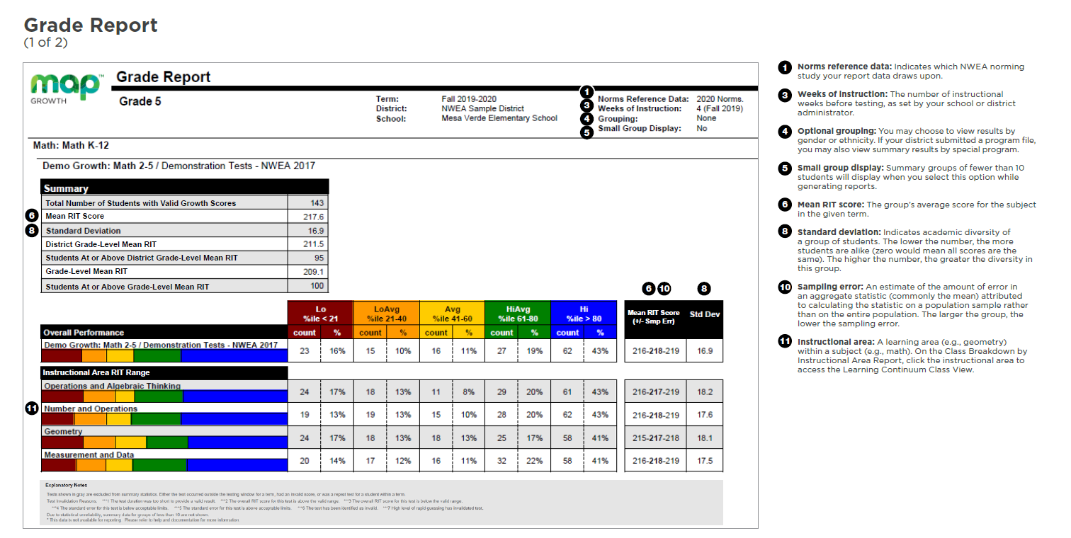
What this report offers | Questions to consider
State-level performance data for a specific test window  Information organized by grade level and subject  Individual student achievement data (RIT scores) for students across the state  Comparisons to normative data and state grade-level mean, reported as network grade-level mean | How is this grade level doing overall?  What is this grade’s lowest instructional area? Highest?  How are we performing compared to national norms?  How might this inform statewide decisions related to programs, resources, or professional learning?  How could this data guide state and district improvement planning?

Projected Proficiency Summary Report
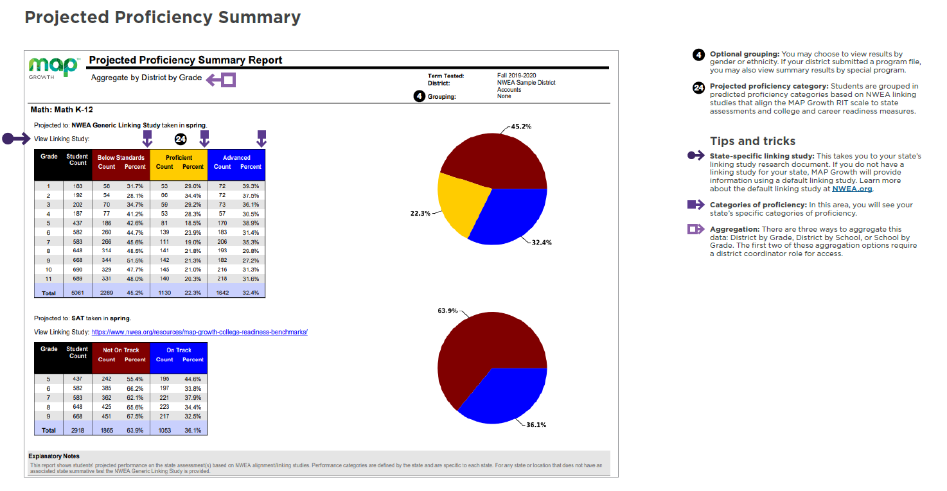
What this report offers | Questions to consider
State-level projected proficiency data for a specific test window  Information organized by test and grade  Aligned to AK STAR state assessment | How are students projected to perform on the AK STAR state assessment?  How could this data guide state and district improvement planning?

Student Growth Summary Report
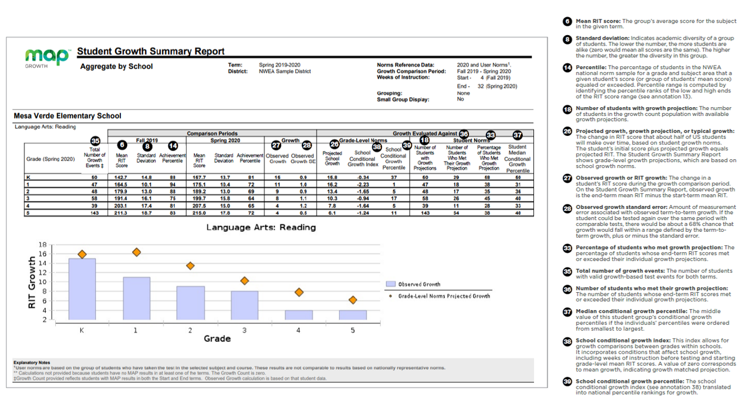
What this report offers | Questions to consider
State-level growth summary data based on two test windows and compared to the national norms  Information organized by grade and subject | Which grade levels are growing above typical and which ones are not?  What are trends over time with student growth?  How might this information support state and district improvement planning and/or goal setting?

Vocabulary
- AK STAR is a criterion referenced assessment.
  - Scores are based on criteria that are established by the state in alignment with state standards.
- NWEA is a norm referenced assessment.
  - A norm-referenced test results in data that distributes the scores across a “normal” distribution based on the actual results of all the students in the sample.
  - Normative Data allows educators to compare achievement status to students’ performance in the same grade at a comparable stage of the school year
- Adaptive Assessment means the difficulty of questions adjusts throughout the assessment based on the student's responses.
- RIT Score/Scale
  - Represents a student’s current level of achievement
  - Measures growth on an equal-interval scale
  - Does not indicate grade-level readiness
- Instructional Level vs Mastery
  - Instructional Level: What students can do with support, or the zone of proximal development (ZPD)
  - Mastery: What students can do independently
    - Mastery scores are the point at which students demonstrate proficiency with the skill or concept
  - MAP Growth scores do not measure mastery

Resources
- Alaska Assessments Webpage
- MAP Growth Reports Portfolio
- AK STAR/MAP Growth Linking Study
- ALE Explorer Tool

