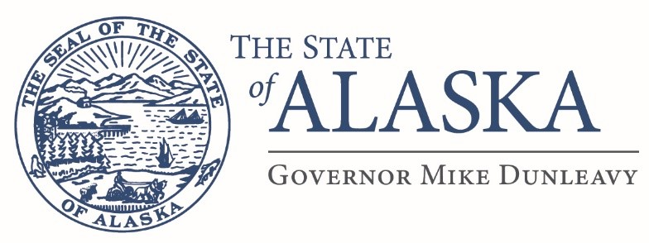
Department of Education &
Early Development

OFFICE OF THE COMMISSIONER
801 West 10th Street, Suite 200
PO Box 110500
Juneau, Alaska 99811-0500
Main: 907.465.2800
TTY/TDD: 907.465.2815
Fax 907.465.4156

MEMORANDUM

TO: Superintendents and/or
District Business Managers

FROM: Dr. Michael Johnson, Commissioner

DATE: February 15, 2019

SUBJECT: Title VII – Impact Aid Adjustment Under AS 14.17.410

The purpose of this memorandum is to give you notice that, pursuant to section 7009(c)(1)(b) of Title VII – Impact Aid, the State of Alaska is requesting permission from the federal government to take impact aid payments into account in determining state aid payments to school districts during the state fiscal year 2020. All school districts receiving impact aid during fiscal year 2020 are subject to such adjustments as provided in AS 14.17.

If you have any questions, please contact Elwin Blackwell, School Finance Manager at 465-8665.

Thank you.

cc: Elwin Blackwell, School Finance Manager

(This document is for informational purposes only. Original was emailed to all superintendents.)

