Alaska Perkins V Combined Form:

Comprehensive Local Needs Assessment
&
Four-Year Plan and Local Application

Career and Technical Education Programs
Form 05-24-016

For those NEW to Perkins/Career and Technical Education:
- Read the CLNA Workbook Guidance (Form 05-20-036a)
- Read the Four-Year Plan & Local Application Guidance (Form 05-24-016b)
- Review your district’s old Comprehensive Local Needs Assessment (CLNA) and Four-Year Plan & Local Application (DEED Program Manager can help you find these in GMS)
- Connect with your DEED CTE Program Manager, review the process, ask questions.
- Review Appendix A, Appendix B, and Appendix C of this document
- Review the CLNA to Four-Year Plan to Budget Tags Sample
- Review ‘How to Use This Form’ - page three of this document
- Complete the CLNA and Four-Year Plan & Local Application Combined Form (Form 05-24-016 - Jumps to page four of this document)
For those Already Familiar with Perkins/Career and Technical Education:
- Review CLNA to Four-Year Plan to Budget Tags Sample (New!)
- Review old Comprehensive Local Needs Assessment (CLNA) and Four-Year Plan & Local Application Documents (can be found in GMS)
- Review ‘How to Use This Form’ – page three of this document
- Complete the CLNA and Four-Year Plan & Local Application Combined Form (Form 05-24-016 - Jumps to page four of this document)
Table of Contents:
How to Use This Form: 3
Combined Form: 4
Part A: Student Performance 4
Part B: Program Quality 5
Part C: CTE Programs of Study (CTEPS) 6
Part D: Recruitment, Retention, Training of CTE Educators 7
Part E: Equity and Access 8
Appendix A: Perkins V Working Platforms and Content 9
Appendix B: Perkins V Program Overview 10
Appendix C: 6 Steps for Perkins V Programs 13

How to Use This Form:
This combined form is designed to help districts track the direct connection between CLNA Needs/Goals for each Part A-E, the plan for those Needs/Goals in the Four-Year Plan & Local Application, and annual budget items in GMS that will be tagged to those Needs/Goals. Districts must ensure that they understand both the Parts A-E that run through all three components of this process, (Appendix B) and the 6 steps of the process itself (Appendix C) before filling out this form. Please refer to the documents linked in the Table of Contents section, as well as the appendices in this document, and contact your DEED Program Manager if you have questions prior to completing this form.
- WHITE box contains a brief description of the Part to be completed. There are five (5) Parts to the form. Each Part contains Five (5) questions. This description is just a reminder. Review provided guidance to ensure full understanding of the requirements of each Part before continuing.

- BLUE section - Comprehensive Local Needs Assessment (CLNA). Review/update every two years. There is a pop-up box link here – this box contains the Perkins V requirements for the CLNA for this Part. Question #1 - Needs must be listed if the district intends to have expenditures for this Part in the future. Needs follow FOCUS format. Question #2 - for each Need there must be a Goal. Goals should follow SMART goal format.

- GREEN section - Four-Year Plan & Local Application for this Part. Review/update every four years. The pop-up box link contains the Perkins V requirements for the Application for this Part. Question #3 - the longest narrative portion of this form – describe the district’s program for this part and how it meets the Perkins V requirements. Question #4 – Action steps directly tied to Needs/Goals from the CLNA for this part, if needed.

- YELLOW section - future GMS entries for this Part. Question #5 - is a general list of budget items that may be requested in GMS to address the Needs/Goals from the CLNA for this Part. Remember that all budget items must be tagged to one of the Parts A-E that directly links a Need/Goal from the CLNA to the budget expenditure.
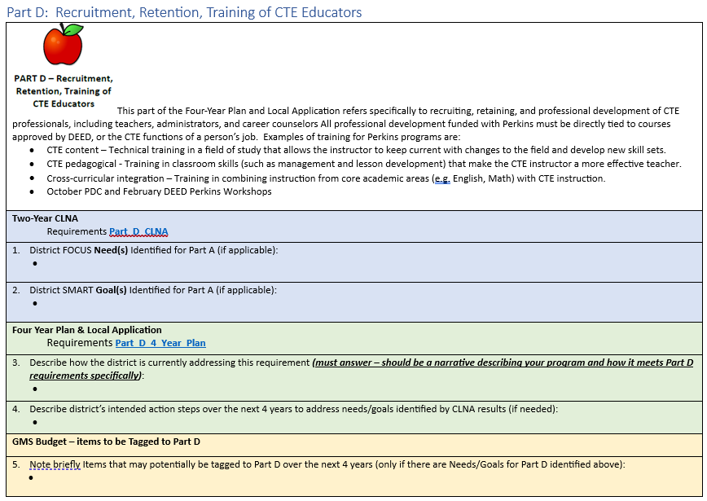
- White (Brief description of the Part)

- Blue (CLNA Questions #1, #2)

- Green (Four-Year Plan Questions #3, #4)

- Yellow (Budget Question #5)

Combined Form 05-24-016:
Comprehensive Local Needs Assessment and Four-Year Plan & Local Application
District:
CLNA Last Approved Date:
Four-Year Plan & Local Application Last Approved Date:

Part A: Student Performance
 | Part A of the Perkins V Program refers specifically to how students in Perkins CTE classes meet the required Perkins V Core Performance Indicators (Four Year Plan and Application Guidance page 5), and whether the district is planning to expend Perkins funds to specifically address any indicators that are not met. For example, if the Math Indicator is not met, a district might spend Perkins funds on collaborative time for Math and Construction/Welding teachers to plan together.

Two-Year CLNA - Requirements Part_A_CLNA
- District FOCUS Need(s) Identified for Part A (if applicable):

- District SMART Goal(s) Identified for Part A (if applicable):

Four Year Plan & Local Application -Requirements
Part_A_Four_Year_Plan
- Describe how the district is currently addressing this requirement (must answer – should be a narrative describing your program and how it meets Part A requirements specifically):

- Describe district’s intended action steps over the next four years to address needs/goals identified by CLNA results above (required if Need/Goal(s) are stated above):

GMS Budget – Items to be tagged to Part A
- General list of items that may potentially be tagged to Part A over the next four years (only if there are Needs/Goals for Part A identified above):

Part B: Program Quality
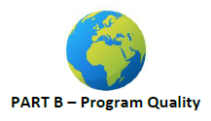 | Part B of the Perkins V Program refers specifically to the ability of the Perkins funded program to be sufficient to meet all of the requirements of Perkins and deliver a quality program that meets the intent of the law and serves all students. Each Perkins program must be of sufficient size, scope and quality (SSQ) (Four Year Plan and Application Guidance page 6-7) to qualify for funding. SSQ means that the Perkins funded program is sufficient to meet all of the requirements of Perkins and deliver a quality program that meets the intent of the law and serves all students.

Two-Year CLNA - Requirements
Part_B_CLNA
- District FOCUS Need(s) Identified for Part B (if applicable):

- District SMART Goal(s) Identified for Part B (if applicable):

Four Year Plan & Local Application - Requirements

Part_B_Four_Year_Plan
- Describe how the district is currently addressing this requirement (must answer – should be a narrative describing your program and how it meets Part B requirements specifically):

- Describe district’s intended action steps over the next four years to address needs/goals identified by CLNA results (required if Need/Goal(s) are stated above):

GMS Budget – Items to be tagged to Part B
- Note briefly Items that may potentially be tagged to Part B over the next four years (only if there are Needs/Goals for Part B identified above):

Part C: CTE Programs of Study (CTEPS)
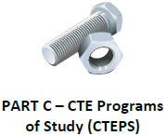 | Part C of the Perkins V Program is the ‘nuts and bolts’ of CTE Programs of Study (CTEPS). Perkins funds can only be used on approved courses and CTEPS, and districts must maintain at least one (1) CTEPS to qualify for Perkins(Four Year Plan and Application Guidance page 9-11). A key principle of Perkins V is that CTE courses are both academically rigorous and provide industry-aligned engagement for students. CTE courses must incorporate a variety of standards into each course offered, including state academic content standards, cultural and employability standards, and industry recognized standards. Alignment to post-secondary programs for further training if desired is necessary for a CTEPS to provide a clear pathway to a career for students.

Two-Year CLNA - Requirements
Part_C_CLNA
- District FOCUS Need(s) Identified for Part A (if applicable):

- District SMART Goal(s) Identified for Part A (if applicable):

Four Year Plan & Local Application - Requirements

Part_C_Four_Year_Plan
- Describe how the district is currently addressing this requirement (must answer – should be a narrative describing your program and how it meets Part C requirements specifically): Include description of at least one complete CTEPS.

- Describe district’s intended action steps over the next four years to address needs/goals identified by CLNA results (required if Need/Goal(s) are stated above):

GMS Budget – Items to be Tagged to Part C
- Note briefly Items that may potentially be tagged to Part C over the next four years (only if there are Needs/Goals for Part C identified above):

Part D: Recruitment, Retention, Training of CTE Educators
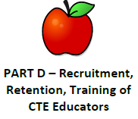 | This part of the Four-Year Plan and Local Application refers specifically to recruiting, retaining, and professional development of CTE professionals, including teachers, administrators, and career counselors (Four Year Plan and Application Guidance page 11). All professional development funded with Perkins must be directly tied to courses approved by DEED, or the CTE functions of a person’s job. For example the CTE Coordinator could attend the DEED February workshop, a CTE teacher could attend training to be able to administer welding certifications, a career counselor could attend a conference on creating CTE pathways and work-study opportunities.

Two-Year CLNA - Requirements
Part_D_CLNA
- District FOCUS Need(s) Identified for Part A (if applicable):

- District SMART Goal(s) Identified for Part A (if applicable):

Four Year Plan & Local Application - Requirements Part_D_Four_Year_Plan
- Describe how the district is currently addressing this requirement (must answer – should be a narrative describing your program and how it meets Part D requirements specifically):

- Describe district’s intended action steps over the next four years to address needs/goals identified by CLNA results (required if Need/Goal(s) are stated above):

GMS Budget – Items to be Tagged to Part D
- Note briefly Items that may potentially be tagged to Part D over the next four years (only if there are Needs/Goals for Part D identified above):

Part E: Equity and Access
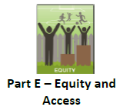 | This part of the Four-Year Plan & Local Application refers specifically to how the district provides both an organized system of career and academic guidance (Four Year Plan and Application Guidance page 11-14) to all students, including current industry information, as well as additional supports to remove barriers and promote equity of participation and success for members of the nine categories of Special Populations.

Two-Year CLNA - Requirements Part_E_CLNA
- District FOCUS Need(s) Identified for Part E (if applicable):

- District SMART Goal(s) Identified for Part E (if applicable):

Four Year Plan & Local Application - Requirements

Part_E_Four_Year_Plan
- Describe how the district is currently addressing this requirement (must answer – should be a narrative describing your program and how it meets Part E requirements specifically):

- Describe district’s intended action steps over the next four years to address needs/goals identified by CLNA results (required if Need/Goal(s) are stated above):

GMS Budget – Items to be Tagged to Part E
- Note briefly Items that may potentially be tagged to Part E over the next four years (only if there are Needs/Goals for Part E identified above):

Appendix A: Perkins V Working Platforms and Content

- DEED/CTE Forms Page
  - Comprehensive Local Needs Assessment Workbook and Guidance (Form 05-20-036a)
  - Four-Year Plan & Local Application Guidance (Form 05-24-016b)
  - Course Description and Standards Crosswalk Form (Form 05-20-038)
  - CTE Program of Study (CTEPS) Template (Form 05-20-035)
  - CLNA and Four-Year Plan & Local Application Combined Form (Form 05-24-016)

- AK Grants Management System (GMS –password and assigned roles required)
  - Annual Update
  - Annual Budgets
  - Advisory Committee Minutes
  - Upload CLNA and Four-Year Plans (as needed)

- DEED/CTE Portal (Portal - username/password required)
  - Secondary Courses and CTEPS Approval
  - All-In-One
    - All-In-One Reporting Form
    - Student data upload by district
  - Secure Access to district data

- DEED CTE Webpage
  - Parts A-E Definitions (overview of what is contained in each Part, or element, of Perkins)
  - Advisory Committee Minutes Template (use this document to accurately hold and document your Advisory Committee meeting)
  - Data Over Time Analysis Template (use this document to analyze and provide data information to your Advisory Committee)
  - CLNA to Four-Year Plan to Budget Tags Sample (this document is a sample response/exemplar to Part E of the new combined document)
  - Perkins Timeline Checklist (use this document to make sure you don’t miss any Perkins required activities or deadlines)

Appendix B: Perkins V Program Overview

The requirements for a Perkins V program in Alaska all work together. Think of them as part of a continuous improvement cycle. These six steps, represented by the gears in the graphic, are also broken down into five Parts A through E that help to define how a district might think about needs, goals, plans and expenditures over time. The goal of a Perkins V program is to provide high quality, ongoing Career and Technical Education pathways for all students that are connected to local and regional industry and or in-demand, high-paying careers. The graphic on the next page illustrates how the Parts A-E connect the CLNA, Four-Year Plan & Local Application, and the budgets in GMS.
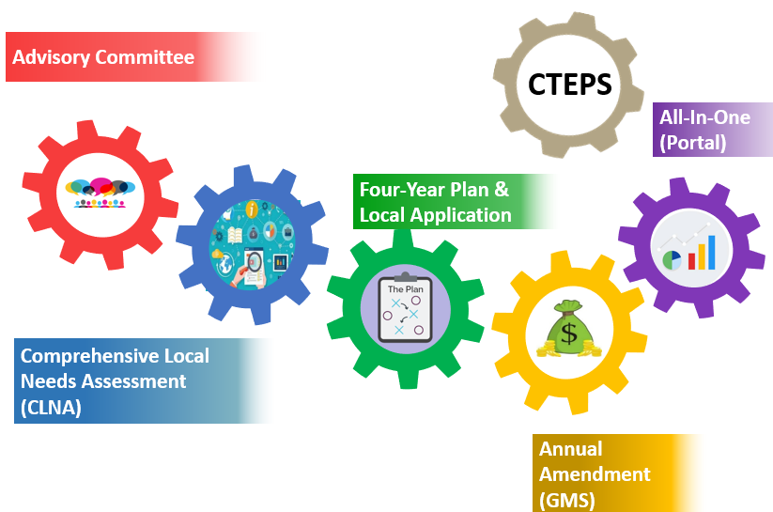
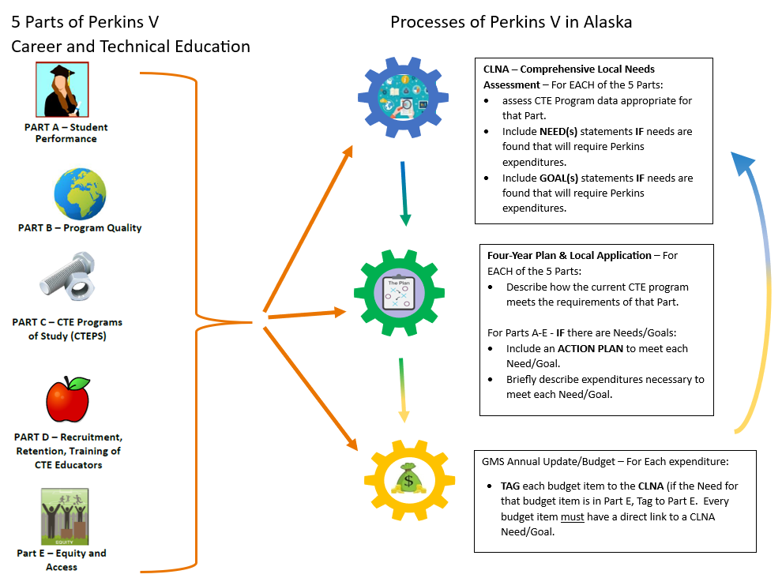

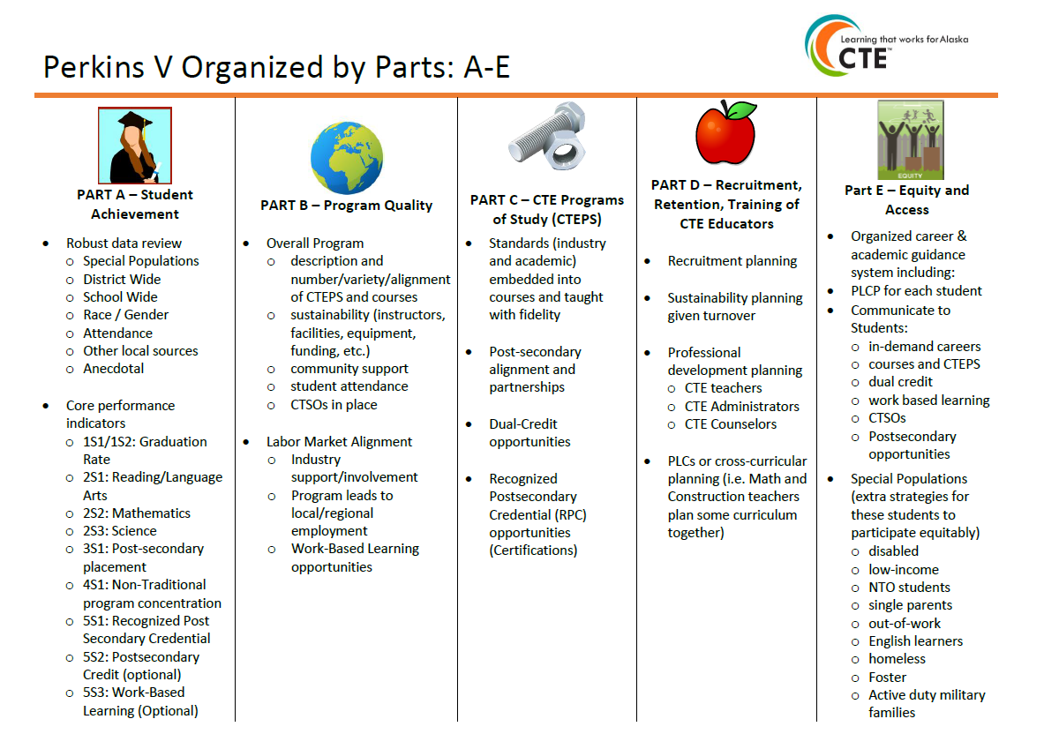

Appendix C: 6 Steps for Perkins V Programs

Step 1: Advisory Committee
 | Districts must create and maintain an Advisory Committee and update membership information annually in GMS. Membership in all categories listed in the law is required. One person may fulfil more than one role, and/or a district may have more than one person serving in a single role. If a district is unable to find a member to fulfill a required role, the district must keep records of the efforts made to fill the role each year. Perkins V requires, at a minimum, the following participants be engaged in the CLNA, Four-Year Plan & Local Application development, and continued consultation.

Required Members:
- Students/Parents
- CTE Teacher
- District Administrator/Principal
- Postsecondary Teacher/Administrator
- Career guidance and advisory professionals
- Specialized instructional teachers/paraprofessionals
- State board or local workforce development (Rotary, Chamber of Commerce, Dept of Labor offices, etc.)
- Local or regional business/industry representatives
- Representatives serving special populations, which include [§3(48)]:
o Individuals with disabilities
o Individuals from economically disadvantaged families
o Individuals preparing for non-traditional fields
o Single parents, including single pregnant women
o Out-of-workforce individuals
o English learners
o Homeless individuals (as described in §725 of McKinney-Vento Homeless Assistance Act (42 U.S.C. 11434a)
o Youth who are in or have aged out of the foster care system
o Youth with a parent who is an active-duty member of the armed forces (as defined in 10 U.S.C. 101(a)(4) and (10 U.S.C. 101(d)(1))
- Regional or local agencies serving out-of-school youth, homeless children and youth, and at-risk youth (as defined in §1432 of ESEA)
- Indian Tribes and Tribal organization representatives, where applicable

Required Meeting/Annual Membership Update:
- Annual Membership list updated in GMS every year
- One meeting per year, minimum (Spring is recommended) must include:
  - Date, attendance, minutes (to be uploaded into GMS annually) [recommended: Advisory Committee Minutes Template]
  - Data Review (See Step 6: Annual All-In-One for Data Guidelines) [recommended: Multi-Year Template for Data Review]
  - Education for members about Perkins V and the district program
  - Opportunity for committee member input

Step 2: CLNA – Comprehensive Local Needs Assessment
 | A Comprehensive Local Needs Assessment (CLNA) must be completed every 2 years. The purpose of the CLNA is to review the Perkins V program elements (divided into five Parts A-E) and determine if there are any needs. The Parts are designed to help the CLNA be completed in ‘bite sized’ chunks. The Parts also function as ‘tags’ – every budget item in Perkins V must be tagged to a need from the CLNA. The CLNA should be conducted by a group of people over the school year. While the CLNA process at the district should include a variety of data, outreach, and discussion to properly assess the Perkins V program, districts only turn in CLNA Results to DEED. The results should be written in the form of FOCUS need and SMART goal statements that drive the rest of the process. The needs and goals will be checked against the Four-Year Plan & Local Application, and each budget item for alignment. Districts are advised to spend some time on the CLNA as the basis and focal point of all the work to follow, ensuring needs and goals that will reflect all Perkins V spending for the next 2 years, shape all action steps in the Four-Year Plan & Local Application, and align directly with all budget items.
Parts A-E of the CLNA:
- Student Performance
- CTE program quality (including Size, Scope, and Quality; and Labor Market Alignment)
- Implementation of full Programs of Study (CTEPS)
- Recruitment, retention, and training of high-quality CTE staff
- Equity and access to high-quality CTE programs for all students (includes nine sub-populations to be considered)
Suggested Stakeholders to Consult:
- Required stakeholders, plus…
- Data staff
- Business and community partners
- Local workforce development and economic development boards
- Former students

Suggested Strategies for Consultation:
- Work groups
- Focus groups
- Individual interviews
- Surveys
- Study circles
CLNA Resources:
- CLNA Process Guidance – Optional CLNA Workbook (Form 05-20-036a)
- Exemplar – CLNA to Four-Year Plan to Budget items CLNA to Budget Tag Sample

- Must use FOCUS Needs statements – statements that adhere to the elements of the FOCUS prompt.
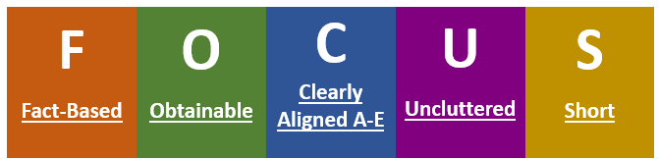

- Must use SMART Goal statements – statements that adhere to the elements of the SMART prompt.
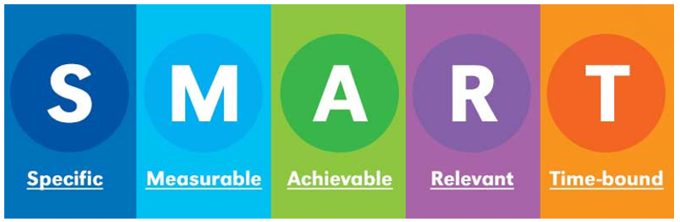

Step 3: Four-Year Plan & Local Application
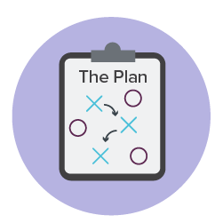 | The Four-Year Plan & Local Application is the district’s application for Perkins V funds. It follows the same five Parts A-E as the CLNA. The Four-Year Plan & Local Application has 3 questions for each Part and should be written so that the description section fully describes the Perkins plan as it is currently operating and outline the action steps so that a new CTE Coordinator could use this document to understand what is currently happening, and what steps need to be taken in the future.

Requirements of the Four-Year Plan & Local Application:
- For Each Part A-E
  - Question #3 - Describe how the district is currently addressing this requirement (must answer):
    - This is where you put narrative – describe challenges and successes if you wish, describe your program so that a parent or someone outside of your district would understand what your district is providing for Career and Technical Education related to the Part in question. Describe specifically how your program as it is currently provided meets the requirements of Perkins V listed in the form (pop-up box) for each Part.
  - Question #4 - Describe district’s intended action steps over the next four years to address needs/goals identified by CLNA results above (if needed):
    - IF your district intends to spend Perkins funds in a particular Part (for example Part B) there should be at least one Need/Goal in the CLNA section for Part B. If there is, you would use that Need/Goal from the CLNA section and write a list of action steps to be taken to meet that need/goal. Steps should be measurable, whenever possible, so that an item can be ‘completed’ and removed from the list in the future. There will be some exceptions to this rule, for example consumable supplies like welding metal and gasses, which will be an ongoing need for a welding course.

Four-Year Plan & Local Application Resources:
- Four-Year Plan & Local Application Guidance (Form 05-20-037a)

Step 4: CTE Courses and Career and Technical Education Program of Study (CTEPS)
  CTEPS | Perkins V programs are all built on the idea that students will be able to take Career and Technical Education Programs of Study – sequences of courses that are grouped together by 16 National Career Clusters and Pathways. Programs of Study, or CTEPS, may start with foundational courses like Employability Skills or Career Exploration, and work up to more technical skills. Each district must maintain one complete CTEPS within a single career cluster to qualify for Perkins V funding. Perkins V funds may only be spent on courses approved by DEED. Course approval requires course alignment with state standards on the Course Description and Standards Crosswalk.

Requirements of a CTEPS:
- Incorporate challenging State academic standards: English/LA, Math, Science, Employability Skills, Cultural
- Incorporate nationally recognized CTE technical standards (i.e., ProStart, NCCER, FAA, US Coast Guard, AWS Welding, etc.)
- Attain a Recognized Postsecondary Credential (RPC) whenever possible. ETT certification and FAA drone flying license are two examples.
- Complete at least two credits in a single occupation specific CTEPS. One of these credits may be foundational – i.e., life skills or exploratory, but the other must be in technical content, for example Welding I and Welding II, if each are .5 credit courses.
- Ability of a student during a typical high school tenure to complete an entire CTEPS, in the order of progression (for example Welding I leading to Welding II, and so on) and without duplicating courses.
- Includes alignment to a postsecondary entity (i.e., dual credit, an agreement with a technical school that a student completing the CTEPS could enter the program without the need for technical remediation, etc.)
- See Diagram – Next page

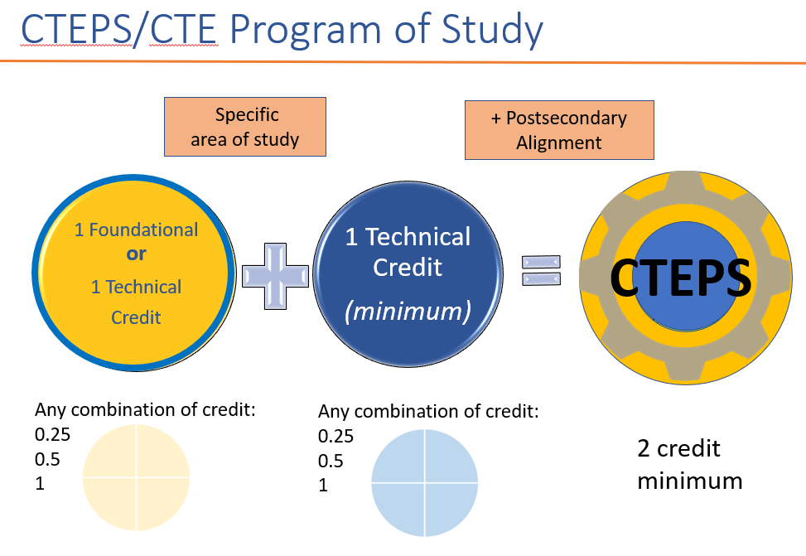
Courses and CTEPS Forms/Resources:
- Course Description and Standards Crosswalk (Form 05-20-038 - Upload to DEED Portal as needed)
- CTE Program of Study (CTEPS) Template (Form 05-20-035)
- CTEPS Course to Career Cluster diagram/16 Career Clusters List
- Alaska Standards Link
- 2018 ACTE Quality CTE Program of Study Framework

Step 5: Annual Amendment (GMS)
 | The annual amendment in the Grants Management System (GMS) is NOT the application. It is simply the place where we approve the annual budgets, make sure all budget items are linked to needs/goals in the CLNA, ensure that federal assurances are met, and ask about any updates to the district’s Advisory Committee or Four-Year Plan & Local Application. Advisory Committee minutes are uploaded into GMS every year, CLNA Results and Four-Year Plan & Local Application documents are uploaded into GMS as needed. All these documents and past budgets are available to anyone from the district with the proper authorization in GMS. Question #5 on the form above for each Part – list items that will likely be tagged to (Part B, for example) over the next four years – general description. These notes are more for the person filling out the CLNA/Application to make the connection between the need in the CLNA and what kinds of expenditures will likely be placed in budgets to fulfill this need. DEED program managers will review every budget item tag in GMS for direct alignment to the CLNA.

GMS Annual Amendment Requirements:
- Assurances Page – required federal assurances
- Budget
  - All budget items must be tagged to a Part of the CLNA (Parts A-E) where the need for this budget item is listed
  - All budget items must have a narrative that includes which approved Perkins Career and Technical Education course the item is for and enough detail that the DEED Program Manager can determine if the item is approvable
- Related Documents Page
  - Advisory Committee minutes, uploaded annually
  - CLNA Results, and Four-Year Plan & Local Application documents, uploaded as needed
- Update page – this page contains information we ask for annually
  - Advisory Committee member list
  - Perkins V program data distribution – Like the Report Card, program data must be available to the public, we check this every year
  - Four-Year Plan & Local Application updates – if you had a significant change in your Application due to unforeseen circumstances, note it here
- Dates to Remember:
  - June 30th – Substantially Approvable (GMS Update must have Advisory Committee minutes, budget, Federal Assurances completed
  - September 30th – Reallocation (GMS Update must be completely approved by this date to qualify for these additional funds)
Step 6: All-In-One Annual Data Collection and Portal
 | The All-In-One Annual Student Data Collection form is a requirement for Perkins V secondary districts. Due every year on June 15th, we ask you to download an Excel spreadsheet from the DEED/CTE Portal, (password required) fill it out and upload it back to the Portal (you CANNOT email it to us, it has personally identifiable student information in it). We collect data on Perkins V Program Participants, and group them into Concentrators – those students who are graduating in the current year, and who have taken two or more Perkins approved courses in the same CTEPS. Districts should review the courses and groupings annually to see if it lines up with CLNA needs and should share it however possible (following FERPA guidelines) with the Advisory Committee annually. DEED generates the data using the student level information and posts it back to the Portal calculated for your use annually.
Perkins V Core Performance Indicators:
1S1: Four-Year Graduation Rate
1S2: Extended-Year Graduation Rate (5 years in Alaska)
2S1: Academic Proficiency in Reading/Language Arts
2S2: Academic Proficiency in Mathematics
2S3: Academic Proficiency in Science
3S1: Secondary Post-Program Placement
4S1: Non-Traditional Program Concentration
5S1: Recognized Postsecondary Credential
5S2: CTE Program Quality Indicator – Postsecondary Credit (Collecting, not reporting to Feds)
5S3: CTE Program Quality Indicator – Work Based Learning (Collecting, not reporting to Feds)

Subpopulation Groups for disaggregation:
- Gender
- Race and ethnicity (African American, Alaska Native/American Indian, Asian/Pacific Islander, Caucasian, Hispanic, Two or More Races)
- Migrant status
- Individuals with disabilities
- Individuals from economically disadvantaged families including low-income youth and adults
- Individuals preparing for non-traditional fields (NTO)
- Single parents including single pregnant women
- Out of work individuals
- English learners
- Homeless individuals
- Youth who are in or who have aged out of the foster care system
- Youth with a parent who is an active-duty member of the armed forces

